Grade 8

Exit Tickets

This document contains printable and customizable versions of the Exit Tickets recommended
in the Into Math Teacher Edition. The Exit Ticket is also available as a Projectable PDF on
Ed: Your Friend in Learning.

Exit Tickets are an optional way to wrap up a lesson. The problem provided for each lesson assesses
whether students grasped the lesson content.

To save paper when printing, the document is formatted with 2 to a page for some lessons and 4 to a page
in other lessons, based on the space students will likely need to answer the question(s).

Copyright © by Houghton Mifflin Harcourt Publishing Company
All rights reserved. No part of the material protected by this copyright may be reproduced or utilized in any form or by any means, electronic or mechanical, including photocopying, recording, broadcasting or by any other information storage and retrieval system, without written permission of the copyright owner unless such copying is expressly permitted by federal copyright law.
Only those pages that are specifically enabled by the program and indicated by the presence of the print icon may be printed and reproduced in classroom quantities by individual teachers using the corresponding student’s textbook or kit as the major vehicle for regular classroom instruction. Requests for information on other matters regarding duplication of this work should be submitted through our Permissions website at https://customercare.hmhco.com/contactus/Permissions.html or mailed to Houghton Mifflin Harcourt Publishing Company, Attn: Compliance, Contracts, and Licensing, 9400 Southpark Center Loop, Orlando, Florida 32819-8647.
HOUGHTON MIFFLIN HARCOURT and the HMH Logo are trademarks and service marks of Houghton Mifflin Harcourt Publishing Company. You shall not display, disparage, dilute or taint Houghton Mifflin Harcourt trademarks and service marks or use any confusingly similar marks, or use Houghton Mifflin Harcourt marks in such a way that would misrepresent the identity of the owner. Any permitted use of Houghton Mifflin Harcourt trademarks and service marks inures to the benefit of Houghton Mifflin Harcourt Publishing Company.
All other trademarks, service marks or registered trademarks appearing on Houghton Mifflin Harcourt Publishing Company websites are the trademarks or service marks of their respective owners.

Module 1 Lesson 1 Name: _____________________________

Reginald rotates a regular hexagon. What is true of the
angles, side lengths, and parallel sides?

Module 1 Lesson 1 Name: _____________________________

Reginald rotates a regular hexagon. What is true of the
angles, side lengths, and parallel sides?

Module 1 Lesson 1 Name: _____________________________

Reginald rotates a regular hexagon. What is true of the
angles, side lengths, and parallel sides?

Module 1 Lesson 1 Name: _____________________________

Reginald rotates a regular hexagon. What is true of the
angles, side lengths, and parallel sides?

Module 1 Lesson 2 Name: _____________________________

The preimage of a rectangle has vertices with coordinates
at (−3, 2), (−3, 5), (2, 5), and (2, 2). The image of the
rectangle has vertices with coordinates at (−2, 0), (−2, 3),
(3, 3), and (3, 0). Describe the translation using mapping
notation.

Module 1 Lesson 2 Name: _____________________________

The preimage of a rectangle has vertices with coordinates
at (−3, 2), (−3, 5), (2, 5), and (2, 2). The image of the
rectangle has vertices with coordinates at (−2, 0), (−2, 3),
(3, 3), and (3, 0). Describe the translation using mapping
notation.

Module 1 Lesson 2 Name: _____________________________

The preimage of a rectangle has vertices with coordinates
at (−3, 2), (−3, 5), (2, 5), and (2, 2). The image of the
rectangle has vertices with coordinates at (−2, 0), (−2, 3),
(3, 3), and (3, 0). Describe the translation using mapping
notation.

Module 1 Lesson 2 Name: _____________________________

The preimage of a rectangle has vertices with coordinates
at (−3, 2), (−3, 5), (2, 5), and (2, 2). The image of the
rectangle has vertices with coordinates at (−2, 0), (−2, 3),
(3, 3), and (3, 0). Describe the translation using mapping
notation.

Module 1 Lesson 3 Name: _____________________________

Consider a triangle with vertices (−2, −2), (−4, −5), and
(−1, −8). What would the vertices of the image be if the
triangle were reflected over the x-axis, then the y-axis?

Module 1 Lesson 3 Name: _____________________________

Consider a triangle with vertices (−2, −2), (−4, −5), and
(−1, −8). What would the vertices of the image be if the
triangle were reflected over the x-axis, then the y-axis?

Module 1 Lesson 3 Name: _____________________________

Consider a triangle with vertices (−2, −2), (−4, −5), and
(−1, −8). What would the vertices of the image be if the
triangle were reflected over the x-axis, then the y-axis?

Module 1 Lesson 3 Name: _____________________________

Consider a triangle with vertices (−2, −2), (−4, −5), and
(−1, −8). What would the vertices of the image be if the
triangle were reflected over the x-axis, then the y-axis?

Module 1 Lesson 4 Name: _____________________________

Figure 1 has vertices (–3, 4), (–1, 3), (–3, 1), and (–5, 2). Rotate it 180° to form Figure 2. Give the coordinates for the
vertices of Figure 2.

Module 1 Lesson 4 Name: _____________________________

Figure 1 has vertices (–3, 4), (–1, 3), (–3, 1), and (–5, 2). Rotate it 180° to form Figure 2. Give the coordinates for the
vertices of Figure 2.

Module 1 Lesson 4 Name: _____________________________

Figure 1 has vertices (–3, 4), (–1, 3), (–3, 1), and (–5, 2). Rotate it 180° to form Figure 2. Give the coordinates for the
vertices of Figure 2.

Module 1 Lesson 4 Name: _____________________________

Figure 1 has vertices (–3, 4), (–1, 3), (–3, 1), and (–5, 2). Rotate it 180° to form Figure 2. Give the coordinates for the
vertices of Figure 2.

Module 1 Lesson 5 Name: _____________________________

What series of transformations can transform one heart into
the other heart? Are the two hearts congruent?

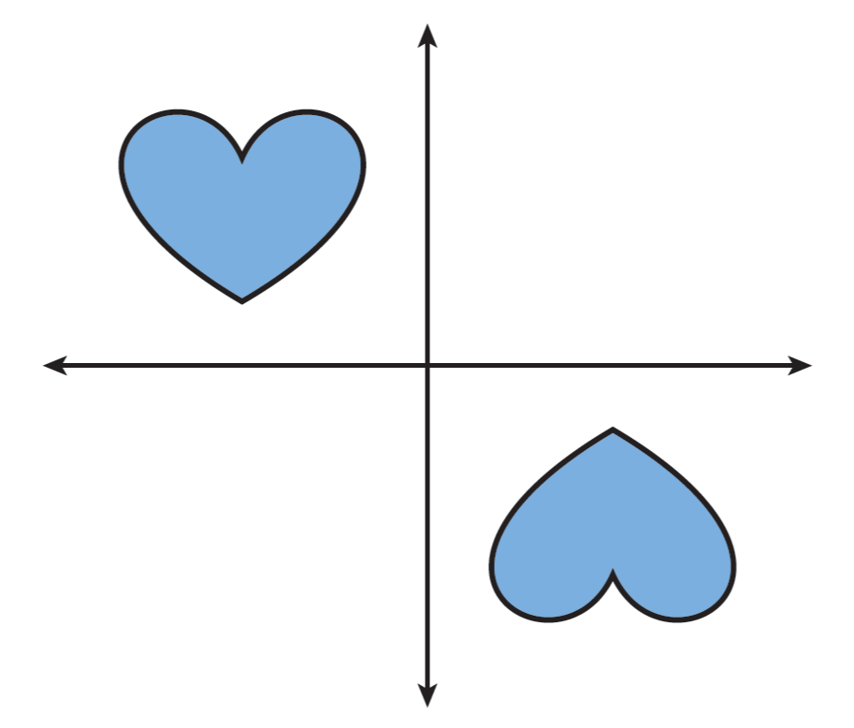

Module 1 Lesson 5 Name: _____________________________

What series of transformations can transform one heart into
the other heart? Are the two hearts congruent?

Module 1 Lesson 5 Name: _____________________________

What series of transformations can transform one heart into
the other heart? Are the two hearts congruent?

Module 1 Lesson 5 Name: _____________________________

What series of transformations can transform one heart into
the other heart? Are the two hearts congruent?

Module 2 Lesson 1 Name: _____________________________

Figure 1 is a triangle that has side lengths of 6 in., 8 in., and
10 in., and angle measures of 90°, 37°, and 53°. It is
enlarged to 1.5 times its size to form Figure 2. What are the
side lengths and angle measures of Figure 2?

Module 2 Lesson 1 Name: _____________________________

Figure 1 is a triangle that has side lengths of 6 in., 8 in., and
10 in., and angle measures of 90°, 37°, and 53°. It is
enlarged to 1.5 times its size to form Figure 2. What are the
side lengths and angle measures of Figure 2?

Module 2 Lesson 1 Name: _____________________________

Figure 1 is a triangle that has side lengths of 6 in., 8 in., and
10 in., and angle measures of 90°, 37°, and 53°. It is
enlarged to 1.5 times its size to form Figure 2. What are the
side lengths and angle measures of Figure 2?

Module 2 Lesson 1 Name: _____________________________

Figure 1 is a triangle that has side lengths of 6 in., 8 in., and
10 in., and angle measures of 90°, 37°, and 53°. It is
enlarged to 1.5 times its size to form Figure 2. What are the
side lengths and angle measures of Figure 2?

Module 2 Lesson 2 Name: _____________________________

Figure 1 is a triangle with vertices at (18, 6), (12, 15), and
(3, 9). It is dilated twice, using the origin as center both
times: once with a scale factor of 4, and once with a scale
factor of $\frac{2}{3}$. What are the locations of the vertices of the
dilated figures?

Module 2 Lesson 2 Name: _____________________________

Figure 1 is a triangle with vertices at (18, 6), (12, 15), and
(3, 9). It is dilated twice, using the origin as center both
times: once with a scale factor of 4, and once with a scale
factor of $\frac{2}{3}$. What are the locations of the vertices of the
dilated figures?

Module 2 Lesson 2 Name: _____________________________

Figure 1 is a triangle with vertices at (18, 6), (12, 15), and
(3, 9). It is dilated twice, using the origin as center both
times: once with a scale factor of 4, and once with a scale
factor of $\frac{2}{3}$. What are the locations of the vertices of the
dilated figures?

Module 2 Lesson 2 Name: _____________________________

Figure 1 is a triangle with vertices at (18, 6), (12, 15), and
(3, 9). It is dilated twice, using the origin as center both
times: once with a scale factor of 4, and once with a scale
factor of $\frac{2}{3}$. What

Module 2 Lesson 3 Name: _____________________________

What sequence of transformations could map B to P?

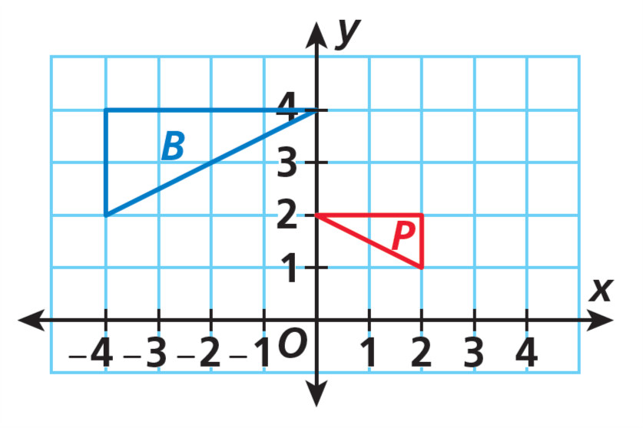

Module 2 Lesson 3 Name: _____________________________

What sequence of transformations could map B to P?

Module 2 Lesson 3 Name: _____________________________

What sequence of transformations could map B to P?

Module 2 Lesson 3 Name: _____________________________

What sequence of transformations could map B to P?

Module 3 Lesson 1 Name: _____________________________

Solve the equation using two different methods. Show
your work.

2.25x + 15 = 9.5x + 0.5

Module 3 Lesson 1 Name: _____________________________

Solve the equation using two different methods. Show
your work.

2.25x + 15 = 9.5x + 0.5

Module 3 Lesson 1 Name: _____________________________

Solve the equation using two different methods. Show
your work.

2.25x + 15 = 9.5x + 0.5

Module 3 Lesson 1 Name: _____________________________

Solve the equation using two different methods. Show
your work.

2.25x + 15 = 9.5x + 0.5

Module 3 Lesson 2 Name: _____________________________

Solve the equation and determine how many solutions the
equation has. Explain your answer.

2.5x − (1.1x − 2) = 2(0.7x)

Module 3 Lesson 2 Name: _____________________________

Solve the equation and determine how many solutions the
equation has. Explain your answer.

2.5x − (1.1x − 2) = 2(0.7x)

Module 3 Lesson 2 Name: _____________________________

Solve the equation and determine how many solutions the
equation has. Explain your answer.

2.5x − (1.1x − 2) = 2(0.7x)

Module 3 Lesson 2 Name: _____________________________

Solve the equation and determine how many solutions the
equation has. Explain your answer.

2.5x − (1.1x − 2) = 2(0.7x)

Module 3 Lesson 3 Name: _____________________________

Tory and Quentin are the same age. Tory’s younger sister is
the same age as Quentin’s younger brother. Tory is 3 years
older than her sister. Quentin’s age is 8 years less than twice
his brother’s age. Write and solve an equation to determine
Tory’s and Quentin’s ages.

Module 3 Lesson 3 Name: _____________________________

Tory and Quentin are the same age. Tory’s younger sister is
the same age as Quentin’s younger brother. Tory is 3 years
older than her sister. Quentin’s age is 8 years less than twice
his brother’s age. Write and solve an equation to determine
Tory’s and Quentin’s ages.

Module 3 Lesson 3 Name: _____________________________

Tory and Quentin are the same age. Tory’s younger sister is
the same age as Quentin’s younger brother. Tory is 3 years
older than her sister. Quentin’s age is 8 years less than twice
his brother’s age. Write and solve an equation to determine
Tory’s and Quentin’s ages.

Module 3 Lesson 3 Name: _____________________________

Tory and Quentin are the same age. Tory’s younger sister is
the same age as Quentin’s younger brother. Tory is 3 years
older than her sister. Quentin’s age is 8 years less than twice
his brother’s age. Write and solve an equation to determine
Tory’s and Quentin’s ages.

Module 4 Lesson 1 Name: _____________________________

An exterior angle of a triangle has a measure of 140°. If the
corresponding remote interior angles are congruent, what
is the measure of each angle?

Module 4 Lesson 1 Name: _____________________________

An exterior angle of a triangle has a measure of 140°. If the
corresponding remote interior angles are congruent, what
is the measure of each angle?

Module 4 Lesson 1 Name: _____________________________

An exterior angle of a triangle has a measure of 140°. If the
corresponding remote interior angles are congruent, what
is the measure of each angle?

Module 4 Lesson 1 Name: _____________________________

An exterior angle of a triangle has a measure of 140°. If the
corresponding remote interior angles are congruent, what
is the measure of each angle?

Module 4 Lesson 2 Name: _____________________________

If two triangles are NOT similar, can they have any
corresponding congruent angles? If so, how many pairs of
corresponding congruent angles can they have?

Module 4 Lesson 2 Name: _____________________________

If two triangles are NOT similar, can they have any
corresponding congruent angles? If so, how many pairs of
corresponding congruent angles can they have?

Module 4 Lesson 2 Name: _____________________________

If two triangles are NOT similar, can they have any
corresponding congruent angles? If so, how many pairs of
corresponding congruent angles can they have?

Module 4 Lesson 2 Name: _____________________________

If two triangles are NOT similar, can they have any
corresponding congruent angles? If so, how many pairs of
corresponding congruent angles can they have?

Module 4 Lesson 3 Name: _____________________________

Find the measures of the two angles.

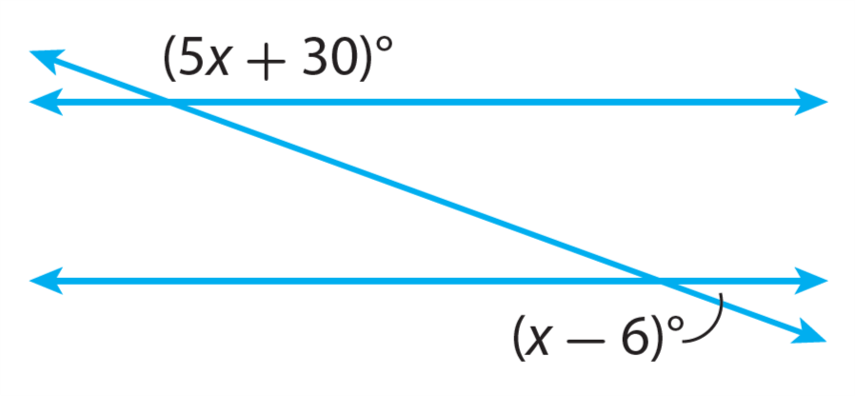

Module 4 Lesson 3 Name: _____________________________

Find the measures of the two angles.

Module 4 Lesson 3 Name: _____________________________

Find the measures of the two angles.

Module 4 Lesson 3 Name: _____________________________

Find the measures of the two angles.

Module 5 Lesson 1 Name: _____________________________

A line passes through the origin and the point (12, 9).
Identify the slope of the line and two additional points on
the line.

Module 5 Lesson 1 Name: _____________________________

A line passes through the origin and the point (12, 9).
Identify the slope of the line and two additional points on
the line.

Module 5 Lesson 1 Name: _____________________________

A line passes through the origin and the point (12, 9).
Identify the slope of the line and two additional points on
the line.

Module 5 Lesson 1 Name: _____________________________

A line passes through the origin and the point (12, 9).
Identify the slope of the line and two additional points on
the line.

Module 5 Lesson 2 Name: _____________________________

Dequan is training for a marathon. He runs 20 miles every
4 days. Write an equation to represent the total number of
miles he runs in x days.

Module 5 Lesson 2 Name: _____________________________

Dequan is training for a marathon. He runs 20 miles every
4 days. Write an equation to represent the total number of
miles he runs in x days.

Module 5 Lesson 2 Name: _____________________________

Dequan is training for a marathon. He runs 20 miles every
4 days. Write an equation to represent the total number of
miles he runs in x days.

Module 5 Lesson 2 Name: _____________________________

Dequan is training for a marathon. He runs 20 miles every
4 days. Write an equation to represent the total number of
miles he runs in x days.

Module 5 Lesson 3 Name: _____________________________

Describe a proportional relationship that would be best
represented with a continuous graph. Explain your reasoning.

Module 5 Lesson 3 Name: _____________________________

Describe a proportional relationship that would be best
represented with a continuous graph. Explain your reasoning.

Module 5 Lesson 3 Name: _____________________________

Describe a proportional relationship that would be best
represented with a continuous graph. Explain your reasoning.

Module 5 Lesson 3 Name: _____________________________

Describe a proportional relationship that would be best
represented with a continuous graph. Explain your reasoning.

Module 5 Lesson 4 Name: _____________________________

Walter, Geraldine, and Tonya are participating in a car wash.
Walter can wash 5 cars in 2 hours. Geraldine can wash 7 cars in 3 hours. Tonya washes cars according to the table shown.

Complete the table. Then compare the car-washing rates of
the three friends. Assume that all the cars are the same size.

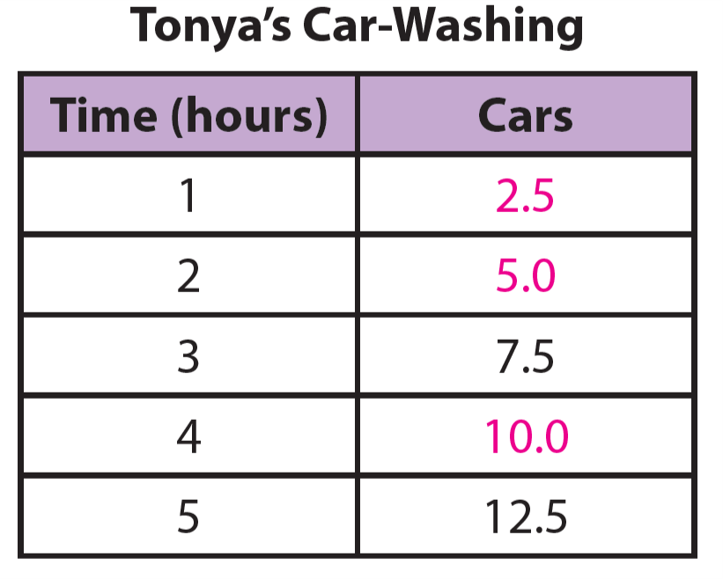

Module 5 Lesson 4 Name: _____________________________

Walter, Geraldine, and Tonya are participating in a car wash.
Walter can wash 5 cars in 2 hours. Geraldine can wash 7 cars in 3 hours. Tonya washes cars according to the table shown.

Complete the table. Then compare the car-washing rates of
the three friends. Assume that all the cars are the same size.

Module 6 Lesson 1 Name: _____________________________

Geri is ordering flower arrangements for a teacher’s
appreciation brunch. She is planning for up to eight table
arrangements that cost $5 each with a $10 set-up fee for
the whole order. Graph the function that represents
the cost.

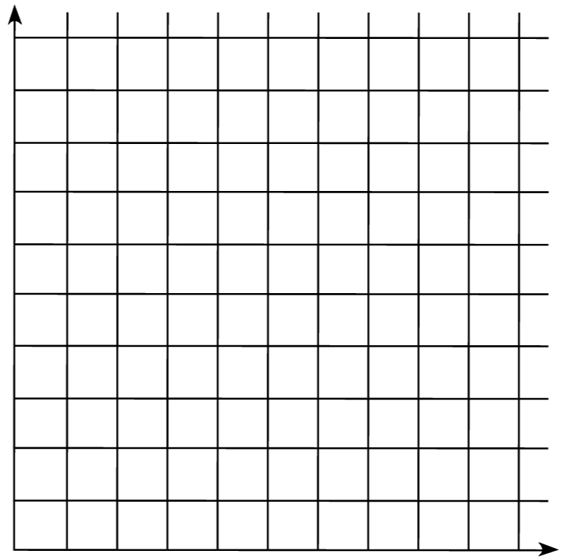

Module 6 Lesson 1 Name: _____________________________

Geri is ordering flower arrangements for a teacher’s
appreciation brunch. She is planning for up to eight table
arrangements that cost $5 each with a $10 set-up fee for
the whole order. Graph the function that represents
the cost.

Module 6 Lesson 2 Name: _____________________________

Francesca identifies one point on a line as (1, 4), and she
knows that the slope is 3. What are the y-intercept and the equation of the line?

Module 6 Lesson 2 Name: _____________________________

Francesca identifies one point on a line as (1, 4), and she
knows that the slope is 3. What are the y-intercept and the equation of the line?

Module 6 Lesson 2 Name: _____________________________

Francesca identifies one point on a line as (1, 4), and she
knows that the slope is 3. What are the y-intercept and the equation of the line?

Module 6 Lesson 2 Name: _____________________________

Francesca identifies one point on a line as (1, 4), and she
knows that the slope is 3. What are the y-intercept and the equation of the line?

Module 6 Lesson 3 Name: _____________________________

Janet, an antique dealer, purchased a classic toy car as an
investment. She wrote the equation y = 40x + 100 to
represent the value y in dollars of her investment x years
after she bought it. What are the initial value and rate of
change? Explain.

Module 6 Lesson 3 Name: _____________________________

Janet, an antique dealer, purchased a classic toy car as an
investment. She wrote the equation y = 40x + 100 to
represent the value y in dollars of her investment x years
after she bought it. What are the initial value and rate of
change? Explain.

Module 6 Lesson 3 Name: _____________________________

Janet, an antique dealer, purchased a classic toy car as an
investment. She wrote the equation y = 40x + 100 to
represent the value y in dollars of her investment x years
after she bought it. What are the initial value and rate of
change? Explain.

Module 6 Lesson 3 Name: _____________________________

Janet, an antique dealer, purchased a classic toy car as an
investment. She wrote the equation y = 40x + 100 to
represent the value y in dollars of her investment x years
after she bought it. What are the initial value and rate of
change? Explain.

Module 6 Lesson 4 Name: _____________________________

Write a linear function containing the following points:
(0, −8) (2, 0)

Module 6 Lesson 4 Name: _____________________________

Write a linear function containing the following points:
(0, −8) (2, 0)

Module 6 Lesson 4 Name: _____________________________

Write a linear function containing the following points:
(0, −8) (2, 0)

Module 6 Lesson 4 Name: _____________________________

Write a linear function containing the following points:
(0, −8) (2, 0)

Module 6 Lesson 5 Name: _____________________________

Olga just got a new job, and she is looking to lease a car.
Dealer A offers her a $2400 trade-in on her old car, with
lease payments of $360 a month. Dealer B offers a trade-in
of $2000 with payments of $320 a month. Olga wants to
lease the car for only 6 months. Which deal is better for
her?

Module 6 Lesson 5 Name: _____________________________

Olga just got a new job, and she is looking to lease a car.
Dealer A offers her a $2400 trade-in on her old car, with
lease payments of $360 a month. Dealer B offers a trade-in
of $2000 with payments of $320 a month. Olga wants to
lease the car for only 6 months. Which deal is better for
her?

Module 6 Lesson 6 Name: _____________________________

Victoria just graduated from college. She saves the same
amount of money each week. After many weeks, she has
enough saved to buy a television. She purchases the
television, then starts saving the same amount each week.

Describe a graph that represents this situation.

Module 6 Lesson 6 Name: _____________________________

Victoria just graduated from college. She saves the same
amount of money each week. After many weeks, she has
enough saved to buy a television. She purchases the
television, then starts saving the same amount each week.

Describe a graph that represents this situation.

Module 6 Lesson 6 Name: _____________________________

Victoria just graduated from college. She saves the same
amount of money each week. After many weeks, she has
enough saved to buy a television. She purchases the
television, then starts saving the same amount each week.

Describe a graph that represents this situation.

Module 6 Lesson 6 Name: _____________________________

Victoria just graduated from college. She saves the same
amount of money each week. After many weeks, she has
enough saved to buy a television. She purchases the
television, then starts saving the same amount each week.

Describe a graph that represents this situation.

Module 7 Lesson 1 Name: _____________________________

Andy is comparing the cost of frozen yogurt at two shops.
At Shop A, the total cost y of x ounces of yogurt is
y = 0.25x + 0.25. At Shop B, the total cost y of x ounces of
yogurt is y = 0.25x + 0.5. Which shop offers a better deal?
How is this shown in the graphs of the equations?

Module 7 Lesson 1 Name: _____________________________

Andy is comparing the cost of frozen yogurt at two shops.
At Shop A, the total cost y of x ounces of yogurt is
y = 0.25x + 0.25. At Shop B, the total cost y of x ounces of
yogurt is y = 0.25x + 0.5. Which shop offers a better deal?
How is this shown in the graphs of the equations?

Module 7 Lesson 1 Name: _____________________________

Andy is comparing the cost of frozen yogurt at two shops.
At Shop A, the total cost y of x ounces of yogurt is
y = 0.25x + 0.25. At Shop B, the total cost y of x ounces of
yogurt is y = 0.25x + 0.5. Which shop offers a better deal?
How is this shown in the graphs of the equations?

Module 7 Lesson 1 Name: _____________________________

Andy is comparing the cost of frozen yogurt at two shops.
At Shop A, the total cost y of x ounces of yogurt is
y = 0.25x + 0.25. At Shop B, the total cost y of x ounces of
yogurt is y = 0.25x + 0.5. Which shop offers a better deal?
How is this shown in the graphs of the equations?

Module 7 Lesson 2 Name: _____________________________

The two straight paths in a community garden are
represented by the equations y = −x + 4 and y = 0.5x – 2.
At what point, if any, do the paths intersect?

Module 7 Lesson 2 Name: _____________________________

The two straight paths in a community garden are
represented by the equations y = −x + 4 and y = 0.5x – 2.
At what point, if any, do the paths intersect?

Module 7 Lesson 2 Name: _____________________________

The two straight paths in a community garden are
represented by the equations y = −x + 4 and y = 0.5x – 2.
At what point, if any, do the paths intersect?

Module 7 Lesson 2 Name: _____________________________

The two straight paths in a community garden are
represented by the equations y = −x + 4 and y = 0.5x – 2.
At what point, if any, do the paths intersect?

Module 7 Lesson 3 Name: _____________________________

Solve the following system of equations by substitution.
$$\left\{\begin{aligned}3x-2y=-22 \\ 2x+y=-3\end{aligned}\right.$$

Module 7 Lesson 3 Name: _____________________________

Solve the following system of equations by substitution.
$$\left\{\begin{aligned}3x-2y=-22 \\ 2x+y=-3\end{aligned}\right.$$

Module 7 Lesson 3 Name: _____________________________

Solve the following system of equations by substitution.
$$\left\{\begin{aligned}3x-2y=-22 \\ 2x+y=-3\end{aligned}\right.$$

Module 7 Lesson 3 Name: _____________________________

Solve the following system of equations by substitution.
$$\left\{\begin{aligned}3x-2y=-22 \\ 2x+y=-3\end{aligned}\right.$$

Module 7 Lesson 4 Name: _____________________________

What is the value of a in the solution to the system of equations?

$$\left\{\begin{aligned}3a+2b=3 \\ 4a+5b=18\end{aligned}\right.$$

Module 7 Lesson 4 Name: _____________________________

What is the value of a in the solution to the system of equations?

$$\left\{\begin{aligned}3a+2b=3 \\ 4a+5b=18\end{aligned}\right.$$

Module 7 Lesson 4 Name: _____________________________

What is the value of a in the solution to the system of equations?

$$\left\{\begin{aligned}3a+2b=3 \\ 4a+5b=18\end{aligned}\right.$$

Module 7 Lesson 4 Name: _____________________________

What is the value of a in the solution to the system of equations?

$$\left\{\begin{aligned}3a+2b=3 \\ 4a+5b=18\end{aligned}\right.$$

Module 7 Lesson 5 Name: _____________________________

How many solutions does the system of equations have?
Explain.
$$\left\{\begin{aligned}x-2y=6 \\ y=\frac{1}{2}x+3\end{aligned}\right.$$

Module 7 Lesson 5 Name: _____________________________

How many solutions does the system of equations have?
Explain.
$$\left\{\begin{aligned}x-2y=6 \\ y=\frac{1}{2}x+3\end{aligned}\right.$$

Module 7 Lesson 5 Name: _____________________________

How many solutions does the system of equations have?
Explain.
$$\left\{\begin{aligned}x-2y=6 \\ y=\frac{1}{2}x+3\end{aligned}\right.$$

Module 7 Lesson 5 Name: _____________________________

How many solutions does the system of equations have?
Explain.
$$\left\{\begin{aligned}x-2y=6 \\ y=\frac{1}{2}x+3\end{aligned}\right.$$

Module 7 Lesson 6 Name: _____________________________

Anna and Celine buy fruit. Anna pays $3.66 for 4 apples and
3 peaches. Celine pays $4.00 for 2 apples and 5 peaches.
What is the price for one apple?

Module 7 Lesson 6 Name: _____________________________

Anna and Celine buy fruit. Anna pays $3.66 for 4 apples and
3 peaches. Celine pays $4.00 for 2 apples and 5 peaches.
What is the price for one apple?

Module 7 Lesson 6 Name: _____________________________

Anna and Celine buy fruit. Anna pays $3.66 for 4 apples and
3 peaches. Celine pays $4.00 for 2 apples and 5 peaches.
What is the price for one apple?

Module 7 Lesson 6 Name: _____________________________

Anna and Celine buy fruit. Anna pays $3.66 for 4 apples and
3 peaches. Celine pays $4.00 for 2 apples and 5 peaches.
What is the price for one apple?

Module 8 Lesson 1 Name: _____________________________

For 12 shows, theater attendance ranges from 30 to 100
patrons, with a cluster near 60, and snack sales range from
$20 to $80. Draw a possible scatter plot that shows a strong
positive association between attendance and snack sales.

Module 8 Lesson 1 Name: _____________________________

For 12 shows, theater attendance ranges from 30 to 100
patrons, with a cluster near 60, and snack sales range from
$20 to $80. Draw a possible scatter plot that shows a strong
positive association between attendance and snack sales.

Module 8 Lesson 1 Name: _____________________________

For 12 shows, theater attendance ranges from 30 to 100
patrons, with a cluster near 60, and snack sales range from
$20 to $80. Draw a possible scatter plot that shows a strong
positive association between attendance and snack sales.

Module 8 Lesson 1 Name: _____________________________

For 12 shows, theater attendance ranges from 30 to 100
patrons, with a cluster near 60, and snack sales range from
$20 to $80. Draw a possible scatter plot that shows a strong
positive association between attendance and snack sales.

Module 8 Lesson 2 Name: _____________________________

How can you determine whether a line is a reasonable trend
line for a data set?

Module 8 Lesson 2 Name: _____________________________

How can you determine whether a line is a reasonable trend
line for a data set?

Module 8 Lesson 2 Name: _____________________________

How can you determine whether a line is a reasonable trend
line for a data set?

Module 8 Lesson 2 Name: _____________________________

How can you determine whether a line is a reasonable trend
line for a data set?

Module 8 Lesson 3 Name: _____________________________

The table shows the Tigers’ scores for 10 games.

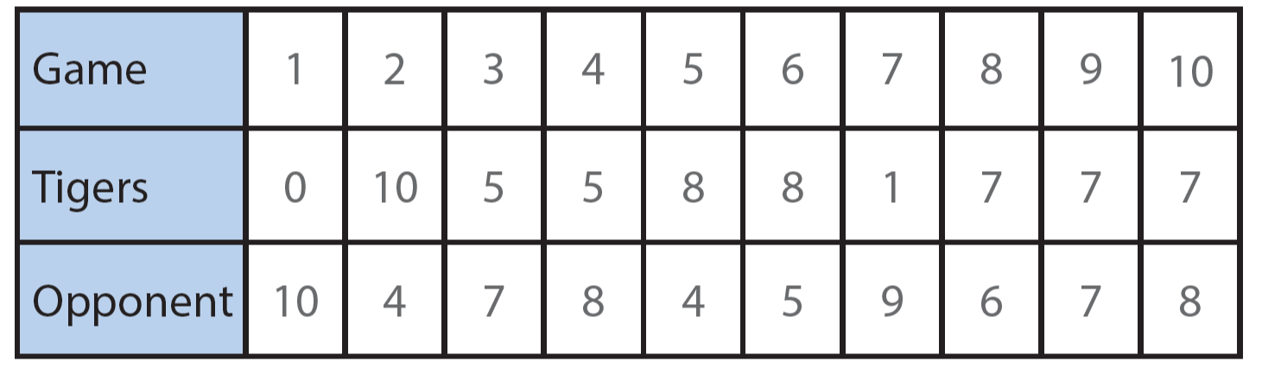

Draw a scatter plot for the data and draw a trend line. Then
describe the association.

Module 8 Lesson 3 Name: _____________________________

The table shows the Tigers’ scores for 10 games.

Draw a scatter plot for the data and draw a trend line. Then
describe the association.

Module 9 Lesson 1 Name: _____________________________

In a survey of 100 students, 60% wake up with an alarm
clock. Of those who wake up with an alarm clock, 80%
exercise to begin the day. Among those who do not use an
alarm clock, 25% exercise to begin the day. Construct a
two-way frequency table to display the data.

Module 9 Lesson 1 Name: _____________________________

In a survey of 100 students, 60% wake up with an alarm
clock. Of those who wake up with an alarm clock, 80%
exercise to begin the day. Among those who do not use an
alarm clock, 25% exercise to begin the day. Construct a
two-way frequency table to display the data.

Module 9 Lesson 1 Name: _____________________________

In a survey of 100 students, 60% wake up with an alarm
clock. Of those who wake up with an alarm clock, 80%
exercise to begin the day. Among those who do not use an
alarm clock, 25% exercise to begin the day. Construct a
two-way frequency table to display the data.

Module 9 Lesson 1 Name: _____________________________

In a survey of 100 students, 60% wake up with an alarm
clock. Of those who wake up with an alarm clock, 80%
exercise to begin the day. Among those who do not use an
alarm clock, 25% exercise to begin the day. Construct a
two-way frequency table to display the data.

Module 9 Lesson 2 Name: _____________________________

Convert this table to a table that shows relative frequencies.

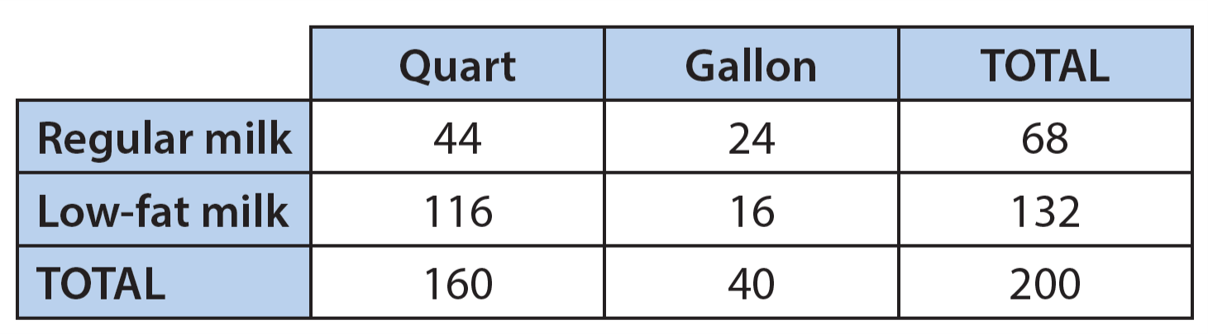

Module 9 Lesson 2 Name: _____________________________

Convert this table to a table that shows relative frequencies.

Module 9 Lesson 2 Name: _____________________________

Convert this table to a table that shows relative frequencies.

Module 9 Lesson 2 Name: _____________________________

Convert this table to a table that shows relative frequencies.

Module 9 Lesson 3 Name: _____________________________

The table shows data from a survey in which high-school
students were asked whether they study French or Spanish
and whether they are in the school’s movie club. Is there an
association between the language a student studies and
whether the student is in the movie club? Explain.

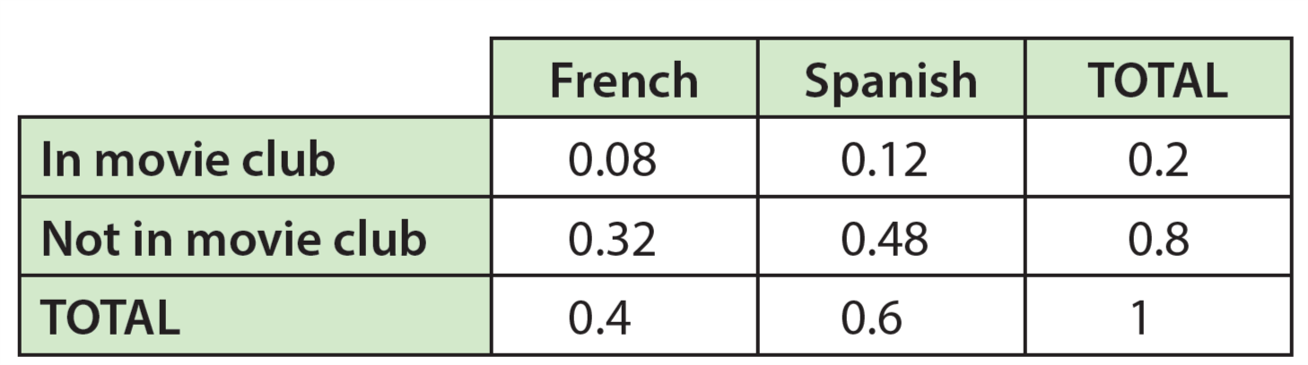

Module 9 Lesson 3 Name: _____________________________

The table shows data from a survey in which high-school
students were asked whether they study French or Spanish
and whether they are in the school’s movie club. Is there an
association between the language a student studies and
whether the student is in the movie club? Explain.

Module 9 Lesson 3 Name: _____________________________

The table shows data from a survey in which high-school
students were asked whether they study French or Spanish
and whether they are in the school’s movie club. Is there an
association between the language a student studies and
whether the student is in the movie club? Explain.

Module 9 Lesson 3 Name: _____________________________

The table shows data from a survey in which high-school
students were asked whether they study French or Spanish
and whether they are in the school’s movie club. Is there an
association between the language a student studies and
whether the student is in the movie club? Explain.

Module 10 Lesson 1 Name: _____________________________

Is the decimal 0.888... rational or irrational? If it is rational,
write it as a fraction. If it is irrational, explain why.

Module 10 Lesson 1 Name: _____________________________

Is the decimal 0.888... rational or irrational? If it is rational,
write it as a fraction. If it is irrational, explain why.

Module 10 Lesson 1 Name: _____________________________

Is the decimal 0.888... rational or irrational? If it is rational,
write it as a fraction. If it is irrational, explain why.

Module 10 Lesson 1 Name: _____________________________

Is the decimal 0.888... rational or irrational? If it is rational,
write it as a fraction. If it is irrational, explain why.

Module 10 Lesson 2 Name: _____________________________

A cube has a volume of $\frac{64}{125}$ cubic feet. What is the edge
length of the cube?

Module 10 Lesson 2 Name: _____________________________

A cube has a volume of $\frac{64}{125}$ cubic feet. What is the edge
length of the cube?

Module 10 Lesson 2 Name: _____________________________

A cube has a volume of $\frac{64}{125}$ cubic feet. What is the edge
length of the cube?

Module 10 Lesson 2 Name: _____________________________

A cube has a volume of $\frac{64}{125}$ cubic feet. What is the edge
length of the cube?

Module 10 Lesson 3 Name: _____________________________

Marc claims that $\sqrt{17}$ is greater than $\sqrt[3]{71}$. Jenny claims that
it is impossible to compare the numbers without a calculator. Is either friend correct? Explain.

Module 10 Lesson 3 Name: _____________________________

Marc claims that $\sqrt{17}$ is greater than $\sqrt[3]{71}$. Jenny claims that
it is impossible to compare the numbers without a calculator. Is either friend correct? Explain.

Module 10 Lesson 3 Name: _____________________________

Marc claims that $\sqrt{17}$ is greater than $\sqrt[3]{71}$. Jenny claims that
it is impossible to compare the numbers without a calculator. Is either friend correct? Explain.

Module 10 Lesson 3 Name: _____________________________

Marc claims that $\sqrt{17}$ is greater than $\sqrt[3]{71}$. Jenny claims that
it is impossible to compare the numbers without a calculator. Is either friend correct? Explain.

Module 11 Lesson 1 Name: _____________________________

A right triangle has leg lengths of 9 meters and 12 meters.
What is the length of the hypotenuse?

Module 11 Lesson 1 Name: _____________________________

A right triangle has leg lengths of 9 meters and 12 meters.
What is the length of the hypotenuse?

Module 11 Lesson 1 Name: _____________________________

A right triangle has leg lengths of 9 meters and 12 meters.
What is the length of the hypotenuse?

Module 11 Lesson 1 Name: _____________________________

A right triangle has leg lengths of 9 meters and 12 meters.
What is the length of the hypotenuse?

Module 11 Lesson 2 Name: _____________________________

Determine if a triangle with sides of lengths 4 cm, 9 cm, and
10 cm is a right triangle and explain how you know.

Module 11 Lesson 2 Name: _____________________________

Determine if a triangle with sides of lengths 4 cm, 9 cm, and
10 cm is a right triangle and explain how you know.

Module 11 Lesson 2 Name: _____________________________

Determine if a triangle with sides of lengths 4 cm, 9 cm, and
10 cm is a right triangle and explain how you know.

Module 11 Lesson 2 Name: _____________________________

Determine if a triangle with sides of lengths 4 cm, 9 cm, and
10 cm is a right triangle and explain how you know.

Module 11 Lesson 3 Name: _____________________________

An artist is constructing a piece of art in the shape of a
rectangle. The artist wants to use string to tightly tie each
vertex of the rectangle to the other three vertices. The
rectangle is 12.0 feet wide and 7.0 feet long. How much
string should the artist use? Round your answer to the
nearest tenth of a foot.

Module 11 Lesson 3 Name: _____________________________

An artist is constructing a piece of art in the shape of a
rectangle. The artist wants to use string to tightly tie each
vertex of the rectangle to the other three vertices. The
rectangle is 12.0 feet wide and 7.0 feet long. How much
string should the artist use? Round your answer to the
nearest tenth of a foot.

Module 11 Lesson 3 Name: _____________________________

An artist is constructing a piece of art in the shape of a
rectangle. The artist wants to use string to tightly tie each
vertex of the rectangle to the other three vertices. The
rectangle is 12.0 feet wide and 7.0 feet long. How much
string should the artist use? Round your answer to the
nearest tenth of a foot.

Module 11 Lesson 3 Name: _____________________________

An artist is constructing a piece of art in the shape of a
rectangle. The artist wants to use string to tightly tie each
vertex of the rectangle to the other three vertices. The
rectangle is 12.0 feet wide and 7.0 feet long. How much
string should the artist use? Round your answer to the
nearest tenth of a foot.

Module 11 Lesson 4 Name: _____________________________

Points A, B, C, and D have the following coordinates:
A: (-3, 7) B: (1, 2) C: (-3, 1) D: (3, -2)

Which segment is longer, $\overline{AB}$ or $\overline{CD}$? How much longer?
Round to the nearest tenth.

Module 11 Lesson 4 Name: _____________________________

Points A, B, C, and D have the following coordinates:
A: (-3, 7) B: (1, 2) C: (-3, 1) D: (3, -2)

Which segment is longer, $\overline{AB}$ or $\overline{CD}$? How much longer?
Round to the nearest tenth.

Module 12 Lesson 1 Name: _____________________________

Simplify $\frac{7^{-1}∙7^{5}}{7^{6}}$.

Module 12 Lesson 1 Name: _____________________________

Simplify $\frac{7^{-1}∙7^{5}}{7^{6}}$.

Module 12 Lesson 1 Name: _____________________________

Simplify $\frac{7^{-1}∙7^{5}}{7^{6}}$.

Module 12 Lesson 1 Name: _____________________________

Simplify $\frac{7^{-1}∙7^{5}}{7^{6}}$.

Module 12 Lesson 2 Name: _____________________________

Determine which number is greater and tell how many
times as great: 4.5 × 10⁹ and 9 × 10⁶.

Module 12 Lesson 2 Name: _____________________________

Determine which number is greater and tell how many
times as great: 4.5 × 10⁹ and 9 × 10⁶.

Module 12 Lesson 2 Name: _____________________________

Determine which number is greater and tell how many
times as great: 4.5 × 10⁹ and 9 × 10⁶.

Module 12 Lesson 2 Name: _____________________________

Determine which number is greater and tell how many
times as great: 4.5 × 10⁹ and 9 × 10⁶.

Module 12 Lesson 3 Name: _____________________________

The population of City A is 4.1 × 10⁶. The population of
City B is 9.6 × 10⁵. Which city has a greater population? How
much greater?

Module 12 Lesson 3 Name: _____________________________

The population of City A is 4.1 × 10⁶. The population of
City B is 9.6 × 10⁵. Which city has a greater population? How
much greater?

Module 12 Lesson 3 Name: _____________________________

The population of City A is 4.1 × 10⁶. The population of
City B is 9.6 × 10⁵. Which city has a greater population? How
much greater?

Module 12 Lesson 3 Name: _____________________________

The population of City A is 4.1 × 10⁶. The population of
City B is 9.6 × 10⁵. Which city has a greater population? How
much greater?

Module 13 Lesson 1 Name: _____________________________

A cylinder has a diameter of 8 meters and a height of
10 meters. What is the volume of the cylinder? Leave your
answer in terms of π.

Module 13 Lesson 1 Name: _____________________________

A cylinder has a diameter of 8 meters and a height of
10 meters. What is the volume of the cylinder? Leave your
answer in terms of π.

Module 13 Lesson 1 Name: _____________________________

A cylinder has a diameter of 8 meters and a height of
10 meters. What is the volume of the cylinder? Leave your
answer in terms of π.

Module 13 Lesson 1 Name: _____________________________

A cylinder has a diameter of 8 meters and a height of
10 meters. What is the volume of the cylinder? Leave your
answer in terms of π.

Module 13 Lesson 2 Name: _____________________________

A cone has a diameter of 12 meters and height of 2 meters.
What is the volume of the cone in terms of π?

Module 13 Lesson 2 Name: _____________________________

A cone has a diameter of 12 meters and height of 2 meters.
What is the volume of the cone in terms of π?

Module 13 Lesson 2 Name: _____________________________

A cone has a diameter of 12 meters and height of 2 meters.
What is the volume of the cone in terms of π?

Module 13 Lesson 2 Name: _____________________________

A cone has a diameter of 12 meters and height of 2 meters.
What is the volume of the cone in terms of π?

Module 13 Lesson 3 Name: _____________________________

A sphere has a diameter of 8 feet. What is the volume of the
sphere to the nearest tenth of a cubic foot? Use 3.14 for π.

Module 13 Lesson 3 Name: _____________________________

A sphere has a diameter of 8 feet. What is the volume of the
sphere to the nearest tenth of a cubic foot? Use 3.14 for π.

Module 13 Lesson 3 Name: _____________________________

A sphere has a diameter of 8 feet. What is the volume of the
sphere to the nearest tenth of a cubic foot? Use 3.14 for π.

Module 13 Lesson 3 Name: _____________________________

A sphere has a diameter of 8 feet. What is the volume of the
sphere to the nearest tenth of a cubic foot? Use 3.14 for π.

Module 13 Lesson 4 Name: _____________________________

A cup in the shape of a cone and a cup in the shape of a
cylinder both have a height of 4 inches and a diameter of
5 inches. What is the volume of each cup? Use 3.14 for π
and round your answers to the nearest hundredth.

Module 13 Lesson 4 Name: _____________________________

A cup in the shape of a cone and a cup in the shape of a
cylinder both have a height of 4 inches and a diameter of
5 inches. What is the volume of each cup? Use 3.14 for π
and round your answers to the nearest hundredth.

Module 13 Lesson 4 Name: _____________________________

A cup in the shape of a cone and a cup in the shape of a
cylinder both have a height of 4 inches and a diameter of
5 inches. What is the volume of each cup? Use 3.14 for π
and round your answers to the nearest hundredth.

Module 13 Lesson 4 Name: _____________________________

A cup in the shape of a cone and a cup in the shape of a
cylinder both have a height of 4 inches and a diameter of
5 inches. What is the volume of each cup? Use 3.14 for π
and round your answers to the nearest hundredth.

