Grade 3

Exit Tickets

This document contains printable and customizable versions of the Exit Tickets recommended
in the Into Math Teacher Edition. The Exit Ticket is also available as a Projectable PDF on
Ed: Your Friend in Learning.

Exit Tickets are an optional way to wrap up a lesson. The problem provided for each lesson assesses
whether students grasped the lesson content.

To save paper when printing, the document is formatted with 2 to a page for some lessons and 4 to a page
in other lessons, based on the space students will likely need to answer the question(s).

Copyright © by Houghton Mifflin Harcourt Publishing Company
All rights reserved. No part of the material protected by this copyright may be reproduced or utilized in any form or by any means, electronic or mechanical, including photocopying, recording, broadcasting or by any other information storage and retrieval system, without written permission of the copyright owner unless such copying is expressly permitted by federal copyright law.
Only those pages that are specifically enabled by the program and indicated by the presence of the print icon may be printed and reproduced in classroom quantities by individual teachers using the corresponding student’s textbook or kit as the major vehicle for regular classroom instruction. Requests for information on other matters regarding duplication of this work should be submitted through our Permissions website at https://customercare.hmhco.com/contactus/Permissions.html or mailed to Houghton Mifflin Harcourt Publishing Company, Attn: Compliance, Contracts, and Licensing, 9400 Southpark Center Loop, Orlando, Florida 32819-8647.
HOUGHTON MIFFLIN HARCOURT and the HMH Logo are trademarks and service marks of Houghton Mifflin Harcourt Publishing Company. You shall not display, disparage, dilute or taint Houghton Mifflin Harcourt trademarks and service marks or use any confusingly similar marks, or use Houghton Mifflin Harcourt marks in such a way that would misrepresent the identity of the owner. Any permitted use of Houghton Mifflin Harcourt trademarks and service marks inures to the benefit of Houghton Mifflin Harcourt Publishing Company.
All other trademarks, service marks or registered trademarks appearing on Houghton Mifflin Harcourt Publishing Company websites are the trademarks or service marks of their respective owners.

Module 1 Lesson 1 Name: _____________________________

Marcus makes 3 buildings using toy blocks.
He uses 8 blocks to make each building.

How many blocks does Marcus use to make the 3 buildings?

Module 1 Lesson 1 Name: _____________________________

Marcus makes 3 buildings using toy blocks.
He uses 8 blocks to make each building.

How many blocks does Marcus use to make the 3 buildings?

Module 1 Lesson 1 Name: _____________________________

Marcus makes 3 buildings using toy blocks.
He uses 8 blocks to make each building.

How many blocks does Marcus use to make the 3 buildings?

Module 1 Lesson 1 Name: _____________________________

Marcus makes 3 buildings using toy blocks.
He uses 8 blocks to make each building.

How many blocks does Marcus use to make the 3 buildings?

Module 1 Lesson 2 Name: _____________________________

Write an addition equation and a multiplication equation to solve.

There are 5 row boats. Each boat has 7 team members. How many team members are on the boats?

Module 1 Lesson 2 Name: _____________________________

Write an addition equation and a multiplication equation to solve.

There are 5 row boats. Each boat has 7 team members. How many team members are on the boats?

Module 1 Lesson 3 Name: _____________________________

A parking lot has 4 rows. Each row has 6 parking spaces. How many cars can park in the lot?

- Draw an array for the problem.
- Write a multiplication equation for the problem.

Module 1 Lesson 3 Name: _____________________________

A parking lot has 4 rows. Each row has 6 parking spaces. How many cars can park in the lot?

- Draw an array for the problem.
- Write a multiplication equation for the problem.

Module 1 Lesson 4 Name: _____________________________

Lori decorates a bulletin board with 6 sheets of construction paper in each row. There are 4 rows. How many sheets of construction paper are on the bulletin board? Describe another way that Lori could arrange the sheets of construction paper.

_________________________________________________

_________________________________________________

_________________________________________________

_________________________________________________
Module 1 Lesson 4 Name: _____________________________

Lori decorates a bulletin board with 6 sheets of construction paper in each row. There are 4 rows. How many sheets of construction paper are on the bulletin board? Describe another way that Lori could arrange the sheets of construction paper.

_________________________________________________

_________________________________________________

_________________________________________________

_________________________________________________

Module 1 Lesson 5 Name: _____________________________

Diandre measures the length of a canoe using a yardstick. A yardstick is 3 feet long. The canoe is 2 yardsticks long.

How many feet long is the canoe?
How can you use a number line to show the length?

Module 1 Lesson 5 Name: _____________________________

Diandre measures the length of a canoe using a yardstick. A yardstick is 3 feet long. The canoe is 2 yardsticks long.

How many feet long is the canoe?
How can you use a number line to show the length?

Module 1 Lesson 6 Name: _____________________________

Each volleyball team has 6 players. There are 10 teams in the league. How many players are in the league?

Module 1 Lesson 6 Name: _____________________________

Each volleyball team has 6 players. There are 10 teams in the league. How many players are in the league?

Module 2 Lesson 1 Name: _____________________________

Do the figures shown have the same area?
Write the area of each figure.

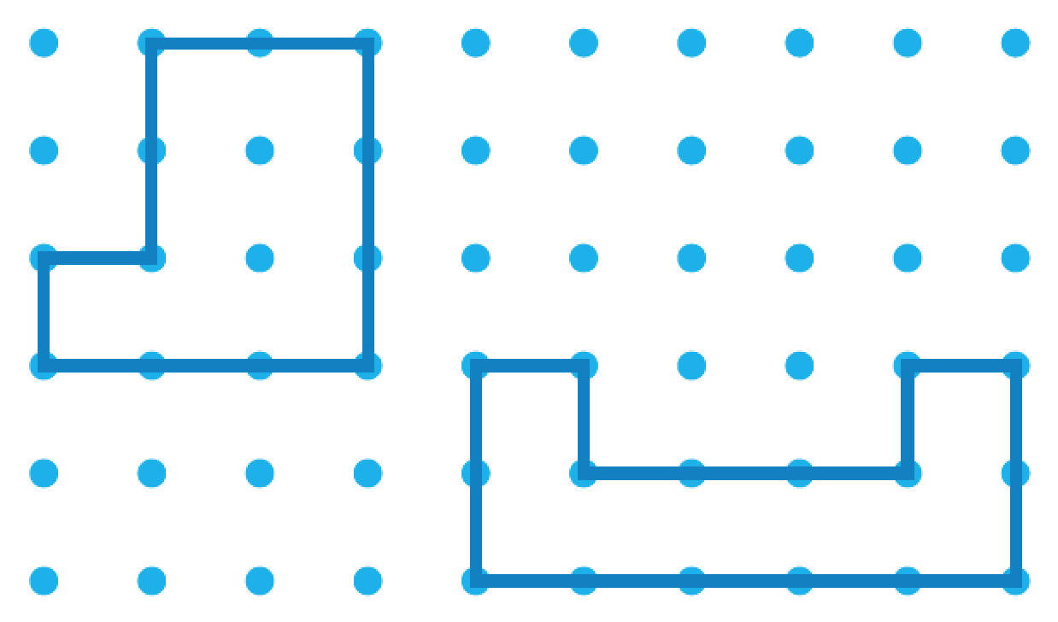

Module 2 Lesson 1 Name: _____________________________

Do the figures shown have the same area?
Write the area of each figure.

Module 2 Lesson 2 Name: _____________________________

Count to find the area of the figure.
Each unit square is 1 square inch.

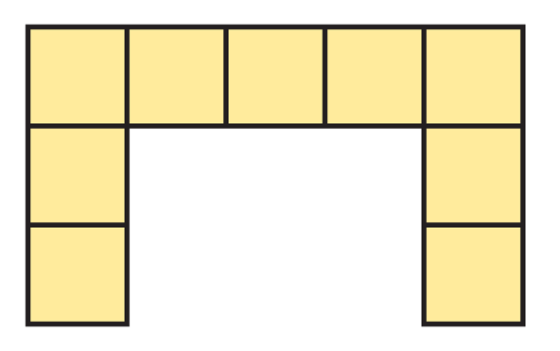

Area = ___________ square inches

Count to find the area of the figure.
Each unit square is 1 square inch.

Area = ___________ square inches

Module 2 Lesson 2 Name: _____________________________

Count to find the area of the figure.
Each unit square is 1 square inch.

Area = ___________ square inches

Count to find the area of the figure.
Each unit square is 1 square inch.

Area = ___________ square inches

Module 2 Lesson 3 Name: _____________________________

Show repeated addition and multiplication to find the area of the rectangle. Each unit square is 1 square foot.

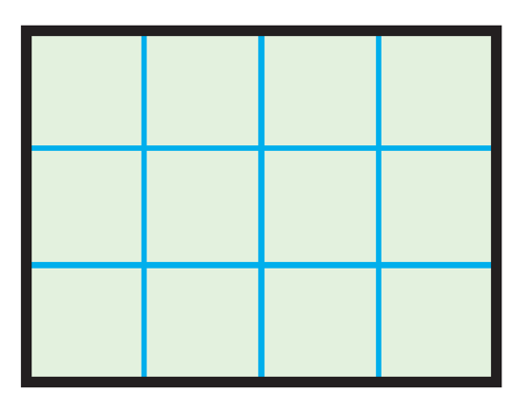

Add. ____________________________________________

Multiply. _________________________________________

Area = __________________________________________

Module 2 Lesson 3 Name: _____________________________

Show repeated addition and multiplication to find the area of the rectangle. Each unit square is 1 square foot.

Add. ____________________________________________

Multiply. _________________________________________

Area = __________________________________________

Module 2 Lesson 4 Name: _____________________________

Multiply to find the area of the rectangle.

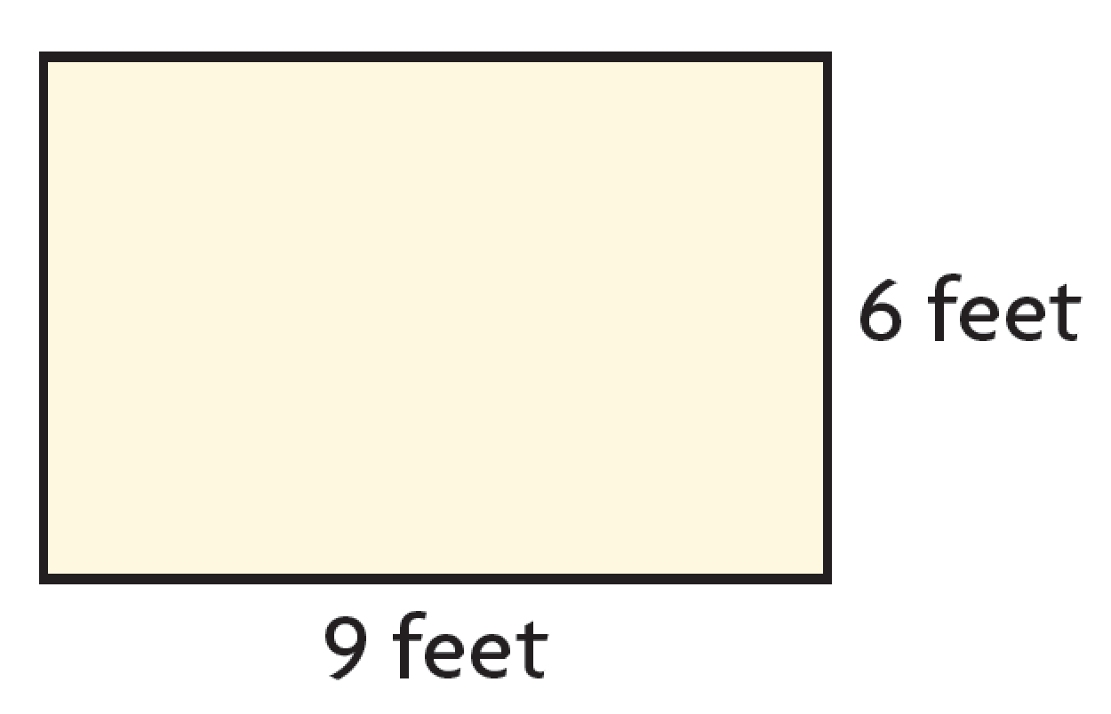

Multiply. _________________________________________

Area = __________________________________________

Module 2 Lesson 4 Name: _____________________________

Multiply to find the area of the rectangle.

Multiply. _________________________________________

Area = __________________________________________

Module 2 Lesson 5 Name: _____________________________

Draw a line to break apart the figure into rectangles. Find the area of the figure.

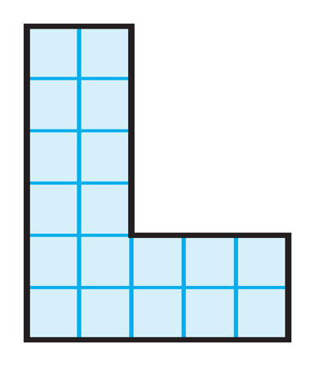

1 = 1 square inch

Module 2 Lesson 5 Name: _____________________________

Draw a line to break apart the figure into rectangles. Find the area of the figure.

1 = 1 square inch

Module 3 Lesson 1 Name: _____________________________

Eight photos fit on each page of a photo album. How many photos will fit on 4 pages?

Use a 2s fact and doubling to solve the problem.

Write a multiplication equation for the problem.

Module 3 Lesson 1 Name: _____________________________

Eight photos fit on each page of a photo album. How many photos will fit on 4 pages?

Use a 2s fact and doubling to solve the problem.

Write a multiplication equation for the problem.

Module 3 Lesson 2 Name: _____________________________

Hassan paid for a drink with 7 dimes. A dime has a value of 10 cents. What is the total amount in cents that Hassan paid?

Module 3 Lesson 2 Name: _____________________________

Hassan paid for a drink with 7 dimes. A dime has a value of 10 cents. What is the total amount in cents that Hassan paid?

Module 3 Lesson 2 Name: _____________________________

Hassan paid for a drink with 7 dimes. A dime has a value of 10 cents. What is the total amount in cents that Hassan paid?

Module 3 Lesson 2 Name: _____________________________

Hassan paid for a drink with 7 dimes. A dime has a value of 10 cents. What is the total amount in cents that Hassan paid?

Module 3 Lesson 3 Name: _____________________________

Arty plants 6 groups of tulip bulbs in a garden. There are 7 tulip bulbs in each group. Choose a strategy you learned today to find how many tulip bulbs there are in the garden.

Module 3 Lesson 3 Name: _____________________________

Arty plants 6 groups of tulip bulbs in a garden. There are 7 tulip bulbs in each group. Choose a strategy you learned today to find how many tulip bulbs there are in the garden.

Module 3 Lesson 3 Name: _____________________________

Arty plants 6 groups of tulip bulbs in a garden. There are 7 tulip bulbs in each group. Choose a strategy you learned today to find how many tulip bulbs there are in the garden.

Module 3 Lesson 3 Name: _____________________________

Arty plants 6 groups of tulip bulbs in a garden. There are 7 tulip bulbs in each group. Choose a strategy you learned today to find how many tulip bulbs there are in the garden.

Module 4 Lesson 1 Name: _____________________________

Each muffin tin has 9 muffins. There is 1 muffin tin. How many muffins are there in the tin?

Module 4 Lesson 1 Name: _____________________________

Each muffin tin has 9 muffins. There is 1 muffin tin. How many muffins are there in the tin?

Module 4 Lesson 1 Name: _____________________________

Each muffin tin has 9 muffins. There is 1 muffin tin. How many muffins are there in the tin?

Module 4 Lesson 1 Name: _____________________________

Each muffin tin has 9 muffins. There is 1 muffin tin. How many muffins are there in the tin?

Module 4 Lesson 2 Name: _____________________________

Complete the equations. Solve.

A parking lot has 5 rows. There are 8 cars in each row. How many cars are there in the parking lot?

5 × 8 = 5 × ( _____ + ______ )

5 × 8 = (5 × ______ ) + (5 × ______ )

5 × 8 = ______ + ______

5 × 8 = ______

There are ______ cars.

Module 4 Lesson 2 Name: _____________________________

Complete the equations. Solve.

A parking lot has 5 rows. There are 8 cars in each row. How many cars are there in the parking lot?

5 × 8 = 5 × ( _____ + ______ )

5 × 8 = (5 × ______ ) + (5 × ______ )

5 × 8 = ______ + ______

5 × 8 = ______

There are ______ cars.

Module 4 Lesson 3 Name: _____________________________

Use the Commutative Property of Multiplication and the Associative Property of Multiplication to solve the problem:

3 × 6 × 2

Module 4 Lesson 3 Name: _____________________________

Use the Commutative Property of Multiplication and the Associative Property of Multiplication to solve the problem:

3 × 6 × 2

Module 4 Lesson 4 Name: _____________________________

Show two different strategies to find the product.

8 × 7 =

Module 4 Lesson 4 Name: _____________________________

Show two different strategies to find the product.

8 × 7 =

Module 4 Lesson 5 Name: _____________________________

Show two different strategies to find the product.

8 × 7 =

Module 4 Lesson 5 Name: _____________________________

Show two different strategies to find the product.

8 × 7 =

Module 4 Lesson 6 Name: _____________________________

Use the Distributive Property with multiplication and
subtraction to solve the problem.

Armand has 6 spools of cable. Each cable is 9 feet long. How much cable does Armand have?

Module 4 Lesson 6 Name: _____________________________

Use the Distributive Property with multiplication and
subtraction to solve the problem.

Armand has 6 spools of cable. Each cable is 9 feet long. How much cable does Armand have?

Module 4 Lesson 7 Name: _____________________________

Use the Distributive Property to show that the product 4 × 9 is an even number.

Module 4 Lesson 7 Name: _____________________________

Use the Distributive Property to show that the product 4 × 9 is an even number.

Module 5 Lesson 1 Name: _____________________________

Use the Distributive Property to find 3 × 40.

Module 5 Lesson 1 Name: _____________________________

Use the Distributive Property to find 3 × 40.

Module 5 Lesson 1 Name: _____________________________

Use the Distributive Property to find 3 × 40.

Module 5 Lesson 1 Name: _____________________________

Use the Distributive Property to find 3 × 40.

Module 5 Lesson 2 Name: _____________________________

Find the product 7 × 40 by rewriting 40 as a product of 10 and a number.

Module 5 Lesson 2 Name: _____________________________

Find the product 7 × 40 by rewriting 40 as a product of 10 and a number.

Module 5 Lesson 2 Name: _____________________________

Find the product 7 × 40 by rewriting 40 as a product of 10 and a number.

Module 5 Lesson 2 Name: _____________________________

Find the product 7 × 40 by rewriting 40 as a product of 10 and a number.

Module 5 Lesson 3 Name: _____________________________

Use place value to find the product.

3 × 60 =

Module 5 Lesson 3 Name: _____________________________

Use place value to find the product.

3 × 60 =

Module 5 Lesson 3 Name: _____________________________

Use place value to find the product.

3 × 60 =

Module 5 Lesson 3 Name: _____________________________

Use place value to find the product.

3 × 60 =

Module 5 Lesson 4 Name: _____________________________

Find the product. Use regrouping, base-ten blocks, or draw a quick picture.

8 × 30 =

Module 5 Lesson 4 Name: _____________________________

Find the product. Use regrouping, base-ten blocks, or draw a quick picture.

8 × 30 =

Module 5 Lesson 4 Name: _____________________________

Find the product. Use regrouping, base-ten blocks, or draw a quick picture.

8 × 30 =

Module 5 Lesson 4 Name: _____________________________

Find the product. Use regrouping, base-ten blocks, or draw a quick picture.

8 × 30 =

Module 6 Lesson 1 Name: _____________________________

Armand is cutting pieces of yarn for an art project. He has a length of yarn that is 48 inches long. Armand cuts the yarn into pieces that are each 6 inches long. How many pieces does Armand make?

Module 6 Lesson 1 Name: _____________________________

Armand is cutting pieces of yarn for an art project. He has a length of yarn that is 48 inches long. Armand cuts the yarn into pieces that are each 6 inches long. How many pieces does Armand make?

Module 6 Lesson 2 Name: _____________________________

Terry has 14 index cards and 2 boxes. He places an equal number of index cards in each box. How many index cards are in each box?

Module 6 Lesson 2 Name: _____________________________

Terry has 14 index cards and 2 boxes. He places an equal number of index cards in each box. How many index cards are in each box?

Module 6 Lesson 3 Name: _____________________________

Sana has 12 granola bars. She places 2 granola bars in each lunch box. How many lunch boxes can she fill?

Module 6 Lesson 3 Name: _____________________________

Sana has 12 granola bars. She places 2 granola bars in each lunch box. How many lunch boxes can she fill?

Module 6 Lesson 3 Name: _____________________________

Sana has 12 granola bars. She places 2 granola bars in each lunch box. How many lunch boxes can she fill?

Module 6 Lesson 3 Name: _____________________________

Sana has 12 granola bars. She places 2 granola bars in each lunch box. How many lunch boxes can she fill?

Module 6 Lesson 4 Name: _____________________________

Ethan has 16 feet of string to make friendship necklaces. He uses 2 feet of string for each necklace. How many friendship necklaces can Ethan make?

Module 6 Lesson 4 Name: _____________________________

Ethan has 16 feet of string to make friendship necklaces. He uses 2 feet of string for each necklace. How many friendship necklaces can Ethan make?

Module 6 Lesson 4 Name: _____________________________

Ethan has 16 feet of string to make friendship necklaces. He uses 2 feet of string for each necklace. How many friendship necklaces can Ethan make?

Module 6 Lesson 4 Name: _____________________________

Ethan has 16 feet of string to make friendship necklaces. He uses 2 feet of string for each necklace. How many friendship necklaces can Ethan make?

Module 6 Lesson 5 Name: _____________________________

Amala makes a puzzle. There are 81 squares and 9 equal rows of squares. How many squares are in each row? Draw an array and write a division equation to support your answer.

Module 6 Lesson 5 Name: _____________________________

Amala makes a puzzle. There are 81 squares and 9 equal rows of squares. How many squares are in each row? Draw an array and write a division equation to support your answer.

Module 6 Lesson 6 Name: _____________________________

Sandy uses 21 pictures to make a photo album. She puts 3 photos on each page. Draw a bar model to show the problem. Find the number of pages Sandy uses.

Module 6 Lesson 6 Name: _____________________________

Sandy uses 21 pictures to make a photo album. She puts 3 photos on each page. Draw a bar model to show the problem. Find the number of pages Sandy uses.

Module 6 Lesson 7 Name: _____________________________

Lamar shares 7 granola bars evenly with 7 friends. How many granola bars does each friend get?

- Draw a visual model for the problem.

- Write a division equation for the problem.

- How many granola bars does each friend get?

Module 6 Lesson 7 Name: _____________________________

Lamar shares 7 granola bars evenly with 7 friends. How many granola bars does each friend get?

- Draw a visual model for the problem.

- Write a division equation for the problem.

- How many granola bars does each friend get?

Module 7 Lesson 1 Name: _____________________________

Theo picks 27 strawberries. He puts the same number of berries in each of 3 bowls. Write related division and multiplication equations to find how many strawberries Theo puts in each bowl.

Module 7 Lesson 1 Name: _____________________________

Theo picks 27 strawberries. He puts the same number of berries in each of 3 bowls. Write related division and multiplication equations to find how many strawberries Theo puts in each bowl.

Module 7 Lesson 1 Name: _____________________________

Theo picks 27 strawberries. He puts the same number of berries in each of 3 bowls. Write related division and multiplication equations to find how many strawberries Theo puts in each bowl.

Module 7 Lesson 1 Name: _____________________________

Theo picks 27 strawberries. He puts the same number of berries in each of 3 bowls. Write related division and multiplication equations to find how many strawberries Theo puts in each bowl.

Module 7 Lesson 2 Name: _____________________________

How many different related facts does the set of numbers 3, 3, and 9 have? Write the facts to justify your answer.

Module 7 Lesson 2 Name: _____________________________

How many different related facts does the set of numbers 3, 3, and 9 have? Write the facts to justify your answer.

Module 7 Lesson 2 Name: _____________________________

How many different related facts does the set of numbers 3, 3, and 9 have? Write the facts to justify your answer.

Module 7 Lesson 2 Name: _____________________________

How many different related facts does the set of numbers 3, 3, and 9 have? Write the facts to justify your answer.

Module 7 Lesson 3 Name: _____________________________

Jannell uses 32 beads to make keychains. How many keychains can she make with 4 beads on each keychain? How many keychains can she make with 8 beads on each keychain?

Module 7 Lesson 3 Name: _____________________________

Jannell uses 32 beads to make keychains. How many keychains can she make with 4 beads on each keychain? How many keychains can she make with 8 beads on each keychain?

Module 7 Lesson 3 Name: _____________________________

Jannell uses 32 beads to make keychains. How many keychains can she make with 4 beads on each keychain? How many keychains can she make with 8 beads on each keychain?

Module 7 Lesson 3 Name: _____________________________

Jannell uses 32 beads to make keychains. How many keychains can she make with 4 beads on each keychain? How many keychains can she make with 8 beads on each keychain?

Module 7 Lesson 4 Name: _____________________________

Mr. Nanda spends $80 on movie tickets for his family. Each ticket costs $10. How many tickets does Mr. Nanda buy?

Module 7 Lesson 4 Name: _____________________________

Mr. Nanda spends $80 on movie tickets for his family. Each ticket costs $10. How many tickets does Mr. Nanda buy?

Module 7 Lesson 4 Name: _____________________________

Mr. Nanda spends $80 on movie tickets for his family. Each ticket costs $10. How many tickets does Mr. Nanda buy?

Module 7 Lesson 4 Name: _____________________________

Mr. Nanda spends $80 on movie tickets for his family. Each ticket costs $10. How many tickets does Mr. Nanda buy?

Module 7 Lesson 5 Name: _____________________________

Grayson earns 6 points for his team for each question he answers correctly. Grayson earns 48 points for his team. How many questions does Grayson answer correctly?

Module 7 Lesson 5 Name: _____________________________

Grayson earns 6 points for his team for each question he answers correctly. Grayson earns 48 points for his team. How many questions does Grayson answer correctly?

Module 7 Lesson 5 Name: _____________________________

Grayson earns 6 points for his team for each question he answers correctly. Grayson earns 48 points for his team. How many questions does Grayson answer correctly?

Module 7 Lesson 5 Name: _____________________________

Grayson earns 6 points for his team for each question he answers correctly. Grayson earns 48 points for his team. How many questions does Grayson answer correctly?

Module 7 Lesson 6 Name: _____________________________

Mato’s summer break from school is 56 days long. How many weeks long is Mato’s summer break? Explain how you solved this problem.

Module 7 Lesson 6 Name: _____________________________

Mato’s summer break from school is 56 days long. How many weeks long is Mato’s summer break? Explain how you solved this problem.

Module 7 Lesson 6 Name: _____________________________

Mato’s summer break from school is 56 days long. How many weeks long is Mato’s summer break? Explain how you solved this problem.

Module 7 Lesson 6 Name: _____________________________

Mato’s summer break from school is 56 days long. How many weeks long is Mato’s summer break? Explain how you solved this problem.

Module 7 Lesson 7 Name: _____________________________

Use the multiplication equation to divide.

6 × 9 = 54

54 ÷ 9 = ______

Module 7 Lesson 7 Name: _____________________________

Use the multiplication equation to divide.

6 × 9 = 54

54 ÷ 9 = ______

Module 7 Lesson 7 Name: _____________________________

Use the multiplication equation to divide.

6 × 9 = 54

54 ÷ 9 = ______

Module 7 Lesson 7 Name: _____________________________

Use the multiplication equation to divide.

6 × 9 = 54

54 ÷ 9 = ______

Module 8 Lesson 1 Name: _____________________________

Describe a pattern. Then write a rule and extend your pattern.

7 13 19 25

Module 8 Lesson 1 Name: _____________________________

Describe a pattern. Then write a rule and extend your pattern.

7 13 19 25

Module 8 Lesson 1 Name: _____________________________

Describe a pattern. Then write a rule and extend your pattern.

7 13 19 25

Module 8 Lesson 1 Name: _____________________________

Describe a pattern. Then write a rule and extend your pattern.

7 13 19 25

Module 8 Lesson 2 Name: _____________________________

Lilia gives 24 sheets of paper to 8 classmates. Each classmate receives the same number of sheets. How many sheets of paper does each classmate receive?

Module 8 Lesson 2 Name: _____________________________

Lilia gives 24 sheets of paper to 8 classmates. Each classmate receives the same number of sheets. How many sheets of paper does each classmate receive?

Module 8 Lesson 2 Name: _____________________________

Lilia gives 24 sheets of paper to 8 classmates. Each classmate receives the same number of sheets. How many sheets of paper does each classmate receive?

Module 8 Lesson 2 Name: _____________________________

Lilia gives 24 sheets of paper to 8 classmates. Each classmate receives the same number of sheets. How many sheets of paper does each classmate receive?

Module 8 Lesson 3 Name: _____________________________

April prepares 20 meals in 5 days. She prepares the same number of meals each day. How many meals does April prepare each day? Write an equation. Use n to represent the unknown number.

Module 8 Lesson 3 Name: _____________________________

April prepares 20 meals in 5 days. She prepares the same number of meals each day. How many meals does April prepare each day? Write an equation. Use n to represent the unknown number.

Module 8 Lesson 3 Name: _____________________________

April prepares 20 meals in 5 days. She prepares the same number of meals each day. How many meals does April prepare each day? Write an equation. Use n to represent the unknown number.

Module 8 Lesson 3 Name: _____________________________

April prepares 20 meals in 5 days. She prepares the same number of meals each day. How many meals does April prepare each day? Write an equation. Use n to represent the unknown number.

Module 8 Lesson 4 Name: _____________________________

Arin has 45 beads to make bracelets. She buys 15 more beads. If Arin puts 10 beads on each bracelet, how many bracelets can she make? Write two equations with letters representing unknowns to solve.

Module 8 Lesson 4 Name: _____________________________

Arin has 45 beads to make bracelets. She buys 15 more beads. If Arin puts 10 beads on each bracelet, how many bracelets can she make? Write two equations with letters representing unknowns to solve.

Module 8 Lesson 4 Name: _____________________________

Arin has 45 beads to make bracelets. She buys 15 more beads. If Arin puts 10 beads on each bracelet, how many bracelets can she make? Write two equations with letters representing unknowns to solve.

Module 8 Lesson 4 Name: _____________________________

Arin has 45 beads to make bracelets. She buys 15 more beads. If Arin puts 10 beads on each bracelet, how many bracelets can she make? Write two equations with letters representing unknowns to solve.

Module 8 Lesson 5 Name: _____________________________

Jeffrey has 28 marbles. He puts 7 marbles in each bag. He gives some bags to his brother. He now has 2 bags left. How many bags does he give to his brother?

Module 8 Lesson 5 Name: _____________________________

Jeffrey has 28 marbles. He puts 7 marbles in each bag. He gives some bags to his brother. He now has 2 bags left. How many bags does he give to his brother?

Module 8 Lesson 5 Name: _____________________________

Jeffrey has 28 marbles. He puts 7 marbles in each bag. He gives some bags to his brother. He now has 2 bags left. How many bags does he give to his brother?

Module 8 Lesson 5 Name: _____________________________

Jeffrey has 28 marbles. He puts 7 marbles in each bag. He gives some bags to his brother. He now has 2 bags left. How many bags does he give to his brother?

Module 9 Lesson 1 Name: _____________________________

Use the number 8 to give an example of the Identity Property of Addition and the Commutative Property of Addition.

Module 9 Lesson 1 Name: _____________________________

Use the number 8 to give an example of the Identity Property of Addition and the Commutative Property of Addition.

Module 9 Lesson 1 Name: _____________________________

Use the number 8 to give an example of the Identity Property of Addition and the Commutative Property of Addition.

Module 9 Lesson 1 Name: _____________________________

Use the number 8 to give an example of the Identity Property of Addition and the Commutative Property of Addition.

Module 9 Lesson 2 Name: _____________________________

While at Yellowstone National Park, scientists hike for 58 minutes, stop to eat lunch, and hike for another 35 minutes. Explain how you could use mental math to find how many minutes they hiked.

Module 9 Lesson 2 Name: _____________________________

While at Yellowstone National Park, scientists hike for 58 minutes, stop to eat lunch, and hike for another 35 minutes. Explain how you could use mental math to find how many minutes they hiked.

Module 9 Lesson 2 Name: _____________________________

While at Yellowstone National Park, scientists hike for 58 minutes, stop to eat lunch, and hike for another 35 minutes. Explain how you could use mental math to find how many minutes they hiked.

Module 9 Lesson 2 Name: _____________________________

While at Yellowstone National Park, scientists hike for 58 minutes, stop to eat lunch, and hike for another 35 minutes. Explain how you could use mental math to find how many minutes they hiked.

Module 9 Lesson 3 Name: _____________________________

Use addition properties to group the addends to find the sum.

51 + 65 + 79 = _________

Module 9 Lesson 3 Name: _____________________________

Use addition properties to group the addends to find the sum.

51 + 65 + 79 = _________

Module 9 Lesson 3 Name: _____________________________

Use addition properties to group the addends to find the sum.

51 + 65 + 79 = _________

Module 9 Lesson 3 Name: _____________________________

Use addition properties to group the addends to find the sum.

51 + 65 + 79 = _________

Module 9 Lesson 4 Name: _____________________________

Mila measures the outside temperature in the morning and in the afternoon. The temperature in the morning is 43 °F, and the temperature in the afternoon is 74 °F. Mila says the outside temperature increased by about 35 °F. Is Mila’s statement reasonable? Explain.

_________________________________________________

_________________________________________________

_________________________________________________

Module 9 Lesson 4 Name: _____________________________

Mila measures the outside temperature in the morning and in the afternoon. The temperature in the morning is 43 °F, and the temperature in the afternoon is 74 °F. Mila says the outside temperature increased by about 35 °F. Is Mila’s statement reasonable? Explain.

_________________________________________________

_________________________________________________

_________________________________________________
Module 9 Lesson 4 Name: _____________________________

Mila measures the outside temperature in the morning and in the afternoon. The temperature in the morning is 43 °F, and the temperature in the afternoon is 74 °F. Mila says the outside temperature increased by about 35 °F. Is Mila’s statement reasonable? Explain.

_________________________________________________

_________________________________________________

_________________________________________________

Module 9 Lesson 4 Name: _____________________________

Mila measures the outside temperature in the morning and in the afternoon. The temperature in the morning is 43 °F, and the temperature in the afternoon is 74 °F. Mila says the outside temperature increased by about 35 °F. Is Mila’s statement reasonable? Explain.

_________________________________________________

_________________________________________________

_________________________________________________
Module 9 Lesson 5 Name: _____________________________

When rounded to the nearest hundred, what number is about 700?

Module 9 Lesson 5 Name: _____________________________

When rounded to the nearest hundred, what number is about 700?

Module 9 Lesson 5 Name: _____________________________

When rounded to the nearest hundred, what number is about 700?

Module 9 Lesson 5 Name: _____________________________

When rounded to the nearest hundred, what number is about 700?

Module 9 Lesson 6 Name: _____________________________

Estimate the sum. Show your work.

267 + 523 = _________

Module 9 Lesson 6 Name: _____________________________

Estimate the sum. Show your work.

267 + 523 = _________

Module 9 Lesson 6 Name: _____________________________

Estimate the sum. Show your work.

267 + 523 = _________

Module 9 Lesson 6 Name: _____________________________

Estimate the sum. Show your work.

267 + 523 = _________

Module 10 Lesson 1 Name: ____________________________

Use expanded form to add.

256
+ 339

Module 10 Lesson 1 Name: ____________________________

Use expanded form to add.

256
+ 339

Module 10 Lesson 1 Name: ____________________________

Use expanded form to add.

256
+ 339

Module 10 Lesson 1 Name: ____________________________

Use expanded form to add.

256
+ 339

Module 10 Lesson 2 Name: ____________________________

Find the sum.

719
+ 83

Module 10 Lesson 2 Name: ____________________________

Find the sum.

719
+ 83

Module 10 Lesson 2 Name: ____________________________

Find the sum.

719
+ 83

Module 10 Lesson 2 Name: ____________________________

Find the sum.

719
+ 83

Module 10 Lesson 3 Name: ____________________________

Combine place values to subtract 307 – 53.

Module 10 Lesson 3 Name: ____________________________

Combine place values to subtract 307 – 53.

Module 10 Lesson 3 Name: ____________________________

Combine place values to subtract 307 – 53.

Module 10 Lesson 3 Name: ____________________________

Combine place values to subtract 307 – 53.

Module 10 Lesson 4 Name: ____________________________

Find the difference. 856 – 429

Module 10 Lesson 4 Name: ____________________________

Find the difference. 856 – 429

Module 10 Lesson 4 Name: ____________________________

Find the difference. 856 – 429

Module 10 Lesson 4 Name: ____________________________

Find the difference. 856 – 429

Module 10 Lesson 5 Name: ____________________________

Circle the problem in which you need to regroup. Choose a strategy to find the difference.

A. 508 − 162

B. 385 – 231

Module 10 Lesson 5 Name: ____________________________

Circle the problem in which you need to regroup. Choose a strategy to find the difference.

A. 508 − 162

B. 385 – 231

Module 10 Lesson 5 Name: ____________________________

Circle the problem in which you need to regroup. Choose a strategy to find the difference.

A. 508 − 162

B. 385 – 231

Module 10 Lesson 5 Name: ____________________________

Circle the problem in which you need to regroup. Choose a strategy to find the difference.

A. 508 − 162

B. 385 – 231

Module 10 Lesson 6 Name: ____________________________

Mr. Rice puts 9 pictures on each of the 4 walls of his office. He puts 5 pictures on his desk. How many pictures does Mr. Rice have in his office? Write equations to model the problem. Use letters for the unknown quantities.

Module 10 Lesson 6 Name: ____________________________

Mr. Rice puts 9 pictures on each of the 4 walls of his office. He puts 5 pictures on his desk. How many pictures does Mr. Rice have in his office? Write equations to model the problem. Use letters for the unknown quantities.

Module 10 Lesson 6 Name: ____________________________

Mr. Rice puts 9 pictures on each of the 4 walls of his office. He puts 5 pictures on his desk. How many pictures does Mr. Rice have in his office? Write equations to model the problem. Use letters for the unknown quantities.

Module 10 Lesson 6 Name: ____________________________

Mr. Rice puts 9 pictures on each of the 4 walls of his office. He puts 5 pictures on his desk. How many pictures does Mr. Rice have in his office? Write equations to model the problem. Use letters for the unknown quantities.

Module 11 Lesson 1 Name: ____________________________

Do the figures shown have the same perimeter? What is the perimeter of each figure?

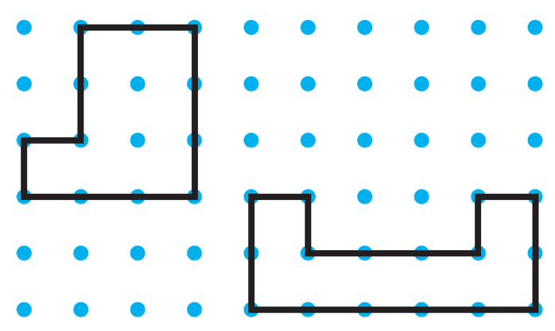

Module 11 Lesson 1 Name: ____________________________

Do the figures shown have the same perimeter? What is the perimeter of each figure?

Module 11 Lesson 1 Name: ____________________________

Do the figures shown have the same perimeter? What is the perimeter of each figure?

Module 11 Lesson 1 Name: ____________________________

Do the figures shown have the same perimeter? What is the perimeter of each figure?

Module 11 Lesson 2 Name: ____________________________

Sabrina is placing a border around a rectangular mirror. The mirror has side lengths of 7 inches and 10 inches. What length of border does Sabrina need?

Module 11 Lesson 2 Name: ____________________________

Sabrina is placing a border around a rectangular mirror. The mirror has side lengths of 7 inches and 10 inches. What length of border does Sabrina need?

Module 11 Lesson 2 Name: ____________________________

Sabrina is placing a border around a rectangular mirror. The mirror has side lengths of 7 inches and 10 inches. What length of border does Sabrina need?

Module 11 Lesson 2 Name: ____________________________

Sabrina is placing a border around a rectangular mirror. The mirror has side lengths of 7 inches and 10 inches. What length of border does Sabrina need?

Module 11 Lesson 3 Name: ____________________________

The perimeter of the rectangle is 22 meters.
What is the unknown side length?

8 m
s

Module 11 Lesson 3 Name: ____________________________

The perimeter of the rectangle is 22 meters.
What is the unknown side length?

8 m
s

Module 11 Lesson 3 Name: ____________________________

The perimeter of the rectangle is 22 meters.
What is the unknown side length?

8 m
s

Module 11 Lesson 3 Name: ____________________________

The perimeter of the rectangle is 22 meters.
What is the unknown side length?

8 m
s

Module 11 Lesson 4 Name: ____________________________

Draw another rectangle that has the same area but a different perimeter. Find the area and perimeter of each rectangle.
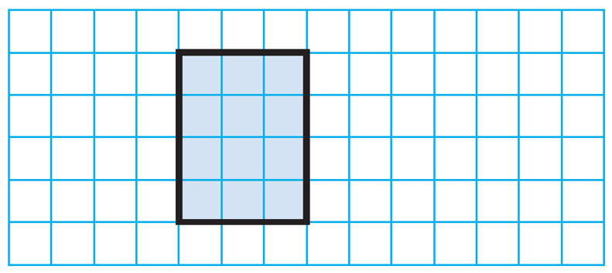

Area: _____________________________

Perimeter: _________________________

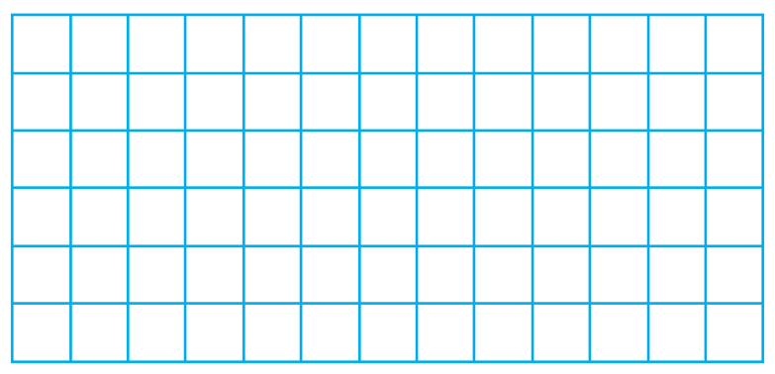

Area: _____________________________

Perimeter: _________________________
Which rectangle has the greater perimeter?
Module 11 Lesson 4 Name: ____________________________

Draw another rectangle that has the same area but a different perimeter. Find the area and perimeter of each rectangle.

Area: _____________________________

Perimeter: _________________________

Area: _____________________________

Perimeter: _________________________

Which rectangle has the greater perimeter?
Module 11 Lesson 5 Name: ____________________________

Stella has two rectangular rugs. One rug has side lengths of 6 feet and 7 feet. The other rug has side lengths of 5 feet and 8 feet.

What is the perimeter of each rug?

What are the side lengths of the rug with the greater
area?

Module 11 Lesson 5 Name: ____________________________

Stella has two rectangular rugs. One rug has side lengths of 6 feet and 7 feet. The other rug has side lengths of 5 feet and 8 feet.

What is the perimeter of each rug?

What are the side lengths of the rug with the greater
area?

Module 12 Lesson 1 Name: ____________________________

A clock shows the hour hand between the 12 and the 1 and the minute hand four marks after the 9. What time does the clock show?

Module 12 Lesson 1 Name: ____________________________

A clock shows the hour hand between the 12 and the 1 and the minute hand four marks after the 9. What time does the clock show?

Module 12 Lesson 1 Name: ____________________________

A clock shows the hour hand between the 12 and the 1 and the minute hand four marks after the 9. What time does the clock show?

Module 12 Lesson 1 Name: ____________________________

A clock shows the hour hand between the 12 and the 1 and the minute hand four marks after the 9. What time does the clock show?

Module 12 Lesson 2 Name: ____________________________

Janice is in the school library at 11:27. Draw a clock with hands to show the time she is in the library. Write the time using a.m. or p.m.

Module 12 Lesson 2 Name: ____________________________

Janice is in the school library at 11:27. Draw a clock with hands to show the time she is in the library. Write the time using a.m. or p.m.

Module 12 Lesson 2 Name: ____________________________

Janice is in the school library at 11:27. Draw a clock with hands to show the time she is in the library. Write the time using a.m. or p.m.

Module 12 Lesson 2 Name: ____________________________

Janice is in the school library at 11:27. Draw a clock with hands to show the time she is in the library. Write the time using a.m. or p.m.

Module 12 Lesson 3 Name: ____________________________

Tamara starts to read at 11:05 a.m. and stops at 11:38 a.m. How many minutes does Tamara read?

Module 12 Lesson 3 Name: ____________________________

Tamara starts to read at 11:05 a.m. and stops at 11:38 a.m. How many minutes does Tamara read?

Module 12 Lesson 3 Name: ____________________________

Tamara starts to read at 11:05 a.m. and stops at 11:38 a.m. How many minutes does Tamara read?

Module 12 Lesson 3 Name: ____________________________

Tamara starts to read at 11:05 a.m. and stops at 11:38 a.m. How many minutes does Tamara read?

Module 12 Lesson 4 Name: ____________________________

Millie wakes up at 6:35 a.m. It takes her 26 minutes to get ready before she leaves for school. At what time is she ready to leave for school?

Module 12 Lesson 4 Name: ____________________________

Millie wakes up at 6:35 a.m. It takes her 26 minutes to get ready before she leaves for school. At what time is she ready to leave for school?

Module 12 Lesson 4 Name: ____________________________

Millie wakes up at 6:35 a.m. It takes her 26 minutes to get ready before she leaves for school. At what time is she ready to leave for school?

Module 12 Lesson 4 Name: ____________________________

Millie wakes up at 6:35 a.m. It takes her 26 minutes to get ready before she leaves for school. At what time is she ready to leave for school?

Module 12 Lesson 5 Name: ____________________________

Conrad arrives at his classroom at 8:07 a.m.
He has 5 minutes to get ready for math. He has math for 42 minutes and then computer time for
10 minutes. At what time does computer time end?

Module 12 Lesson 5 Name: ____________________________

Conrad arrives at his classroom at 8:07 a.m.
He has 5 minutes to get ready for math. He has math for 42 minutes and then computer time for
10 minutes. At what time does computer time end?

Module 12 Lesson 5 Name: ____________________________

Conrad arrives at his classroom at 8:07 a.m.
He has 5 minutes to get ready for math. He has math for 42 minutes and then computer time for
10 minutes. At what time does computer time end?

Module 12 Lesson 5 Name: ____________________________

Conrad arrives at his classroom at 8:07 a.m.
He has 5 minutes to get ready for math. He has math for 42 minutes and then computer time for
10 minutes. At what time does computer time end?

Module 13 Lesson 1 Name: ____________________________

Draw lines to divide the circle into eighths.

Module 13 Lesson 1 Name: ____________________________

Draw lines to divide the circle into eighths.

Module 13 Lesson 1 Name: ____________________________

Draw lines to divide the circle into eighths.

Module 13 Lesson 1 Name: ____________________________

Draw lines to divide the circle into eighths.

Module 13 Lesson 2 Name: ____________________________

Write a fraction to name the shaded part of the whole.

Module 13 Lesson 2 Name: ____________________________

Write a fraction to name the shaded part of the whole.

Module 13 Lesson 2 Name: ____________________________

Write a fraction to name the shaded part of the whole.

Module 13 Lesson 2 Name: ____________________________

Write a fraction to name the shaded part of the whole.

Module 13 Lesson 3 Name: ____________________________

Tom has a group of 8 apples, and 5 of the apples are green. What fraction of the apples is green?

Module 13 Lesson 3 Name: ____________________________

Tom has a group of 8 apples, and 5 of the apples are green. What fraction of the apples is green?

Module 13 Lesson 3 Name: ____________________________

Tom has a group of 8 apples, and 5 of the apples are green. What fraction of the apples is green?

Module 13 Lesson 3 Name: ____________________________

Tom has a group of 8 apples, and 5 of the apples are green. What fraction of the apples is green?

Module 13 Lesson 4 Name: ____________________________

What fraction names the point halfway between
$\frac{2}{6}$ and $\frac{4}{6}$ on the number line?

Module 13 Lesson 4 Name: ____________________________

What fraction names the point halfway between
$\frac{2}{6}$ and $\frac{4}{6}$ on the number line?

Module 13 Lesson 4 Name: ____________________________

What fraction names the point halfway between
$\frac{2}{6}$ and $\frac{4}{6}$ on the number line?

Module 13 Lesson 4 Name: ____________________________

What fraction names the point halfway between
$\frac{2}{6}$ and $\frac{4}{6}$ on the number line?

Module 13 Lesson 5 Name: ____________________________

Billy has $\frac{6}{2}$ pizzas to share with his friends. How many whole pizzas does Billy have?

Module 13 Lesson 5 Name: ____________________________

Billy has $\frac{6}{2}$ pizzas to share with his friends. How many whole pizzas does Billy have?

Module 13 Lesson 5 Name: ____________________________

Billy has $\frac{6}{2}$ pizzas to share with his friends. How many whole pizzas does Billy have?

Module 13 Lesson 5 Name: ____________________________

Billy has $\frac{6}{2}$ pizzas to share with his friends. How many whole pizzas does Billy have?

Module 13 Lesson 6 Name: ____________________________

Monica has $\frac{5}{2}$ grapefruits. Write the number of grapefruits as a mixed number.

Module 13 Lesson 6 Name: ____________________________

Monica has $\frac{5}{2}$ grapefruits. Write the number of grapefruits as a mixed number.

Module 13 Lesson 6 Name: ____________________________

Monica has $\frac{5}{2}$ grapefruits. Write the number of grapefruits as a mixed number.

Module 13 Lesson 6 Name: ____________________________

Monica has $\frac{5}{2}$ grapefruits. Write the number of grapefruits as a mixed number.

Module 13 Lesson 7 Name: ____________________________

Measure the length of a book to the nearest half inch.

Name of Book: __________________________________

Length of Book: _________________________________

Module 13 Lesson 7 Name: ____________________________

Measure the length of a book to the nearest half inch.

Name of Book: __________________________________

Length of Book: _________________________________

Module 13 Lesson 7 Name: ____________________________

Measure the length of a book to the nearest half inch.

Name of Book: __________________________________

Length of Book: _________________________________

Module 13 Lesson 7 Name: ____________________________

Measure the length of a book to the nearest half inch.

Name of Book: __________________________________

Length of Book: _________________________________

Module 14 Lesson 1 Name: ____________________________

Are the parts of this rectangle equal in area? If yes, what fraction names each part of the rectangle?

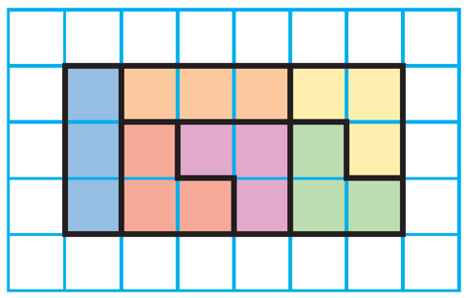

Module 14 Lesson 1 Name: ____________________________

Are the parts of this rectangle equal in area? If yes, what fraction names each part of the rectangle?

Module 14 Lesson 1 Name: ____________________________

Are the parts of this rectangle equal in area? If yes, what fraction names each part of the rectangle?

Module 14 Lesson 1 Name: ____________________________

Are the parts of this rectangle equal in area? If yes, what fraction names each part of the rectangle?

Module 14 Lesson 2 Name: ____________________________

Draw to show two different ways to divide the shape into 4 parts with equal areas. Shade $\frac{1}{4}$ of each shape.

Draw to show two different ways to divide the shape into 4 parts with equal areas. Shade $\frac{1}{4}$ of each shape.

Module 14 Lesson 2 Name: ____________________________

Draw to show two different ways to divide the shape into 4 parts with equal areas. Shade $\frac{1}{4}$ of each shape.

Draw to show two different ways to divide the shape into 4 parts with equal areas. Shade $\frac{1}{4}$ of each shape.

Module 14 Lesson 3 Name: ____________________________

Divide a circle into 8 equal parts. Write a fraction to represent each equal part.

Module 14 Lesson 3 Name: ____________________________

Divide a circle into 8 equal parts. Write a fraction to represent each equal part.

Module 14 Lesson 3 Name: ____________________________

Divide a circle into 8 equal parts. Write a fraction to represent each equal part.

Module 14 Lesson 3 Name: ____________________________

Divide a circle into 8 equal parts. Write a fraction to represent each equal part.

Module 15 Lesson 1 Name: ____________________________

Rachael and Todd each had 6 orange slices. Rachael has eaten $\frac{4}{6}$ of her slices.
Todd has eaten $\frac{2}{6}$ of his slices.
Who has the greater part of their slices left to eat? Explain how you solved the problem.

Module 15 Lesson 1 Name: ____________________________

Rachael and Todd each had 6 orange slices. Rachael has eaten $\frac{4}{6}$ of her slices.
Todd has eaten $\frac{2}{6}$ of his slices.
Who has the greater part of their slices left to eat? Explain how you solved the problem.

Module 15 Lesson 2 Name: ____________________________

Compare.

$\frac{3}{4}$ $\frac{2}{4}$

Module 15 Lesson 2 Name: ____________________________

Compare.

$\frac{3}{4}$ $\frac{2}{4}$

Module 15 Lesson 2 Name: ____________________________

Compare.

$\frac{3}{4}$ $\frac{2}{4}$

Module 15 Lesson 2 Name: ____________________________

Compare.

$\frac{3}{4}$ $\frac{2}{4}$

Module 15 Lesson 3 Name: ____________________________

Compare.

$\frac{4}{6}$ $\frac{4}{8}$

Module 15 Lesson 3 Name: ____________________________

Compare.

$\frac{4}{6}$ $\frac{4}{8}$

Module 15 Lesson 3 Name: ____________________________

Compare.

$\frac{4}{6}$ $\frac{4}{8}$

Module 15 Lesson 3 Name: ____________________________

Compare.

$\frac{4}{6}$ $\frac{4}{8}$

Module 15 Lesson 4 Name: ____________________________

Compare.

$\frac{5}{6}$ $\frac{7}{8}$

Module 15 Lesson 4 Name: ____________________________

Compare.

$\frac{5}{6}$ $\frac{7}{8}$

Module 15 Lesson 4 Name: ____________________________

Compare.

$\frac{5}{6}$ $\frac{7}{8}$

Module 15 Lesson 4 Name: ____________________________

Compare.

$\frac{5}{6}$ $\frac{7}{8}$

Module 16 Lesson 1 Name: ____________________________

What fraction in eighths is equivalent to $\frac{1}{4}$ ?

Module 16 Lesson 1 Name: ____________________________

What fraction in eighths is equivalent to $\frac{1}{4}$ ?

Module 16 Lesson 1 Name: ____________________________

What fraction in eighths is equivalent to $\frac{1}{4}$ ?

Module 16 Lesson 1 Name: ____________________________

What fraction in eighths is equivalent to $\frac{1}{4}$ ?

Module 16 Lesson 2 Name: ____________________________

Trent shows $\frac{4}{8}$ of a rectangle shaded. What fraction with fourths is equivalent to $\frac{4}{8}$ ?

Module 16 Lesson 2 Name: ____________________________

Trent shows $\frac{4}{8}$ of a rectangle shaded. What fraction with fourths is equivalent to $\frac{4}{8}$ ?

Module 16 Lesson 2 Name: ____________________________

Trent shows $\frac{4}{8}$ of a rectangle shaded. What fraction with fourths is equivalent to $\frac{4}{8}$ ?

Module 16 Lesson 2 Name: ____________________________

Trent shows $\frac{4}{8}$ of a rectangle shaded. What fraction with fourths is equivalent to $\frac{4}{8}$ ?

Module 16 Lesson 3 Name: ____________________________

Draw a visual model to show a fraction that is equivalent to $\frac{2}{3}$ .

Module 16 Lesson 3 Name: ____________________________

Draw a visual model to show a fraction that is equivalent to $\frac{2}{3}$ .

Module 16 Lesson 3 Name: ____________________________

Draw a visual model to show a fraction that is equivalent to $\frac{2}{3}$ .

Module 16 Lesson 3 Name: ____________________________

Draw a visual model to show a fraction that is equivalent to $\frac{2}{3}$ .

Module 17 Lesson 1 Name: ____________________________

Estimate the order of the containers by liquid volume from least to greatest: pasta sauce jar, fish tank, yogurt container.

Module 17 Lesson 1 Name: ____________________________

Estimate the order of the containers by liquid volume from least to greatest: pasta sauce jar, fish tank, yogurt container.

Module 17 Lesson 1 Name: ____________________________

Estimate the order of the containers by liquid volume from least to greatest: pasta sauce jar, fish tank, yogurt container.

Module 17 Lesson 1 Name: ____________________________

Estimate the order of the containers by liquid volume from least to greatest: pasta sauce jar, fish tank, yogurt container.

Module 17 Lesson 2 Name: ____________________________

Yilda will use a pan balance to measure the mass of a package of flour. Then she will measure the mass of a hat. Which unit should she use to measure the mass of each object, grams or kilograms? Estimate which object has the greater mass.

Module 17 Lesson 2 Name: ____________________________

Yilda will use a pan balance to measure the mass of a package of flour. Then she will measure the mass of a hat. Which unit should she use to measure the mass of each object, grams or kilograms? Estimate which object has the greater mass.

Module 17 Lesson 2 Name: ____________________________

Yilda will use a pan balance to measure the mass of a package of flour. Then she will measure the mass of a hat. Which unit should she use to measure the mass of each object, grams or kilograms? Estimate which object has the greater mass.

Module 17 Lesson 2 Name: ____________________________

Yilda will use a pan balance to measure the mass of a package of flour. Then she will measure the mass of a hat. Which unit should she use to measure the mass of each object, grams or kilograms? Estimate which object has the greater mass.

Module 17 Lesson 3 Name: ____________________________

Harv drinks the same amount of water each day. He drinks 12 liters of water in 4 days. How much water does Harv drink each day?

Module 17 Lesson 3 Name: ____________________________

Harv drinks the same amount of water each day. He drinks 12 liters of water in 4 days. How much water does Harv drink each day?

Module 17 Lesson 3 Name: ____________________________

Harv drinks the same amount of water each day. He drinks 12 liters of water in 4 days. How much water does Harv drink each day?

Module 17 Lesson 3 Name: ____________________________

Harv drinks the same amount of water each day. He drinks 12 liters of water in 4 days. How much water does Harv drink each day?

Module 18 Lesson 1 Name: ____________________________

How many more books did Lamar read than Andy?

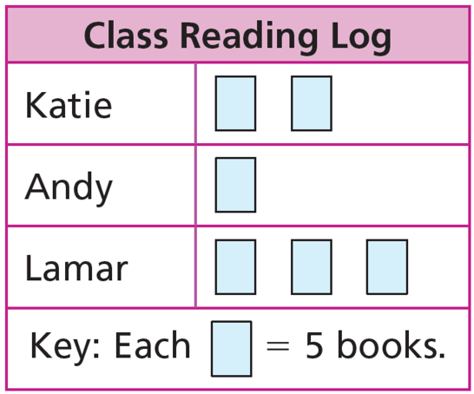

Module 18 Lesson 1 Name: ____________________________

How many more books did Lamar read than Andy?

Module 18 Lesson 1 Name: ____________________________

How many more books did Lamar read than Andy?

Module 18 Lesson 1 Name: ____________________________

How many more books did Lamar read than Andy?

Module 18 Lesson 2 Name: ____________________________

Ava collects data about the types of activities students are doing at the beach. Ava will use a symbol of a beach ball to stand for 2 votes. How should a row look for 15 votes?

Module 18 Lesson 2 Name: ____________________________

Ava collects data about the types of activities students are doing at the beach. Ava will use a symbol of a beach ball to stand for 2 votes. How should a row look for 15 votes?

Module 18 Lesson 2 Name: ____________________________

Ava collects data about the types of activities students are doing at the beach. Ava will use a symbol of a beach ball to stand for 2 votes. How should a row look for 15 votes?

Module 18 Lesson 2 Name: ____________________________

Ava collects data about the types of activities students are doing at the beach. Ava will use a symbol of a beach ball to stand for 2 votes. How should a row look for 15 votes?

Module 18 Lesson 3 Name: ____________________________

How many fewer students choose red than blue?

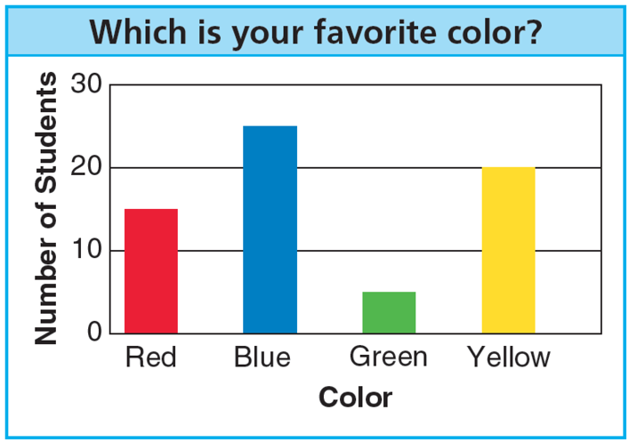

Module 18 Lesson 3 Name: ____________________________

How many fewer students choose red than blue?

Module 18 Lesson 3 Name: ____________________________

How many fewer students choose red than blue?

Module 18 Lesson 3 Name: ____________________________

How many fewer students choose red than blue?

Module 18 Lesson 4 Name: ____________________________

Rita surveyed the staff about the amount of each type of lunch food that was sold on Friday. Rita made a table listing the following results:

Lunch Food Sold Friday
Food | Number Sold
Pizza | 36
Sandwich | 12
Salad | 8

What scale might Rita choose for her bar graph? Which bar will be the shortest? Which bar will be the tallest/longest?

Module 18 Lesson 4 Name: ____________________________

Rita surveyed the staff about the amount of each type of lunch food that was sold on Friday. Rita made a table listing the following results:

Lunch Food Sold Friday
Food | Number Sold
Pizza | 36
Sandwich | 12
Salad | 8

What scale might Rita choose for her bar graph? Which bar will be the shortest? Which bar will be the tallest/longest?

Module 18 Lesson 5 Name: ____________________________

There are no ✗s above 8 $\frac{1}{2}$ inches on the line plot below. What does this tell you about the candles used for the party?

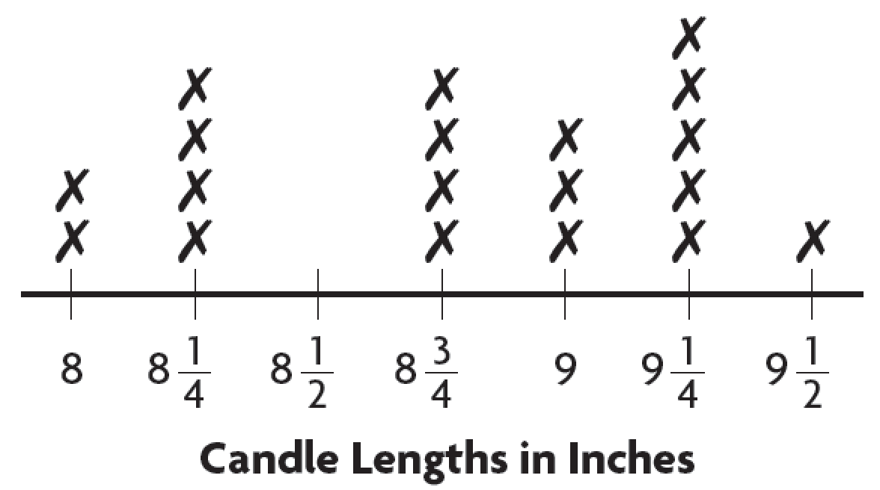

_______________________________________________

_______________________________________________

_______________________________________________

_______________________________________________

_______________________________________________

Module 18 Lesson 5 Name: ____________________________

There are no ✗s above 8 $\frac{1}{2}$ inches on the line plot below. What does this tell you about the candles used for the party?

_______________________________________________

_______________________________________________

_______________________________________________

_______________________________________________

_______________________________________________

Module 18 Lesson 6 Name: ____________________________

What is the difference between the number of keys at the shortest length and the number of keys at the longest length?
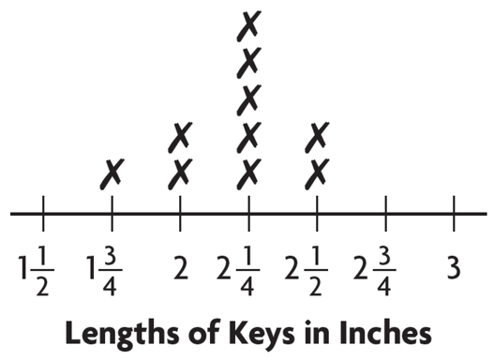

Module 18 Lesson 6 Name: ____________________________

What is the difference between the number of keys at the shortest length and the number of keys at the longest length?

Module 18 Lesson 6 Name: ____________________________

What is the difference between the number of keys at the shortest length and the number of keys at the longest length?

Module 18 Lesson 6 Name: ____________________________

What is the difference between the number of keys at the shortest length and the number of keys at the longest length?

Module 18 Lesson 7 Name: ____________________________

Look at the data in the tally chart. How many fewer visitors are there on Thursday than on Monday and Friday combined?

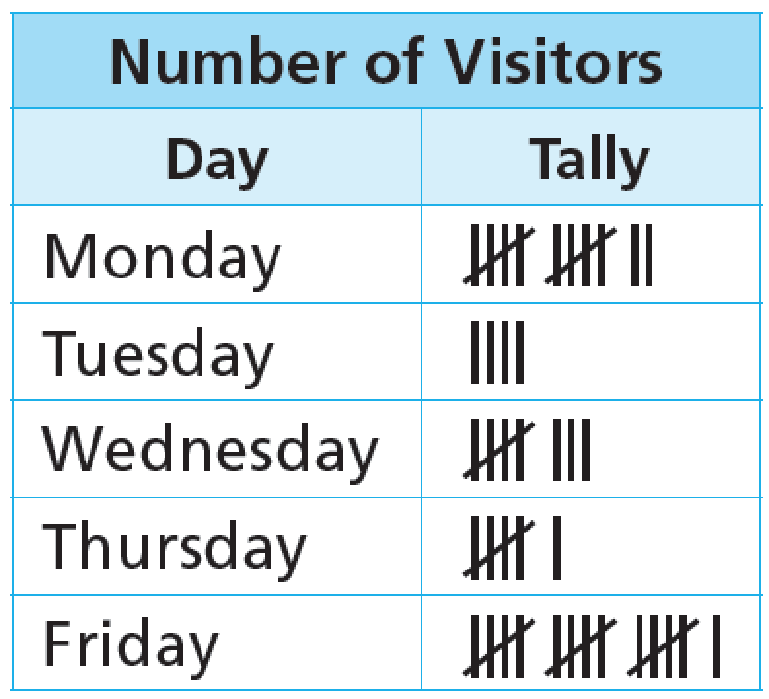

Module 18 Lesson 7 Name: ____________________________

Look at the data in the tally chart. How many fewer visitors are there on Thursday than on Monday and Friday combined?

Module 18 Lesson 7 Name: ____________________________

Look at the data in the tally chart. How many fewer visitors are there on Thursday than on Monday and Friday combined?

Module 18 Lesson 7 Name: ____________________________

Look at the data in the tally chart. How many fewer visitors are there on Thursday than on Monday and Friday combined?

Module 19 Lesson 1 Name: ____________________________

Describe attributes of this shape using vocabulary words from the list.

plane shape, line segment,
closed shape, open shape,
polygon, side, angles, vertex

Module 19 Lesson 1 Name: ____________________________

Describe attributes of this shape using vocabulary words from the list.

plane shape, line segment,
closed shape, open shape,
polygon, side, angles, vertex

Module 19 Lesson 1 Name: ____________________________

Describe attributes of this shape using vocabulary words from the list.

plane shape, line segment,
closed shape, open shape,
polygon, side, angles, vertex

Module 19 Lesson 1 Name: ____________________________

Describe attributes of this shape using vocabulary words from the list.

plane shape, line segment,
closed shape, open shape,
polygon, side, angles, vertex

Module 19 Lesson 2 Name: ____________________________

Draw a shape with 5 sides. Label each angle as a right angle, greater than a right angle, or less than a right angle.

Module 19 Lesson 2 Name: ____________________________

Draw a shape with 5 sides. Label each angle as a right angle, greater than a right angle, or less than a right angle.

Module 19 Lesson 2 Name: ____________________________

Draw a shape with 5 sides. Label each angle as a right angle, greater than a right angle, or less than a right angle.

Module 19 Lesson 2 Name: ____________________________

Draw a shape with 5 sides. Label each angle as a right angle, greater than a right angle, or less than a right angle.

Module 19 Lesson 3 Name: ____________________________

Describe the sides of this shape.

Module 19 Lesson 3 Name: ____________________________

Describe the sides of this shape.

Module 19 Lesson 3 Name: ____________________________

Describe the sides of this shape.

Module 19 Lesson 3 Name: ____________________________

Describe the sides of this shape.

Module 19 Lesson 4 Name: ____________________________

Which statement is always true? Explain.
All rectangles are squares.
All squares are rectangles.

Module 19 Lesson 4 Name: ____________________________

Which statement is always true? Explain.
All rectangles are squares.
All squares are rectangles.

Module 19 Lesson 4 Name: ____________________________

Which statement is always true? Explain.
All rectangles are squares.
All squares are rectangles.

Module 19 Lesson 4 Name: ____________________________

Which statement is always true? Explain.
All rectangles are squares.
All squares are rectangles.

Module 20 Lesson 1 Name: ____________________________

Name a quadrilateral that can have 2 pairs of parallel sides and no right angles. Draw one.

Module 20 Lesson 1 Name: ____________________________

Name a quadrilateral that can have 2 pairs of parallel sides and no right angles. Draw one.

Module 20 Lesson 1 Name: ____________________________

Name a quadrilateral that can have 2 pairs of parallel sides and no right angles. Draw one.

Module 20 Lesson 1 Name: ____________________________

Name a quadrilateral that can have 2 pairs of parallel sides and no right angles. Draw one.

Module 20 Lesson 2 Name: ____________________________

Solve the riddle.
I am a parallelogram with 4 right angles. All of my sides are equal in length. Draw me. What am I?

Module 20 Lesson 2 Name: ____________________________

Solve the riddle.
I am a parallelogram with 4 right angles. All of my sides are equal in length. Draw me. What am I?

Module 20 Lesson 2 Name: ____________________________

Solve the riddle.
I am a parallelogram with 4 right angles. All of my sides are equal in length. Draw me. What am I?

Module 20 Lesson 2 Name: ____________________________

Solve the riddle.
I am a parallelogram with 4 right angles. All of my sides are equal in length. Draw me. What am I?

Module 20 Lesson 3 Name: ____________________________

Complete the Venn diagram by writing a label or name for each category.

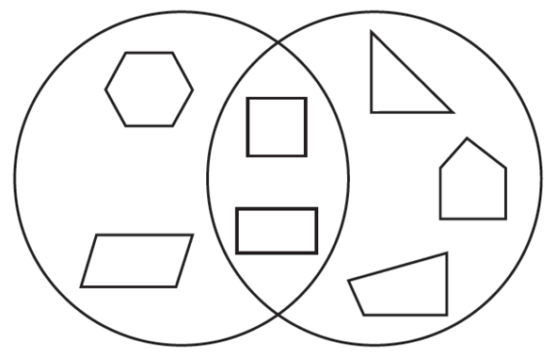

Module 20 Lesson 3 Name: ____________________________

Complete the Venn diagram by writing a label or name for each category.

Module 20 Lesson 3 Name: ____________________________

Complete the Venn diagram by writing a label or name for each category.

Module 20 Lesson 3 Name: ____________________________

Complete the Venn diagram by writing a label or name for each category.

