Grade 1

Exit Tickets

This document contains printable and customizable versions of the Exit Tickets recommended
in the Into Math Teacher Edition. The Exit Ticket is also available as a Projectable PDF on
Ed: Your Friend in Learning.

Exit Tickets are an optional way to wrap up a lesson. The problem provided for each lesson assesses
whether students grasped the lesson content.

Exit Tickets in Grades K and 1 should be read aloud to students. The directions are provided on each Exit Ticket to ensure it is clear what students were asked to do.

To save paper when printing, the document is formatted with 2 to a page for some lessons and 4 to a page
in other lessons, based on the space students will likely need to answer the question(s).

Copyright © by Houghton Mifflin Harcourt Publishing Company
All rights reserved. No part of the material protected by this copyright may be reproduced or utilized in any form or by any means, electronic or mechanical, including photocopying, recording, broadcasting or by any other information storage and retrieval system, without written permission of the copyright owner unless such copying is expressly permitted by federal copyright law.
Only those pages that are specifically enabled by the program and indicated by the presence of the print icon may be printed and reproduced in classroom quantities by individual teachers using the corresponding student’s textbook or kit as the major vehicle for regular classroom instruction. Requests for information on other matters regarding duplication of this work should be submitted through our Permissions website at https://customercare.hmhco.com/contactus/Permissions.html or mailed to Houghton Mifflin Harcourt Publishing Company, Attn: Compliance, Contracts, and Licensing, 9400 Southpark Center Loop, Orlando, Florida 32819-8647.
HOUGHTON MIFFLIN HARCOURT and the HMH Logo are trademarks and service marks of Houghton Mifflin Harcourt Publishing Company. You shall not display, disparage, dilute or taint Houghton Mifflin Harcourt trademarks and service marks or use any confusingly similar marks, or use Houghton Mifflin Harcourt marks in such a way that would misrepresent the identity of the owner. Any permitted use of Houghton Mifflin Harcourt trademarks and service marks inures to the benefit of Houghton Mifflin Harcourt Publishing Company.
All other trademarks, service marks or registered trademarks appearing on Houghton Mifflin Harcourt Publishing Company websites are the trademarks or service marks of their respective owners.

Module 1 Lesson 1 Name: _____________________________

There are 4 elephants in the field.
Then 2 elephants join them.

What equation can you use to find how many elephants there are now?

Module 1 Lesson 1 Name: _____________________________

There are 4 elephants in the field.
Then 2 elephants join them.

What equation can you use to find how many elephants there are now?

Module 1 Lesson 1 Name: _____________________________

There are 4 elephants in the field.
Then 2 elephants join them.

What equation can you use to find how many elephants there are now?

Module 1 Lesson 1 Name: _____________________________

There are 4 elephants in the field.
Then 2 elephants join them.

What equation can you use to find how many elephants there are now?

Module 1 Lesson 2 Name: _____________________________

Count on to add. What is 2 + 6?

Module 1 Lesson 2 Name: _____________________________

Count on to add. What is 2 + 6?

Module 1 Lesson 2 Name: _____________________________

Count on to add. What is 2 + 6?

Module 1 Lesson 2 Name: _____________________________

Count on to add. What is 2 + 6?

Module 1 Lesson 3 Name: _____________________________

Use counters in ten frames to represent the problem 10 + 8.

Write an addition equation and write the sum.

Module 1 Lesson 3 Name: _____________________________

Use counters in ten frames to represent the problem 10 + 8.

Write an addition equation and write the sum.

Module 1 Lesson 3 Name: _____________________________

Use counters in ten frames to represent the problem 10 + 8.

Write an addition equation and write the sum.

Module 1 Lesson 3 Name: _____________________________

Use counters in ten frames to represent the problem 10 + 8.

Write an addition equation and write the sum.

Module 1 Lesson 4 Name: _____________________________

Make a ten to solve.
6 + 7 =

Module 1 Lesson 4 Name: _____________________________

Make a ten to solve.
6 + 7 =

Module 1 Lesson 4 Name: _____________________________

Make a ten to solve.
6 + 7 =

Module 1 Lesson 4 Name: _____________________________

Make a ten to solve.
6 + 7 =

Module 1 Lesson 5 Name: _____________________________

What is the sum of the doubles fact 9 + 9?

Module 1 Lesson 5 Name: _____________________________

What is the sum of the doubles fact 9 + 9?

Module 1 Lesson 5 Name: _____________________________

What is the sum of the doubles fact 9 + 9?

Module 1 Lesson 5 Name: _____________________________

What is the sum of the doubles fact 9 + 9?

Module 1 Lesson 6 Name: _____________________________

Use doubles to solve. What is the sum of 9 + 8?

Module 1 Lesson 6 Name: _____________________________

Use doubles to solve. What is the sum of 9 + 8?

Module 1 Lesson 6 Name: _____________________________

Use doubles to solve. What is the sum of 9 + 8?

Module 1 Lesson 6 Name: _____________________________

Use doubles to solve. What is the sum of 9 + 8?

Module 1 Lesson 7 Name: _____________________________

Show how to solve 9 + 8 in two ways.

Module 1 Lesson 7 Name: _____________________________

Show how to solve 9 + 8 in two ways.

Module 1 Lesson 7 Name: _____________________________

Show how to solve 9 + 8 in two ways.

Module 1 Lesson 7 Name: _____________________________

Show how to solve 9 + 8 in two ways.

Module 2 Lesson 1 Name: _____________________________

12 goats are in a field. Then 7 goats run away.

How can you write a subtraction equation to find how many goats there are now?

Module 2 Lesson 1 Name: _____________________________

12 goats are in a field. Then 7 goats run away.

How can you write a subtraction equation to find how many goats there are now?

Module 2 Lesson 1 Name: _____________________________

12 goats are in a field. Then 7 goats run away.

How can you write a subtraction equation to find how many goats there are now?

Module 2 Lesson 1 Name: _____________________________

12 goats are in a field. Then 7 goats run away.

How can you write a subtraction equation to find how many goats there are now?

Module 2 Lesson 2 Name: _____________________________

Sara has 11 seashells.
She gives 3 seashells to her sister.
How many seashells does Sara have now?
Count back to solve.

Module 2 Lesson 2 Name: _____________________________

Sara has 11 seashells.
She gives 3 seashells to her sister.
How many seashells does Sara have now?
Count back to solve.

Module 2 Lesson 2 Name: _____________________________

Sara has 11 seashells.
She gives 3 seashells to her sister.
How many seashells does Sara have now?
Count back to solve.

Module 2 Lesson 2 Name: _____________________________

Sara has 11 seashells.
She gives 3 seashells to her sister.
How many seashells does Sara have now?
Count back to solve.

Module 2 Lesson 3 Name: _____________________________

Jake has 8 pets. 5 are fish. The rest of his pets are birds. How many birds does Jake have?

Use counting on to subtract to solve.

Module 2 Lesson 3 Name: _____________________________

Jake has 8 pets. 5 are fish. The rest of his pets are birds. How many birds does Jake have?

Use counting on to subtract to solve.

Module 2 Lesson 3 Name: _____________________________

Jake has 8 pets. 5 are fish. The rest of his pets are birds. How many birds does Jake have?

Use counting on to subtract to solve.

Module 2 Lesson 3 Name: _____________________________

Jake has 8 pets. 5 are fish. The rest of his pets are birds. How many birds does Jake have?

Use counting on to subtract to solve.

Module 2 Lesson 4 Name: _____________________________

Sara has 14 flowers.
8 are red, and the rest are yellow.
How many flowers are yellow?
14 – 8 =
Show how to use addition to help solve.

Module 2 Lesson 4 Name: _____________________________

Sara has 14 flowers.
8 are red, and the rest are yellow.
How many flowers are yellow?
14 – 8 =
Show how to use addition to help solve.

Module 2 Lesson 4 Name: _____________________________

Sara has 14 flowers.
8 are red, and the rest are yellow.
How many flowers are yellow?
14 – 8 =
Show how to use addition to help solve.

Module 2 Lesson 4 Name: _____________________________

Sara has 14 flowers.
8 are red, and the rest are yellow.
How many flowers are yellow?
14 – 8 =
Show how to use addition to help solve.

Module 2 Lesson 5 Name: _____________________________

How can you make a ten to subtract 13 – 5?

____________________________________________________________________________________________________________________________________________________________________________________________________
__________________________________________________________________________________________________
__________________________________________________________________________________________________
Module 2 Lesson 5 Name: _____________________________

How can you make a ten to subtract 13 – 5?

____________________________________________________________________________________________________________________________________________________________________________________________________
__________________________________________________________________________________________________
__________________________________________________________________________________________________
Module 2 Lesson 6 Name: _____________________________

11 birds sit in a tree.
2 of the birds fly away.
How many birds are in the tree now?
Use any strategy to solve.

Module 2 Lesson 6 Name: _____________________________

11 birds sit in a tree.
2 of the birds fly away.
How many birds are in the tree now?
Use any strategy to solve.

Module 2 Lesson 6 Name: _____________________________

11 birds sit in a tree.
2 of the birds fly away.
How many birds are in the tree now?
Use any strategy to solve.

Module 2 Lesson 6 Name: _____________________________

11 birds sit in a tree.
2 of the birds fly away.
How many birds are in the tree now?
Use any strategy to solve.

Module 3 Lesson 1 Name: _____________________________

Kayla has 7 toy bears and 2 toy bunnies. How many toy bears and bunnies does she have? Write two equations that you can use to solve this problem.

Module 3 Lesson 1 Name: _____________________________

Kayla has 7 toy bears and 2 toy bunnies. How many toy bears and bunnies does she have? Write two equations that you can use to solve this problem.

Module 3 Lesson 1 Name: _____________________________

Kayla has 7 toy bears and 2 toy bunnies. How many toy bears and bunnies does she have? Write two equations that you can use to solve this problem.

Module 3 Lesson 1 Name: _____________________________

Kayla has 7 toy bears and 2 toy bunnies. How many toy bears and bunnies does she have? Write two equations that you can use to solve this problem.

Module 3 Lesson 2 Name: _____________________________

There are 9 children on the playground. Then 3 more children come to the playground. How many children are on the playground now?
To solve the problem, Kendra writes 3 + 9 = 12. Bob writes 9 + 3 = 12. Who got the right answer? Explain.

________________________________________________________________________________________________________________________________________________________________________________________________________________________________________________________________________________________________________________________________________________________________________________________________________
Module 3 Lesson 2 Name: _____________________________

There are 9 children on the playground. Then 3 more children come to the playground. How many children are on the playground now?
To solve the problem, Kendra writes 3 + 9 = 12. Bob writes 9 + 3 = 12. Who got the right answer? Explain.

________________________________________________________________________________________________________________________________________________________________________________________________________________________________________________________________________________________________________________________________________________________________________________________________________
Module 3 Lesson 3 Name: _____________________________

In a kitchen, there are 3 big pots, 2 medium pots, and 5 small pots. How many pots are there in all?

Module 3 Lesson 3 Name: _____________________________

In a kitchen, there are 3 big pots, 2 medium pots, and 5 small pots. How many pots are there in all?

Module 3 Lesson 3 Name: _____________________________

In a kitchen, there are 3 big pots, 2 medium pots, and 5 small pots. How many pots are there in all?

Module 3 Lesson 3 Name: _____________________________

In a kitchen, there are 3 big pots, 2 medium pots, and 5 small pots. How many pots are there in all?

Module 3 Lesson 4 Name: _____________________________

5 + 3 + 5 =

Find the sum. Use a strategy to explain how you chose which addends to add together first.

Module 3 Lesson 4 Name: _____________________________

5 + 3 + 5 =

Find the sum. Use a strategy to explain how you chose which addends to add together first.

Module 3 Lesson 4 Name: _____________________________

5 + 3 + 5 =

Find the sum. Use a strategy to explain how you chose which addends to add together first.

Module 3 Lesson 4 Name: _____________________________

5 + 3 + 5 =

Find the sum. Use a strategy to explain how you chose which addends to add together first.

Module 3 Lesson 5 Name: _____________________________

There are 3 black dogs and 7 spotted dogs at the park. There are also 2 brown dogs at the park. How many dogs are at the park?

Module 3 Lesson 5 Name: _____________________________

There are 3 black dogs and 7 spotted dogs at the park. There are also 2 brown dogs at the park. How many dogs are at the park?

Module 3 Lesson 5 Name: _____________________________

There are 3 black dogs and 7 spotted dogs at the park. There are also 2 brown dogs at the park. How many dogs are at the park?

Module 3 Lesson 5 Name: _____________________________

There are 3 black dogs and 7 spotted dogs at the park. There are also 2 brown dogs at the park. How many dogs are at the park?

Module 3 Lesson 6 Name: _____________________________

Explain why 7 – 5 = 4 + 2 is false.

______________________________________________________________________________________________________________________________________________________________________________________________________________________________________________________________________________________________________
Module 3 Lesson 6 Name: _____________________________

Explain why 7 – 5 = 4 + 2 is false.

______________________________________________________________________________________________________________________________________________________________________________________________________________________________________________________________________________________________________
Module 3 Lesson 7 Name: _____________________________

There are 4 children on the left side of the classroom and 5 children on the right side of the classroom. How many children are in the classroom?

Module 3 Lesson 7 Name: _____________________________

There are 4 children on the left side of the classroom and 5 children on the right side of the classroom. How many children are in the classroom?

Module 3 Lesson 7 Name: _____________________________

There are 4 children on the left side of the classroom and 5 children on the right side of the classroom. How many children are in the classroom?

Module 3 Lesson 7 Name: _____________________________

There are 4 children on the left side of the classroom and 5 children on the right side of the classroom. How many children are in the classroom?

Module 4 Lesson 1 Name: _____________________________

Joey has 12 windows in his house.
3 are open, and the rest are closed.
How many windows are closed?

Show how to use addition to subtract 12 – 3.

Module 4 Lesson 1 Name: _____________________________

Joey has 12 windows in his house.
3 are open, and the rest are closed.
How many windows are closed?

Show how to use addition to subtract 12 – 3.

Module 4 Lesson 2 Name: _____________________________

There are 12 houses on Park Street.
4 houses have yellow roofs. The rest have red roofs.

Write related facts to represent the houses. Use connecting cubes if you need to.

How many houses have red roofs?

Module 4 Lesson 2 Name: _____________________________

There are 12 houses on Park Street.
4 houses have yellow roofs. The rest have red roofs.

Write related facts to represent the houses. Use connecting cubes if you need to.

How many houses have red roofs?

Module 4 Lesson 3 Name: _____________________________

Which of these facts are related?

4 + 7 = 11

3 + 4 = 7

11 − 4 = 7

Module 4 Lesson 3 Name: _____________________________

Which of these facts are related?

4 + 7 = 11

3 + 4 = 7

11 − 4 = 7

Module 4 Lesson 3 Name: _____________________________

Which of these facts are related?

4 + 7 = 11

3 + 4 = 7

11 − 4 = 7

Module 4 Lesson 3 Name: _____________________________

Which of these facts are related?

4 + 7 = 11

3 + 4 = 7

11 − 4 = 7

Module 4 Lesson 4 Name: _____________________________

There are 11 horses. 8 of them are in the field. The rest are in the barn. How many horses are in the barn?

Write a subtraction equation to solve.
Then check your answer with addition.

Module 4 Lesson 4 Name: _____________________________

There are 11 horses. 8 of them are in the field. The rest are in the barn. How many horses are in the barn?

Write a subtraction equation to solve.
Then check your answer with addition.

Module 4 Lesson 5 Name: _____________________________

8 bunnies are big. The rest are small.
There are 13 bunnies altogether.
How many bunnies are small?

Use subtraction to solve.

8 + = 13

Module 4 Lesson 5 Name: _____________________________

8 bunnies are big. The rest are small.
There are 13 bunnies altogether.
How many bunnies are small?

Use subtraction to solve.

8 + = 13

Module 4 Lesson 5 Name: _____________________________

8 bunnies are big. The rest are small.
There are 13 bunnies altogether.
How many bunnies are small?

Use subtraction to solve.

8 + = 13

Module 4 Lesson 5 Name: _____________________________

8 bunnies are big. The rest are small.
There are 13 bunnies altogether.
How many bunnies are small?

Use subtraction to solve.

8 + = 13

Module 4 Lesson 6 Name: _____________________________

Sergio has 12 toy animals.
6 are bears, and the rest are tigers.
How many toy tigers does Sergio have?

Write a related subtraction fact to solve.

6 + = 12

Module 4 Lesson 6 Name: _____________________________

Sergio has 12 toy animals.
6 are bears, and the rest are tigers.
How many toy tigers does Sergio have?

Write a related subtraction fact to solve.

6 + = 12

Module 4 Lesson 6 Name: _____________________________

Sergio has 12 toy animals.
6 are bears, and the rest are tigers.
How many toy tigers does Sergio have?

Write a related subtraction fact to solve.

6 + = 12

Module 4 Lesson 6 Name: _____________________________

Sergio has 12 toy animals.
6 are bears, and the rest are tigers.
How many toy tigers does Sergio have?

Write a related subtraction fact to solve.

6 + = 12

Module 4 Lesson 7 Name: _____________________________

Tara has 9 books. She gives 3 books to Laura.
How many books does Tara have now?

Write a subtraction equation to solve.

Module 4 Lesson 7 Name: _____________________________

Tara has 9 books. She gives 3 books to Laura.
How many books does Tara have now?

Write a subtraction equation to solve.

Module 4 Lesson 7 Name: _____________________________

Tara has 9 books. She gives 3 books to Laura.
How many books does Tara have now?

Write a subtraction equation to solve.

Module 4 Lesson 7 Name: _____________________________

Tara has 9 books. She gives 3 books to Laura.
How many books does Tara have now?

Write a subtraction equation to solve.

Module 5 Lesson 1 Name: _____________________________

If Megan has 14 pears and she gives 7 to a friend, how many pears does she have left?

Module 5 Lesson 1 Name: _____________________________

If Megan has 14 pears and she gives 7 to a friend, how many pears does she have left?

Module 5 Lesson 2 Name: _____________________________

Dan sees 5 geese in a pond. Some more geese come. Now Dan sees 14 geese in the pond. How many geese come to the pond?

Module 5 Lesson 2 Name: _____________________________

Dan sees 5 geese in a pond. Some more geese come. Now Dan sees 14 geese in the pond. How many geese come to the pond?

Module 5 Lesson 3 Name: _____________________________

Alexis has some leaves. She gets 2 more leaves from her sister. Now she has 11 leaves. How many leaves did she have to start?

Module 5 Lesson 3 Name: _____________________________

Alexis has some leaves. She gets 2 more leaves from her sister. Now she has 11 leaves. How many leaves did she have to start?

Module 5 Lesson 4 Name: _____________________________

A soccer team has some soccer balls. They get 7 more soccer balls. Now the team has 15 soccer balls. How many soccer balls did the team have to start?

Module 5 Lesson 4 Name: _____________________________

A soccer team has some soccer balls. They get 7 more soccer balls. Now the team has 15 soccer balls. How many soccer balls did the team have to start?

Module 6 Lesson 1 Name: _____________________________

Greta has 8 star stickers. Ms. Garbo gives her 3 more star stickers. How many star stickers does Greta have now?

____________ + ____________ = ____________

____________ star stickers

Module 6 Lesson 1 Name: _____________________________

Greta has 8 star stickers. Ms. Garbo gives her 3 more star stickers. How many star stickers does Greta have now?

____________ + ____________ = ____________

____________ star stickers

Module 6 Lesson 2 Name: _____________________________

Eliza sees 12 dogs in the park. Some are big and some are small. How many could be big, and how many could be small?

Module 6 Lesson 2 Name: _____________________________

Eliza sees 12 dogs in the park. Some are big and some are small. How many could be big, and how many could be small?

Module 6 Lesson 3 Name: _____________________________

Benjamin sees 15 cars on the street. 9 are blue and the rest are red. How many red cars does Benjamin see?

Module 6 Lesson 3 Name: ____________________________

Benjamin sees 15 cars on the street. 9 are blue and the rest are red. How many red cars does Benjamin see?

Module 6 Lesson 4 Name: _____________________________

Clara sees 9 ants. Jose sees 4 ants. How many ants do they see in all?

Complete a bar model and write an equation to solve the problem.

Equation: ________________________________________

Module 6 Lesson 4 Name: _____________________________

Clara sees 9 ants. Jose sees 4 ants. How many ants do they see in all?

Complete a bar model and write an equation to solve the problem.

Equation: ________________________________________

Module 6 Lesson 5 Name: _____________________________

Asher has 11 skateboards. Some are blue and some are green. How many skateboards could be blue, and how many could be green?

Complete a bar model and write an equation that shows your solution.

Equation: ________________________________________

Module 6 Lesson 5 Name: _____________________________

Asher has 11 skateboards. Some are blue and some are green. How many skateboards could be blue, and how many could be green?

Complete a bar model and write an equation that shows your solution.

Equation: ________________________________________

Module 6 Lesson 6 Name: _____________________________

There are 16 seashells on the beach. Some are round and some are long. How many of each could there be? Explain.

______________________________________________________________________________________________________________________________________________________________________________________________________________________________________________________________________________________________________
Module 6 Lesson 6 Name: _____________________________

There are 16 seashells on the beach. Some are round and some are long. How many of each could there be? Explain.

______________________________________________________________________________________________________________________________________________________________________________________________________________________________________________________________________________________________________
Module 6 Lesson 7 Name: _____________________________

Corianne gives 6 smiley face stickers to Mark. She still has 9 smiley face stickers. How many stickers did she start with?

Module 6 Lesson 7 Name: _____________________________

Corianne gives 6 smiley face stickers to Mark. She still has 9 smiley face stickers. How many stickers did she start with?

Module 6 Lesson 7 Name: _____________________________

Corianne gives 6 smiley face stickers to Mark. She still has 9 smiley face stickers. How many stickers did she start with?

Module 6 Lesson 7 Name: _____________________________

Corianne gives 6 smiley face stickers to Mark. She still has 9 smiley face stickers. How many stickers did she start with?

Module 7 Lesson 1 Name: _____________________________

Marty has 5 apples. Tamara has 8 apples. How many more apples does Tamara have than Marty?

Show how to solve this problem using any method you know.

Module 7 Lesson 1 Name: _____________________________

Marty has 5 apples. Tamara has 8 apples. How many more apples does Tamara have than Marty?

Show how to solve this problem using any method you know.

Module 7 Lesson 2 Name: _____________________________

Cindy has 4 strawberries. Jeff has 6 more strawberries than Cindy. How many strawberries does Jeff have?

Show how to solve this problem using any method you know.

Module 7 Lesson 2 Name: _____________________________

Cindy has 4 strawberries. Jeff has 6 more strawberries than Cindy. How many strawberries does Jeff have?

Show how to solve this problem using any method you know.

Module 7 Lesson 3 Name: _____________________________

Muriel has 8 books. Cam has 5 fewer books than Muriel. How many books does Cam have?

Show how to solve this problem using any method you know.

Module 7 Lesson 3 Name: _____________________________

Muriel has 8 books. Cam has 5 fewer books than Muriel. How many books does Cam have?

Show how to solve this problem using any method you know.

Module 7 Lesson 4 Name: _____________________________

Nancy has 8 peaches. Sharon has 17 peaches. How many fewer peaches does Nancy have than Sharon?

Complete a provided blank bar model and explain how it models the problem.

____________________________________________________________________________________________________________________________________________________________________________________________________
Module 7 Lesson 4 Name: _____________________________

Nancy has 8 peaches. Sharon has 17 peaches. How many fewer peaches does Nancy have than Sharon?

Complete a provided blank bar model and explain how it models the problem.

____________________________________________________________________________________________________________________________________________________________________________________________________
Module 7 Lesson 5 Name: _____________________________

Zena has 14 fish in her aquarium. Marco has 5 fewer fish in his aquarium than Zena. How many fish does Marco have in his aquarium?

Show how to solve this problem using any method you know.

Module 7 Lesson 5 Name: _____________________________

Zena has 14 fish in her aquarium. Marco has 5 fewer fish in his aquarium than Zena. How many fish does Marco have in his aquarium?

Show how to solve this problem using any method you know.
Module 7 Lesson 6 Name: _____________________________

Carol has 7 fish in her aquarium. William has 4 more fish in his aquarium than Carol. How many fish does William have in his aquarium?

How can you use the make a ten strategy to solve this problem?

Module 7 Lesson 6 Name: _____________________________

Carol has 7 fish in her aquarium. William has 4 more fish in his aquarium than Carol. How many fish does William have in his aquarium?

How can you use the make a ten strategy to solve this problem?

Module 7 Lesson 7 Name: _____________________________

Draw a picture to show an addition or subtraction situation.

Samantha has 9 counters. Howard has 15 counters. How many fewer counters does Samantha have than Howard?

Module 7 Lesson 7 Name: _____________________________

Draw a picture to show an addition or subtraction situation.

Samantha has 9 counters. Howard has 15 counters. How many fewer counters does Samantha have than Howard?

Module 8 Lesson 1 Name: _____________________________

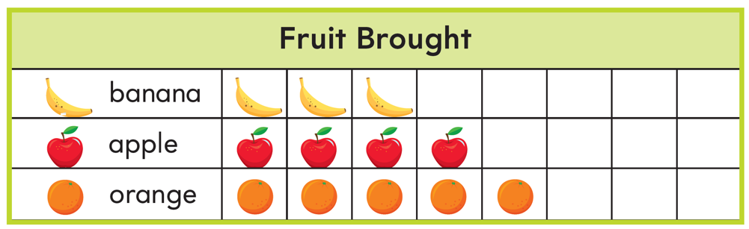

What equation can you write to find how many more apples there are than bananas?

Module 8 Lesson 1 Name: _____________________________

What equation can you write to find how many more apples there are than bananas?

Module 8 Lesson 2 Name: _____________________________

Stacey has three sets of blocks, six markers, and five dolls. Make a picture graph to show Stacey’s toys.

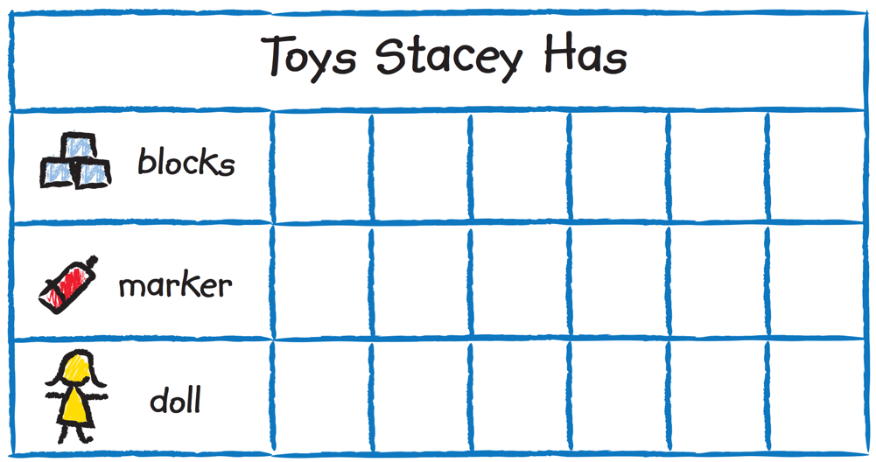

Module 8 Lesson 2 Name: _____________________________

Stacey has three sets of blocks, six markers, and five dolls. Make a picture graph to show Stacey’s toys.

Module 8 Lesson 3 Name: _____________________________

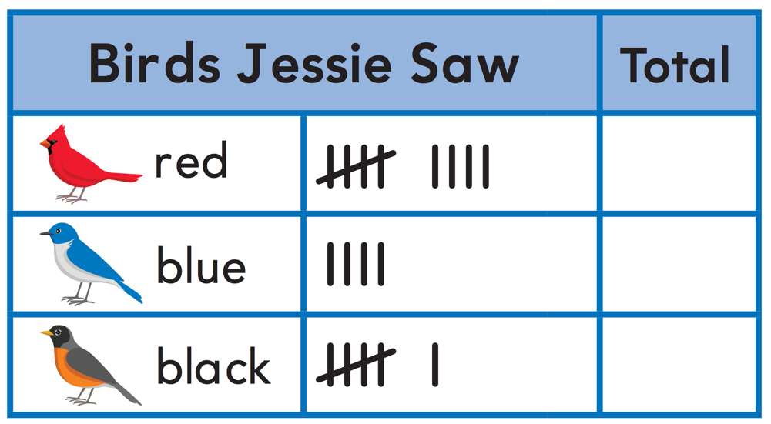

Complete the tally chart.

How many more red birds did Jessie see than black birds?

Module 8 Lesson 3 Name: _____________________________

Complete the tally chart.

How many more red birds did Jessie see than black birds?

Module 8 Lesson 4 Name: _____________________________

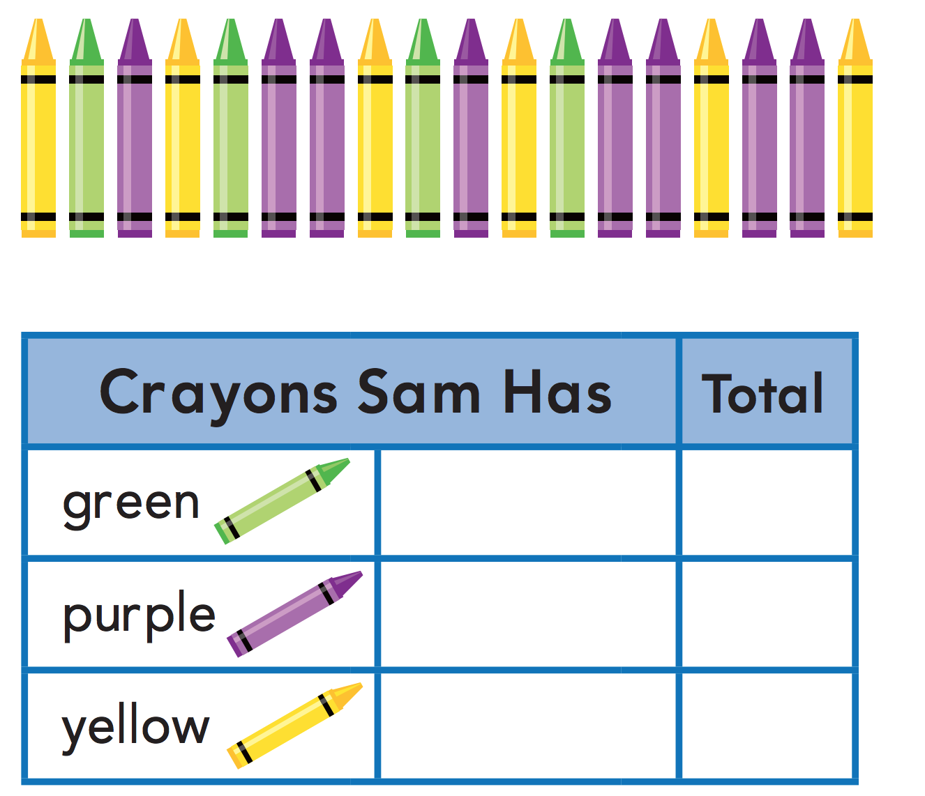

Make a tally chart to show the crayons.

Module 8 Lesson 4 Name: _____________________________

Make a tally chart to show the crayons.

Module 8 Lesson 5 Name: _____________________________

A bar graph shows the number of yellow daisies and the number of white daisies in a vase. Explain how to use the bars in the bar graph to find whether there are more white daisies or yellow daisies.

_________________________________________________________________________________________________________________________________________________________________________________________________________________________________________________________________________________________________________________________________________________________________________________________________________________________________________________________
Module 8 Lesson 5 Name: _____________________________

A bar graph shows the number of yellow daisies and the number of white daisies in a vase. Explain how to use the bars in the bar graph to find whether there are more white daisies or yellow daisies.

_________________________________________________________________________________________________________________________________________________________________________________________________________________________________________________________________________________________________________________________________________________________________________________________________________________________________________________________
Module 8 Lesson 6 Name: _____________________________

Write a question you can use the Favorite Frozen Yogurt bar graph to answer. Include the answer.

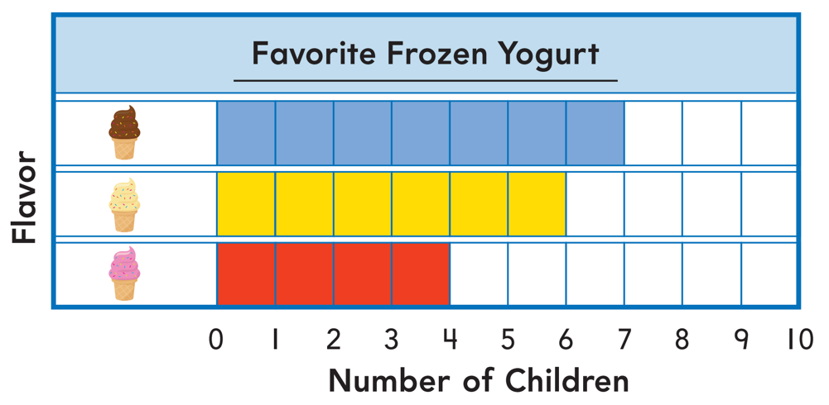

_____________________________________________________________________________________________________________________________________________________________________________________________________________________________________________________
Module 8 Lesson 6 Name: _____________________________

Write a question you can use the Favorite Frozen Yogurt bar graph to answer. Include the answer.

_____________________________________________________________________________________________________________________________________________________________________________________________________________________________________________________
Module 8 Lesson 7 Name: _____________________________

Mrs. Soluri found 6 green markers. She found 2 more red markers than green markers. She found 3 fewer blue markers than green markers.

Make a bar graph to represent the different markers Mrs. Soluri found.

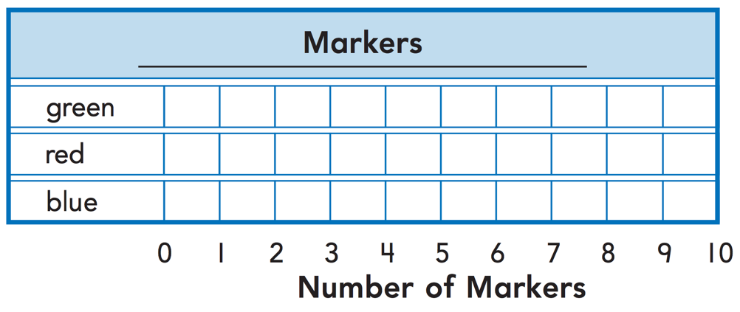

Module 8 Lesson 7 Name: _____________________________

Mrs. Soluri found 6 green markers. She found 2 more red markers than green markers. She found 3 fewer blue markers than green markers.

Make a bar graph to represent the different markers Mrs. Soluri found.

Module 9 Lesson 1 Name: _____________________________

Draw a quick picture to show the number 12.

Module 9 Lesson 1 Name: _____________________________

Draw a quick picture to show the number 12.

Module 9 Lesson 1 Name: _____________________________

Draw a quick picture to show the number 12.

Module 9 Lesson 1 Name: _____________________________

Draw a quick picture to show the number 12.

Module 9 Lesson 2 Name: _____________________________

Use a concrete or visual model to show how to write the number 14 as a ten and some ones.

Module 9 Lesson 2 Name: _____________________________

Use a concrete or visual model to show how to write the number 14 as a ten and some ones.

Module 9 Lesson 2 Name: _____________________________

Use a concrete or visual model to show how to write the number 14 as a ten and some ones.

Module 9 Lesson 2 Name: _____________________________

Use a concrete or visual model to show how to write the number 14 as a ten and some ones.

Module 9 Lesson 3 Name: _____________________________

Draw a quick picture to show the number 80. Identify the number of tens.

Module 9 Lesson 3 Name: _____________________________

Draw a quick picture to show the number 80. Identify the number of tens.

Module 9 Lesson 3 Name: _____________________________

Draw a quick picture to show the number 80. Identify the number of tens.

Module 9 Lesson 3 Name: _____________________________

Draw a quick picture to show the number 80. Identify the number of tens.

Module 10 Lesson 1 Name: ____________________________

Jessica plays a video game. She has a score of 96. Then she scores 5 more points. What is her score now?

Show how to count to solve.

Module 10 Lesson 1 Name: ____________________________

Jessica plays a video game. She has a score of 96. Then she scores 5 more points. What is her score now?

Show how to count to solve.

Module 10 Lesson 1 Name: ____________________________

Jessica plays a video game. She has a score of 96. Then she scores 5 more points. What is her score now?

Show how to count to solve.

Module 10 Lesson 1 Name: ____________________________

Jessica plays a video game. She has a score of 96. Then she scores 5 more points. What is her score now?

Show how to count to solve.

Module 10 Lesson 2 Name: _____________________________

Use objects to represent the number 26 as tens and ones. How many tens are there? How many ones?

Module 10 Lesson 2 Name: _____________________________

Use objects to represent the number 26 as tens and ones. How many tens are there? How many ones?

Module 10 Lesson 2 Name: _____________________________

Use objects to represent the number 26 as tens and ones. How many tens are there? How many ones?

Module 10 Lesson 2 Name: _____________________________

Use objects to represent the number 26 as tens and ones. How many tens are there? How many ones?

Module 10 Lesson 3 Name: _____________________________

Sara picks 49 cherries to make a pie.

Draw a quick picture to show the number of cherries.

How many tens are there? How many ones?

Module 10 Lesson 3 Name: _____________________________

Sara picks 49 cherries to make a pie.

Draw a quick picture to show the number of cherries.

How many tens are there? How many ones?

Module 10 Lesson 4 Name: _____________________________

Draw quick pictures to show the number 73 as tens and ones in two different ways.

Module 10 Lesson 4 Name: _____________________________

Draw quick pictures to show the number 73 as tens and ones in two different ways.

Module 10 Lesson 5 Name: _____________________________

Draw a quick picture to show 100.

Then draw to show 9 more.

What number does your quick picture show?

Module 10 Lesson 5 Name: _____________________________

Draw a quick picture to show 100.

Then draw to show 9 more.

What number does your quick picture show?

Module 10 Lesson 6 Name: _____________________________

Megan uses 11 tens 9 ones to represent a number. What is the number?

Module 10 Lesson 6 Name: _____________________________

Megan uses 11 tens 9 ones to represent a number. What is the number?

Module 10 Lesson 6 Name: _____________________________

Megan uses 11 tens 9 ones to represent a number. What is the number?

Module 10 Lesson 6 Name: _____________________________

Megan uses 11 tens 9 ones to represent a number. What is the number?

Module 11 Lesson 1 Name: _____________________________

Draw a quick picture to compare 32 and 23 using tens and ones. Then write which number is greater.

____________ is greater than ____________

Module 11 Lesson 1 Name: _____________________________

Draw a quick picture to compare 32 and 23 using tens and ones. Then write which number is greater.

____________ is greater than ____________

Module 11 Lesson 2 Name: _____________________________

Write two two-digit numbers. Draw quick pictures to show the numbers and circle the number that is less.

Module 11 Lesson 2 Name: _____________________________

Write two two-digit numbers. Draw quick pictures to show the numbers and circle the number that is less.

Module 11 Lesson 2 Name: _____________________________

Write two two-digit numbers. Draw quick pictures to show the numbers and circle the number that is less.

Module 11 Lesson 2 Name: _____________________________

Write two two-digit numbers. Draw quick pictures to show the numbers and circle the number that is less.

Module 11 Lesson 3 Name: _____________________________

Solve the riddle.

A number is not greater than 40.
A number is not less than 40.

What is the number?

Module 11 Lesson 3 Name: _____________________________

Solve the riddle.

A number is not greater than 40.
A number is not less than 40.

What is the number?

Module 11 Lesson 3 Name: _____________________________

Solve the riddle.

A number is not greater than 40.
A number is not less than 40.

What is the number?

Module 11 Lesson 3 Name: _____________________________

Solve the riddle.

A number is not greater than 40.
A number is not less than 40.

What is the number?

Module 11 Lesson 4 Name: _____________________________

Solve the riddle.

Miguel collects toy cars.
He has less than 40 toy cars.
He has more than 25 toy cars.
He does not have 30 toy cars.

How many cars could Miguel have?

Module 11 Lesson 4 Name: _____________________________

Solve the riddle.

Miguel collects toy cars.
He has less than 40 toy cars.
He has more than 25 toy cars.
He does not have 30 toy cars.

How many cars could Miguel have?

Module 11 Lesson 4 Name: _____________________________

Solve the riddle.

Miguel collects toy cars.
He has less than 40 toy cars.
He has more than 25 toy cars.
He does not have 30 toy cars.

How many cars could Miguel have?

Module 11 Lesson 4 Name: _____________________________

Solve the riddle.

Miguel collects toy cars.
He has less than 40 toy cars.
He has more than 25 toy cars.
He does not have 30 toy cars.

How many cars could Miguel have?

Module 12 Lesson 1 Name: _____________________________

There are 50 oranges and grapefruits on a table. 20 are oranges. How many grapefruits are there?

Show how to solve this problem using any method you know.

Module 12 Lesson 1 Name: _____________________________

There are 50 oranges and grapefruits on a table. 20 are oranges. How many grapefruits are there?

Show how to solve this problem using any method you know.

Module 12 Lesson 2 Name: _____________________________

Serena has 50 seashells. She gives some to Drew. Now she has 10 seashells. How many seashells does she give to Drew?

Show how to solve this problem using any method you know.

Module 12 Lesson 2 Name: _____________________________

Serena has 50 seashells. She gives some to Drew. Now she has 10 seashells. How many seashells does she give to Drew?

Show how to solve this problem using any method you know.

Module 12 Lesson 3 Name: _____________________________

Juanita found 30 rocks. She wants to have 50 rocks in all. How many more rocks does she need to find?

Show how to solve this problem using any method you know.

Module 12 Lesson 3 Name: _____________________________

Juanita found 30 rocks. She wants to have 50 rocks in all. How many more rocks does she need to find?

Show how to solve this problem using any method you know.

Module 12 Lesson 4 Name: _____________________________

22 + 10 = _____________

Explain how to use a hundred chart to solve the problem.

__________________________________________________________________________________________________
__________________________________________________________________________________________________
__________________________________________________________________________________________________
__________________________________________________________________________________________________
Module 12 Lesson 4 Name: _____________________________

22 + 10 = _____________

Explain how to use a hundred chart to solve the problem.

__________________________________________________________________________________________________
__________________________________________________________________________________________________
__________________________________________________________________________________________________
__________________________________________________________________________________________________
Module 12 Lesson 5 Name: _____________________________

Start with a number between 11 and 89. Add 1 or more tens to your number. Write an equation to show how you find sum.

Module 12 Lesson 5 Name: _____________________________

Start with a number between 11 and 89. Add 1 or more tens to your number. Write an equation to show how you find sum.

Module 12 Lesson 5 Name: _____________________________

Start with a number between 11 and 89. Add 1 or more tens to your number. Write an equation to show how you find sum.

Module 12 Lesson 5 Name: _____________________________

Start with a number between 11 and 89. Add 1 or more tens to your number. Write an equation to show how you find sum.

Module 12 Lesson 6 Name: _____________________________

Use the strategy make a ten to solve this equation.

25 + 9 = ___________

Module 12 Lesson 6 Name: _____________________________

Use the strategy make a ten to solve this equation.

25 + 9 = ___________

Module 12 Lesson 6 Name: _____________________________

Use the strategy make a ten to solve this equation.

25 + 9 = ___________

Module 12 Lesson 6 Name: _____________________________

Use the strategy make a ten to solve this equation.

25 + 9 = ___________

Module 12 Lesson 7 Name: _____________________________

Use the open number line to show your work using the strategy make a ten.

25 + 6 = ___________

Module 12 Lesson 7 Name: _____________________________

Use the open number line to show your work using the strategy make a ten.

25 + 6 = ___________

Module 12 Lesson 7 Name: _____________________________

Use the open number line to show your work using the strategy make a ten.

25 + 6 = ___________

Module 12 Lesson 7 Name: _____________________________

Use the open number line to show your work using the strategy make a ten.

25 + 6 = ___________

Module 12 Lesson 8 Name: _____________________________

Cindy has 17 goldfish. Buster has 10 more goldfish than Cindy. How many goldfish does Buster have?
Draw a picture to show and write how many.

Buster has ________ goldfish.

Module 12 Lesson 8 Name: _____________________________

Cindy has 17 goldfish. Buster has 10 more goldfish than Cindy. How many goldfish does Buster have?
Draw a picture to show and write how many.

Buster has ________ goldfish.

Module 13 Lesson 1 Name: _____________________________

Explain how to use a hundred chart to solve

12+20 =

__________________________________________________________________________________________________
__________________________________________________________________________________________________
__________________________________________________________________________________________________
__________________________________________________________________________________________________
_________________________________________________
Module 13 Lesson 1 Name: _____________________________

Explain how to use a hundred chart to solve

12+20 =

__________________________________________________________________________________________________
__________________________________________________________________________________________________
__________________________________________________________________________________________________
__________________________________________________________________________________________________
_________________________________________________
Module 13 Lesson 2 Name: _____________________________

Explain how to use tens and ones to add 59 and 16.

__________________________________________________________________________________________________
__________________________________________________________________________________________________
__________________________________________________________________________________________________
__________________________________________________________________________________________________
_________________________________________________
Module 13 Lesson 2 Name: _____________________________

Explain how to use tens and ones to add 59 and 16.

__________________________________________________________________________________________________
__________________________________________________________________________________________________
__________________________________________________________________________________________________
__________________________________________________________________________________________________
_________________________________________________
Module 13 Lesson 3 Name: _____________________________

Explain how to use tens and ones to subtract
80 – 20.

__________________________________________________________________________________________________
__________________________________________________________________________________________________
__________________________________________________________________________________________________
__________________________________________________________________________________________________
_________________________________________________
Module 13 Lesson 3 Name: _____________________________

Explain how to use tens and ones to subtract
80 – 20.

__________________________________________________________________________________________________
__________________________________________________________________________________________________
__________________________________________________________________________________________________
__________________________________________________________________________________________________
_________________________________________________
Module 13 Lesson 4 Name: _____________________________

Tell how you know whether to add or subtract to solve. Then solve the problem.

I have 23 pencils and 30 markers. How many pencils and markers do I have?

__________________________________________________________________________________________________
__________________________________________________________________________________________________
__________________________________________________________________________________________________
_________________________________________________
Module 13 Lesson 4 Name: _____________________________

Tell how you know whether to add or subtract to solve. Then solve the problem.

I have 23 pencils and 30 markers. How many pencils and markers do I have?

__________________________________________________________________________________________________
__________________________________________________________________________________________________
__________________________________________________________________________________________________
_________________________________________________
Module 13 Lesson 5 Name: _____________________________

Explain a strategy you would use to solve this problem:
I have 14 marbles. I give 7 marbles to my brother. How many marbles do I have left?

__________________________________________________________________________________________________
__________________________________________________________________________________________________
__________________________________________________________________________________________________
_________________________________________________
Module 13 Lesson 5 Name: _____________________________

Explain a strategy you would use to solve this problem:
I have 14 marbles. I give 7 marbles to my brother. How many marbles do I have left?

__________________________________________________________________________________________________
__________________________________________________________________________________________________
__________________________________________________________________________________________________
_________________________________________________
Module 13 Lesson 5 Name: _____________________________

What is 13 + 60?

Module 13 Lesson 5 Name: _____________________________

What is 13 + 60?

Module 13 Lesson 5 Name: _____________________________

What is 13 + 60?

Module 13 Lesson 5 Name: _____________________________

What is 13 + 60?

Module 14 Lesson 1 Name: _____________________________

Kathryn has a three-dimensional shape that only has flat surfaces. What shape could she have?

__________________________________________________________________________________________________

Module 14 Lesson 1 Name: _____________________________

Kathryn has a three-dimensional shape that only has flat surfaces. What shape could she have?

__________________________________________________________________________________________________

Module 14 Lesson 1 Name: _____________________________

Kathryn has a three-dimensional shape that only has flat surfaces. What shape could she have?

__________________________________________________________________________________________________

Module 14 Lesson 1 Name: _____________________________

Kathryn has a three-dimensional shape that only has flat surfaces. What shape could she have?

__________________________________________________________________________________________________

Module 14 Lesson 2 Name: _____________________________

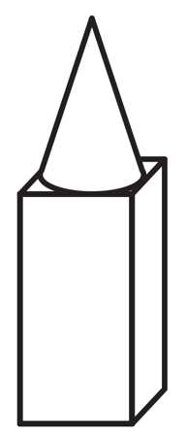

How can you combine shapes to make this shape?

_________________________________________________
_________________________________________________
_________________________________________________
_________________________________________________
_________________________________________________
_________________________________________________
_________________________________________________
Module 14 Lesson 2 Name: _____________________________

How can you combine shapes to make this shape?

_________________________________________________
_________________________________________________
_________________________________________________
_________________________________________________
_________________________________________________
_________________________________________________
_________________________________________________
Module 14 Lesson 3 Name: _____________________________

Armando combines 2 cylinders. He stacks them so the flat surfaces touch. Jackie make the same combined shape. If Armando and Jackie put their combined shapes together, what might their new shape look like? Explain.

_________________________________________________
_________________________________________________
_________________________________________________
_________________________________________________
_________________________________________________
_________________________________________________
_________________________________________________
_________________________________________________
_________________________________________________
Module 14 Lesson 3 Name: _____________________________

Armando combines 2 cylinders. He stacks them so the flat surfaces touch. Jackie make the same combined shape. If Armando and Jackie put their combined shapes together, what might their new shape look like? Explain.

_________________________________________________
_________________________________________________
_________________________________________________
_________________________________________________
_________________________________________________
_________________________________________________
_________________________________________________
_________________________________________________
_________________________________________________
Module 14 Lesson 3 Name: _____________________________

Draw an object that has the shape of a cylinder.

Module 14 Lesson 3 Name: _____________________________

Draw an object that has the shape of a cylinder.

Module 14 Lesson 3 Name: _____________________________

Draw an object that has the shape of a cylinder.

Module 14 Lesson 3 Name: _____________________________

Draw an object that has the shape of a cylinder.

Module15 Lesson 1 Name: _____________________________

Sandra uses two-dimensional shapes with straight sides to make cards. Name some two-dimensional shapes that have straight sides.

_________________________________________________
_________________________________________________
_________________________________________________

Module15 Lesson 1 Name: _____________________________

Sandra uses two-dimensional shapes with straight sides to make cards. Name some two-dimensional shapes that have straight sides.

_________________________________________________
_________________________________________________
_________________________________________________
Module15 Lesson 1 Name: _____________________________

Sandra uses two-dimensional shapes with straight sides to make cards. Name some two-dimensional shapes that have straight sides.

_________________________________________________
_________________________________________________
_________________________________________________

Module15 Lesson 1 Name: _____________________________

Sandra uses two-dimensional shapes with straight sides to make cards. Name some two-dimensional shapes that have straight sides.

_________________________________________________
_________________________________________________
_________________________________________________
Module 15 Lesson 2 Name: _____________________________

Marcus uses straight lines to draw two-dimensional shapes. Name four shapes he can draw.

_________________________________________________
_________________________________________________
_________________________________________________
_________________________________________________
Module 15 Lesson 2 Name: _____________________________

Marcus uses straight lines to draw two-dimensional shapes. Name four shapes he can draw.

_________________________________________________
_________________________________________________
_________________________________________________
_________________________________________________
Module 15 Lesson 3 Name: _____________________________

Combine shapes to make a trapezoid.

Module 15 Lesson 3 Name: _____________________________

Combine shapes to make a trapezoid.

Module 15 Lesson 3 Name: _____________________________

Combine shapes to make a trapezoid.

Module 15 Lesson 3 Name: _____________________________

Combine shapes to make a trapezoid.

Module 15 Lesson 4 Name: _____________________________

Draw to show how to combine four or more different shapes to make a new larger shape.

Module 15 Lesson 4 Name: _____________________________

Draw to show how to combine four or more different shapes to make a new larger shape.

Module 15 Lesson 5 Name: _____________________________

Draw to show the steps.
• Combine two shapes.
• Repeat the combined shape.
• Put the two combined shapes together to make a new larger shape.

Module 15 Lesson 5 Name: _____________________________

Draw to show the steps.
• Combine two shapes.
• Repeat the combined shape.
• Put the two combined shapes together to make a new larger shape.

Module 16 Lesson 1 Name: _____________________________

Draw a square that has been made by two shapes that are the same size and shape.

Module 16 Lesson 1 Name: _____________________________

Draw a square that has been made by two shapes that are the same size and shape.

Module 16 Lesson 1 Name: _____________________________

Draw a square that has been made by two shapes that are the same size and shape.

Module 16 Lesson 1 Name: _____________________________

Draw a square that has been made by two shapes that are the same size and shape.

Module 16 Lesson 2 Name: _____________________________

Draw a circle. Then draw a line in the circle to show two unequal shares.

Module 16 Lesson 2 Name: _____________________________

Draw a circle. Then draw a line in the circle to show two unequal shares.

Module 16 Lesson 2 Name: _____________________________

Draw a circle. Then draw a line in the circle to show two unequal shares.

Module 16 Lesson 2 Name: _____________________________

Draw a circle. Then draw a line in the circle to show two unequal shares.

Module 16 Lesson 3 Name: _____________________________

Draw a rectangle. Draw a line to make halves. Color half of the rectangle.

Module 16 Lesson 3 Name: _____________________________

Draw a rectangle. Draw a line to make halves. Color half of the rectangle.

Module 16 Lesson 3 Name: _____________________________

Draw a rectangle. Draw a line to make halves. Color half of the rectangle.

Module 16 Lesson 3 Name: _____________________________

Draw a rectangle. Draw a line to make halves. Color half of the rectangle.

Module 16 Lesson 4 Name: _____________________________

Draw a square. Draw lines to make quarters. Color one quarter of the square.

Module 16 Lesson 4 Name: _____________________________

Draw a square. Draw lines to make quarters. Color one quarter of the square.

Module 16 Lesson 4 Name: _____________________________

Draw a square. Draw lines to make quarters. Color one quarter of the square.

Module 16 Lesson 4 Name: _____________________________

Draw a square. Draw lines to make quarters. Color one quarter of the square.

Module 17 Lesson 1 Name: _____________________________

You have three pencils of different lengths. Draw a picture to order the pencils from longest to shortest.

Module 17 Lesson 1 Name: _____________________________

You have three pencils of different lengths. Draw a picture to order the pencils from longest to shortest.

Module 17 Lesson 2 Name: _____________________________

The shelf is longer than the string. The book is shorter than the string. Is the book longer or shorter than the shelf?

_________________________________________________
_________________________________________________
_________________________________________________
_________________________________________________

Module 17 Lesson 2 Name: _____________________________

The shelf is longer than the string. The book is shorter than the string. Is the book longer or shorter than the shelf?

_________________________________________________
_________________________________________________
_________________________________________________
_________________________________________________
Module 17 Lesson 2 Name: _____________________________

The shelf is longer than the string. The book is shorter than the string. Is the book longer or shorter than the shelf?

_________________________________________________
_________________________________________________
_________________________________________________
_________________________________________________

Module 17 Lesson 2 Name: _____________________________

The shelf is longer than the string. The book is shorter than the string. Is the book longer or shorter than the shelf?

_________________________________________________
_________________________________________________
_________________________________________________
_________________________________________________
Module 17 Lesson 3 Name: _____________________________

Measure the object using nonstandard units. How long is a pencil?

About ___________ units

Module 17 Lesson 3 Name: _____________________________

Measure the object using nonstandard units. How long is a pencil?

About ___________ units

Module 17 Lesson 3 Name: _____________________________

Measure the object using nonstandard units. How long is a pencil?

About ___________ units

Module 17 Lesson 3 Name: _____________________________

Measure the object using nonstandard units. How long is a pencil?

About ___________ units

Module 17 Lesson 4 Name: _____________________________

Measure a crayon using a nonstandard measuring tool. How many units long is the crayon?

About ___________ units

Module 17 Lesson 4 Name: _____________________________

Measure a crayon using a nonstandard measuring tool. How many units long is the crayon?

About ___________ units

Module 17 Lesson 4 Name: _____________________________

Measure a crayon using a nonstandard measuring tool. How many units long is the crayon?

About ___________ units

Module 17 Lesson 4 Name: _____________________________

Measure a crayon using a nonstandard measuring tool. How many units long is the crayon?

About ___________ units

Module 18 Lesson 1 Name: _____________________________

The hour hand points to the 3.

The time is ________ o’clock.

The hour hand points to the ________.
The time is 4:00.

Module 18 Lesson 1 Name: _____________________________

The hour hand points to the 3.

The time is ________ o’clock.

The hour hand points to the ________.
The time is 4:00.

Module 18 Lesson 1 Name: _____________________________

The hour hand points to the 3.

The time is ________ o’clock.

The hour hand points to the ________.
The time is 4:00.

Module 18 Lesson 1 Name: _____________________________

The hour hand points to the 3.

The time is ________ o’clock.

The hour hand points to the ________.
The time is 4:00.

Module 18 Lesson 2 Name: _____________________________

The hour hand points halfway between the 9 and 10.

The time is half past _______ o'clock.

The hour hand points halfway between

the _______ and ________. The time is half past 7 o'clock.

Module 18 Lesson 2 Name: _____________________________

The hour hand points halfway between the 9 and 10.

The time is half past _______ o'clock.

The hour hand points halfway between

the _______ and ________. The time is half past 7 o'clock.

Module 18 Lesson 2 Name: _____________________________

The hour hand points halfway between the 9 and 10.

The time is half past _______ o'clock.

The hour hand points halfway between

the _______ and ________. The time is half past 7 o'clock.

Module 18 Lesson 2 Name: _____________________________

The hour hand points halfway between the 9 and 10.

The time is half past _______ o'clock.

The hour hand points halfway between

the _______ and ________. The time is half past 7 o'clock.

Module 18 Lesson 3 Name: _____________________________

Jessica rides her bike to school. She leaves her home at 8:30. Draw to show the time.
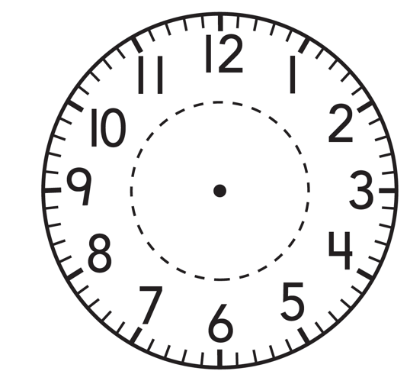

Module 18 Lesson 3 Name: _____________________________

Jessica rides her bike to school. She leaves her home at 8:30. Draw to show the time.
Module 18 Lesson 3 Name: _____________________________

Jessica rides her bike to school. She leaves her home at 8:30. Draw to show the time.

Module 18 Lesson 3 Name: _____________________________

Jessica rides her bike to school. She leaves her home at 8:30. Draw to show the time.

Module 18 Lesson 4 Name: _____________________________

The hour hand points between 1 and 2. The minute hand points to the 6. What is the time?

Module 18 Lesson 4 Name: _____________________________

The hour hand points between 1 and 2. The minute hand points to the 6. What is the time?

Module 18 Lesson 4 Name: _____________________________

The hour hand points between 1 and 2. The minute hand points to the 6. What is the time?

Module 18 Lesson 4 Name: _____________________________

The hour hand points between 1 and 2. The minute hand points to the 6. What is the time?

