Grade 2

Exit Tickets

This document contains printable and customizable versions of the Exit Tickets recommended
in the Into Math Teacher Edition. The Exit Ticket is also available as a Projectable PDF on
Ed: Your Friend in Learning.

Exit Tickets are an optional way to wrap up a lesson. The problem provided for each lesson assesses
whether students grasped the lesson content.

To save paper when printing, the document is formatted with 2 to a page for some lessons and 4 to a page
in other lessons, based on the space students will likely need to answer the question(s).

Copyright © by Houghton Mifflin Harcourt Publishing Company
All rights reserved. No part of the material protected by this copyright may be reproduced or utilized in any form or by any means, electronic or mechanical, including photocopying, recording, broadcasting or by any other information storage and retrieval system, without written permission of the copyright owner unless such copying is expressly permitted by federal copyright law.
Only those pages that are specifically enabled by the program and indicated by the presence of the print icon may be printed and reproduced in classroom quantities by individual teachers using the corresponding student’s textbook or kit as the major vehicle for regular classroom instruction. Requests for information on other matters regarding duplication of this work should be submitted through our Permissions website at https://customercare.hmhco.com/contactus/Permissions.html or mailed to Houghton Mifflin Harcourt Publishing Company, Attn: Compliance, Contracts, and Licensing, 9400 Southpark Center Loop, Orlando, Florida 32819-8647.
HOUGHTON MIFFLIN HARCOURT and the HMH Logo are trademarks and service marks of Houghton Mifflin Harcourt Publishing Company. You shall not display, disparage, dilute or taint Houghton Mifflin Harcourt trademarks and service marks or use any confusingly similar marks, or use Houghton Mifflin Harcourt marks in such a way that would misrepresent the identity of the owner. Any permitted use of Houghton Mifflin Harcourt trademarks and service marks inures to the benefit of Houghton Mifflin Harcourt Publishing Company.
All other trademarks, service marks or registered trademarks appearing on Houghton Mifflin Harcourt Publishing Company websites are the trademarks or service marks of their respective owners.

Module 1 Lesson 1 Name: _____________________________

Paula records 5 songs. Then she records 6 more songs. She uses the doubles fact 5 + 5 = 10 and then subtracts 1 to find the sum.

Explain the error Paula made. Then find the total number of songs she recorded.

__________________________________________________________________________________________________
__________________________________________________________________________________________________
__________________________________________________________________________________________________
__________________________________________________________________________________________________
_________________________________________________
Module 1 Lesson 1 Name: _____________________________

Paula records 5 songs. Then she records 6 more songs. She uses the doubles fact 5 + 5 = 10 and then subtracts 1 to find the sum.

Explain the error Paula made. Then find the total number of songs she recorded.

__________________________________________________________________________________________________
__________________________________________________________________________________________________
__________________________________________________________________________________________________
__________________________________________________________________________________________________
_________________________________________________
Module 1 Lesson 2 Name: _____________________________

There are 9 ladybugs on a plant. There are 3 ladybugs on another plant. How many ladybugs are on both plants?

Module 1 Lesson 2 Name: _____________________________

There are 9 ladybugs on a plant. There are 3 ladybugs on another plant. How many ladybugs are on both plants?

Module 1 Lesson 2 Name: _____________________________

There are 9 ladybugs on a plant. There are 3 ladybugs on another plant. How many ladybugs are on both plants?

Module 1 Lesson 2 Name: _____________________________

There are 9 ladybugs on a plant. There are 3 ladybugs on another plant. How many ladybugs are on both plants?

Module 1 Lesson 3 Name: _____________________________

Benjamin plants 5 trees on Saturday and 7 trees on Sunday. How many trees does he plant on the two days?

Write an addition fact. Complete the bar model. Write a related subtraction fact. Solve.

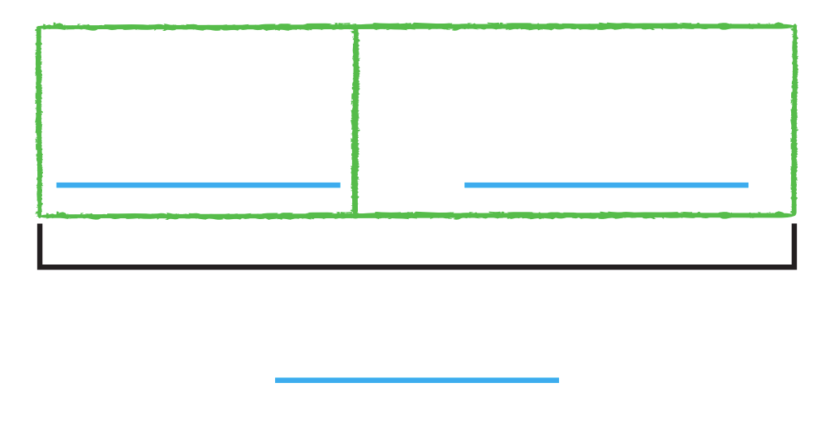

Module 1 Lesson 3 Name: _____________________________

Benjamin plants 5 trees on Saturday and 7 trees on Sunday. How many trees does he plant on the two days?

Write an addition fact. Complete the bar model. Write a related subtraction fact. Solve.

Module 1 Lesson 4 Name: _____________________________

Hank read 11 books. Karen read 3 books. Explain how to count back to find how many more books Hank read. Then solve the problem.

Module 1 Lesson 4 Name: _____________________________

Hank read 11 books. Karen read 3 books. Explain how to count back to find how many more books Hank read. Then solve the problem.

Module 1 Lesson 4 Name: _____________________________

Hank read 11 books. Karen read 3 books. Explain how to count back to find how many more books Hank read. Then solve the problem.

Module 1 Lesson 4 Name: _____________________________

Hank read 11 books. Karen read 3 books. Explain how to count back to find how many more books Hank read. Then solve the problem.

Module 1 Lesson 5 Name: _____________________________

Julie has 7 tickets to the football game. She buys 6 more. How many tickets does she have now?

Module 1 Lesson 5 Name: _____________________________

Julie has 7 tickets to the football game. She buys 6 more. How many tickets does she have now?

Module 1 Lesson 5 Name: _____________________________

Julie has 7 tickets to the football game. She buys 6 more. How many tickets does she have now?

Module 1 Lesson 5 Name: _____________________________

Julie has 7 tickets to the football game. She buys 6 more. How many tickets does she have now?

Module 1 Lesson 6 Name: _____________________________

There are 15 kayaks on the lake. There are 7 blue kayaks. The rest are red. How many kayaks are red? Use a number line to show how you can make a ten to subtract.

Module 1 Lesson 6 Name: _____________________________

There are 15 kayaks on the lake. There are 7 blue kayaks. The rest are red. How many kayaks are red? Use a number line to show how you can make a ten to subtract.

Module 1 Lesson 6 Name: _____________________________

There are 15 kayaks on the lake. There are 7 blue kayaks. The rest are red. How many kayaks are red? Use a number line to show how you can make a ten to subtract.

Module 1 Lesson 6 Name: _____________________________

There are 15 kayaks on the lake. There are 7 blue kayaks. The rest are red. How many kayaks are red? Use a number line to show how you can make a ten to subtract.

Module 1 Lesson 7 Name: _____________________________

Jenna has 3 bags. There are 4 books in the first bag, 5 books in the second bag, and 6 books in the third bag. How many books does she have altogether? Explain how you solved the problem.

Module 1 Lesson 7 Name: _____________________________

Jenna has 3 bags. There are 4 books in the first bag, 5 books in the second bag, and 6 books in the third bag. How many books does she have altogether? Explain how you solved the problem.

Module 1 Lesson 7 Name: _____________________________

Jenna has 3 bags. There are 4 books in the first bag, 5 books in the second bag, and 6 books in the third bag. How many books does she have altogether? Explain how you solved the problem.

Module 1 Lesson 7 Name: _____________________________

Jenna has 3 bags. There are 4 books in the first bag, 5 books in the second bag, and 6 books in the third bag. How many books does she have altogether? Explain how you solved the problem.
Module 2 Lesson 1 Name: _____________________________

Manny blows 7 bubbles. Use tools to show 7 bubbles. Make pairs. Write even or odd .

Module 2 Lesson 1 Name: _____________________________

Manny blows 7 bubbles. Use tools to show 7 bubbles. Make pairs. Write even or odd .

Module 2 Lesson 1 Name: _____________________________

Manny blows 7 bubbles. Use tools to show 7 bubbles. Make pairs. Write even or odd .

Module 2 Lesson 1 Name: _____________________________

Manny blows 7 bubbles. Use tools to show 7 bubbles. Make pairs. Write even or odd .

Module 2 Lesson 2 Name: _____________________________

Use tools to show 16. Make two equal groups. Then write an addition equation to show the number as the sum of two equal addends.

_________ + _________ = _________

Module 2 Lesson 2 Name: _____________________________

Use tools to show 16. Make two equal groups. Then write an addition equation to show the number as the sum of two equal addends.

_________ + _________ = _________

Module 2 Lesson 3 Name: _____________________________

Nina puts pears in 4 rows. She puts 5 pears in each row. How many pears are there? Use tools or draw to solve.

_________ pears

Module 2 Lesson 3 Name: _____________________________

Nina puts pears in 4 rows. She puts 5 pears in each row. How many pears are there? Use tools or draw to solve.

_________ pears

Module 2 Lesson 4 Name: _____________________________

Find the number of rows and the number of objects in each row. Then write an addition equation to find the total.

Module 2 Lesson 4 Name: _____________________________

Find the number of rows and the number of objects in each row. Then write an addition equation to find the total.

Module 2 Lesson 4 Name: _____________________________

Find the number of rows and the number of objects in each row. Then write an addition equation to find the total.

Module 2 Lesson 4 Name: _____________________________

Find the number of rows and the number of objects in each row. Then write an addition equation to find the total.

Module 2 Lesson 5 Name: _____________________________

Find the number of rows and the number of objects in each row. Then write an addition equation to find the total.

Module 2 Lesson 5 Name: _____________________________

Find the number of rows and the number of objects in each row. Then write an addition equation to find the total.

Module 2 Lesson 5 Name: _____________________________

Find the number of rows and the number of objects in each row. Then write an addition equation to find the total.

Module 2 Lesson 5 Name: _____________________________

Find the number of rows and the number of objects in each row. Then write an addition equation to find the total.

Module 3 Lesson 1 Name: _____________________________

Ask 10 classmates to tell how they get to school. Record the data in a tally chart.

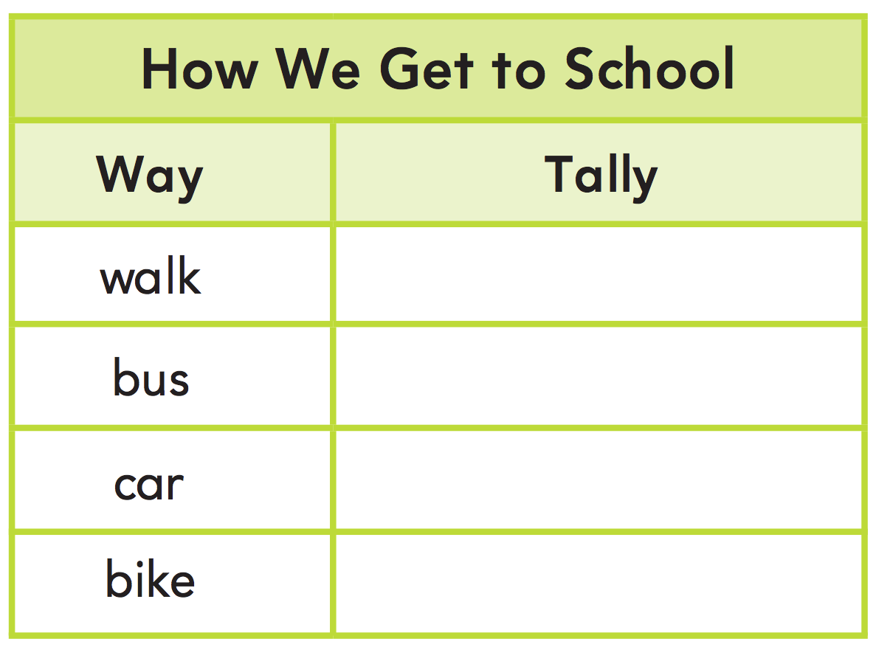

Module 3 Lesson 1 Name: _____________________________

Ask 10 classmates to tell how they get to school. Record the data in a tally chart.

Module 3 Lesson 2 Name: _____________________________

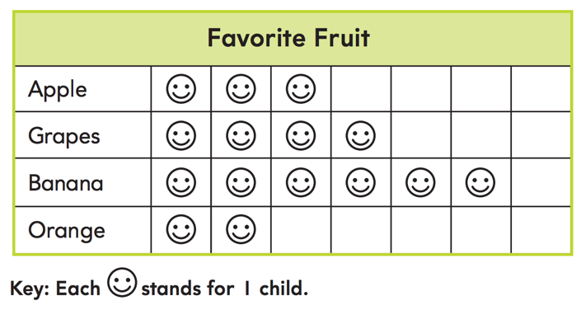

How many children chose a favorite fruit?

Module 3 Lesson 2 Name: _____________________________

How many children chose a favorite fruit?

Module 3 Lesson 2 Name: _____________________________

How many children chose a favorite fruit?

Module 3 Lesson 2 Name: _____________________________

How many children chose a favorite fruit?

Module 3 Lesson 3 Name: _____________________________

While playing a game, Tisha scored 7 points, Juan scored 5 points, Christie scored 8 points, and Arun scored 4 points. Draw a picture graph to show the data.
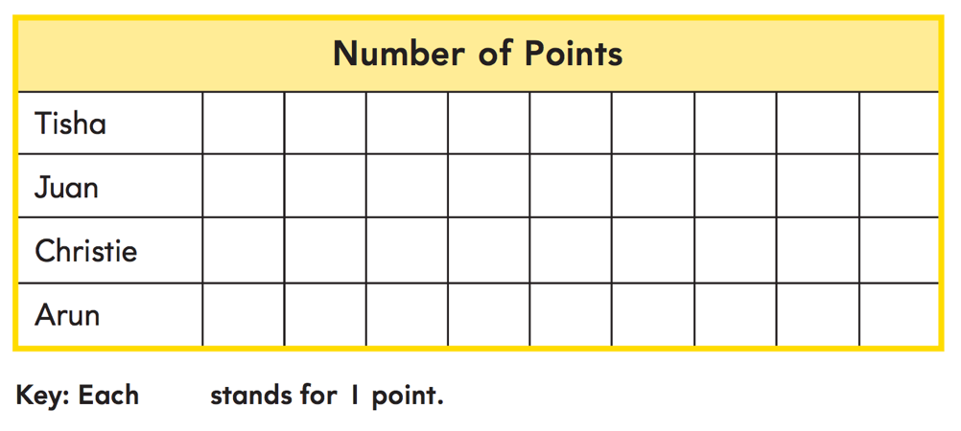

Module 3 Lesson 3 Name: _____________________________

While playing a game, Tisha scored 7 points, Juan scored 5 points, Christie scored 8 points, and Arun scored 4 points. Draw a picture graph to show the data.
Module 3 Lesson 3 Name: _____________________________

While playing a game, Tisha scored 7 points, Juan scored 5 points, Christie scored 8 points, and Arun scored 4 points. Draw a picture graph to show the data.

Module 3 Lesson 3 Name: _____________________________

While playing a game, Tisha scored 7 points, Juan scored 5 points, Christie scored 8 points, and Arun scored 4 points. Draw a picture graph to show the data.
Module 3 Lesson 4 Name: _____________________________

Use the bar graph to solve the problem.

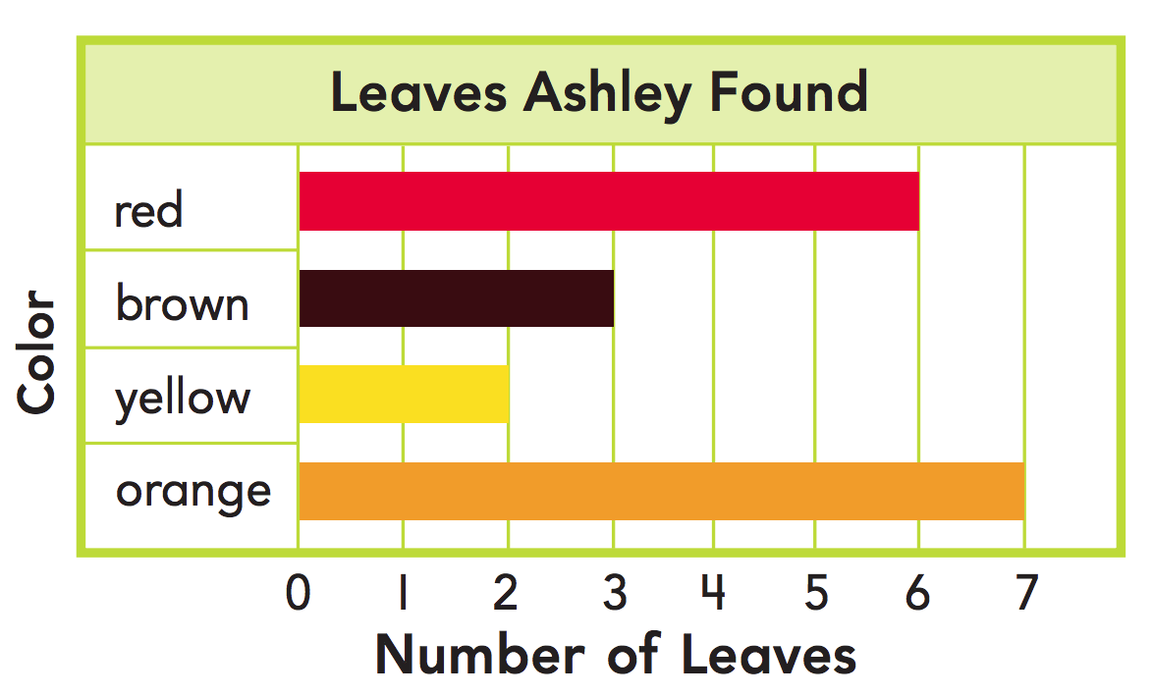

How many more orange leaves than brown leaves did Ashley find?

Module 3 Lesson 4 Name: _____________________________

Use the bar graph to solve the problem.

How many more orange leaves than brown leaves did Ashley find?

Module 3 Lesson 5 Name: _____________________________

Carlos made 3 goals on Monday, 4 goals on Tuesday, 2 goals on Wednesday, and 4 goals on Thursday. Draw a bar graph.

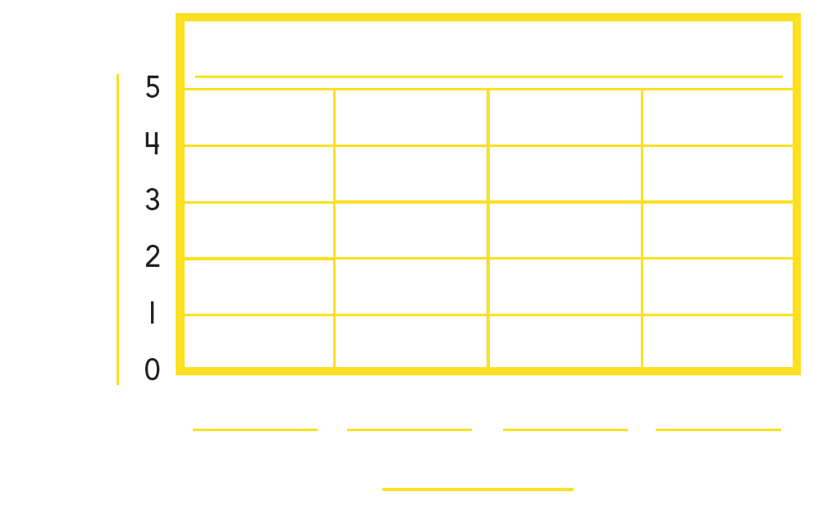

Module 3 Lesson 5 Name: _____________________________

Carlos made 3 goals on Monday, 4 goals on Tuesday, 2 goals on Wednesday, and 4 goals on Thursday. Draw a bar graph.

Module 4 Lesson 1 Name: _____________________________

Stickers come in packs of ten. John has 300 stickers. How many packets of stickers does John have?

Module 4 Lesson 1 Name: _____________________________

Stickers come in packs of ten. John has 300 stickers. How many packets of stickers does John have?

Module 4 Lesson 1 Name: _____________________________

Stickers come in packs of ten. John has 300 stickers. How many packets of stickers does John have?

Module 4 Lesson 1 Name: _____________________________

Stickers come in packs of ten. John has 300 stickers. How many packets of stickers does John have?

Module 4 Lesson 2 Name: _____________________________

Jimmy has 21 boxes of pens. Each box has 10 pens. How many pens are in the boxes? What is the digit in the tens place?

Module 4 Lesson 2 Name: _____________________________

Jimmy has 21 boxes of pens. Each box has 10 pens. How many pens are in the boxes? What is the digit in the tens place?

Module 4 Lesson 2 Name: _____________________________

Jimmy has 21 boxes of pens. Each box has 10 pens. How many pens are in the boxes? What is the digit in the tens place?

Module 4 Lesson 2 Name: _____________________________

Jimmy has 21 boxes of pens. Each box has 10 pens. How many pens are in the boxes? What is the digit in the tens place?

Module 4 Lesson 3 Name: _____________________________

Ms. Walker is buying snacks. There are 10 bags in a box. If Ms. Walker buys 13 boxes, how many bags of snacks did she buy?

Module 4 Lesson 3 Name: _____________________________

Ms. Walker is buying snacks. There are 10 bags in a box. If Ms. Walker buys 13 boxes, how many bags of snacks did she buy?

Module 4 Lesson 3 Name: _____________________________

Ms. Walker is buying snacks. There are 10 bags in a box. If Ms. Walker buys 13 boxes, how many bags of snacks did she buy?

Module 4 Lesson 3 Name: _____________________________

Ms. Walker is buying snacks. There are 10 bags in a box. If Ms. Walker buys 13 boxes, how many bags of snacks did she buy?

Module 4 Lesson 4 Name: _____________________________

Show the number 309 with base-ten blocks.

Module 4 Lesson 4 Name: _____________________________

Show the number 309 with base-ten blocks.

Module 4 Lesson 4 Name: _____________________________

Show the number 309 with base-ten blocks.

Module 4 Lesson 4 Name: _____________________________

Show the number 309 with base-ten blocks.

Module 4 Lesson 5 Name: _____________________________

Write a number with a 2 in the ones place, a 5 in the hundreds place, and a 6 in the tens place.

Module 4 Lesson 5 Name: _____________________________

Write a number with a 2 in the ones place, a 5 in the hundreds place, and a 6 in the tens place.

Module 4 Lesson 5 Name: _____________________________

Write a number with a 2 in the ones place, a 5 in the hundreds place, and a 6 in the tens place.

Module 4 Lesson 5 Name: _____________________________

Write a number with a 2 in the ones place, a 5 in the hundreds place, and a 6 in the tens place.

Module 5 Lesson 1 Name: _____________________________

Shondra has 238 stickers in her collection. Show how many stickers Shondra has in different ways.

_________ hundreds _________ tens _________ ones

__________ + __________ + __________

Shondra has __________ stickers.

Module 5 Lesson 1 Name: _____________________________

Shondra has 238 stickers in her collection. Show how many stickers Shondra has in different ways.

_________ hundreds _________ tens _________ ones

__________ + __________ + __________

Shondra has __________ stickers.

Module 5 Lesson 2 Name: _____________________________

Talia has 187 seeds. Draw a quick picture to show how many seeds Talia has and then write the number name.

__________________________________________________________________________________________________________
__________________________________________________________________________________________________________
Module 5 Lesson 2 Name: _____________________________

Talia has 187 seeds. Draw a quick picture to show how many seeds Talia has and then write the number name.

__________________________________________________________________________________________________________
__________________________________________________________________________________________________________
Module 5 Lesson 3 Name: _____________________________

Caitlyn has one hundred eighteen blocks. Use expanded form to show how many blocks Caitlyn has.

__________ + __________ + __________ = __________

Module 5 Lesson 3 Name: _____________________________

Caitlyn has one hundred eighteen blocks. Use expanded form to show how many blocks Caitlyn has.

__________ + __________ + __________ = __________

Module 5 Lesson 3 Name: _____________________________

Caitlyn has one hundred eighteen blocks. Use expanded form to show how many blocks Caitlyn has.

__________ + __________ + __________ = __________

Module 5 Lesson 3 Name: _____________________________

Caitlyn has one hundred eighteen blocks. Use expanded form to show how many blocks Caitlyn has.

__________ + __________ + __________ = __________

Module 5 Lesson 4 Name: _____________________________

Chloe has three hundred sixty-two stickers. Draw quick pictures to show the number of stickers in two different ways.

_________ hundreds _________ tens _________ ones

_________ hundreds _________ tens _________ ones

Module 5 Lesson 4 Name: _____________________________

Chloe has three hundred sixty-two stickers. Draw quick pictures to show the number of stickers in two different ways.

_________ hundreds _________ tens _________ ones

_________ hundreds _________ tens _________ ones

Module 5 Lesson 5 Name: _____________________________

Find the blue dot on the number line. Then write the number marked by the dot in two different ways.

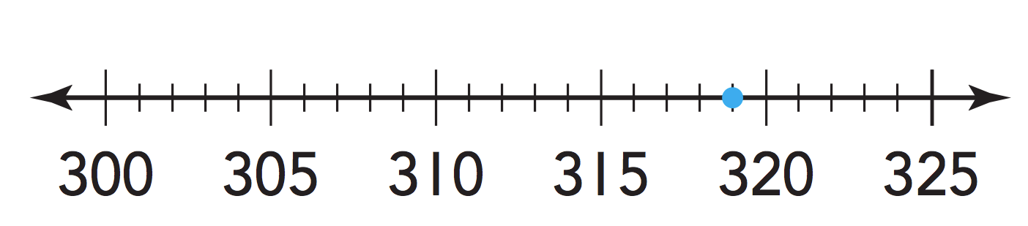

__________________________________________________________________________________________________________
__________________________________________________________________________________________________________
__________________________________________________________________________________________________________
__________________________________________________________________________________________________________
Module 5 Lesson 5 Name: _____________________________

Find the blue dot on the number line. Then write the number marked by the dot in two different ways.

__________________________________________________________________________________________________________
__________________________________________________________________________________________________________
__________________________________________________________________________________________________________
__________________________________________________________________________________________________________
Module 6 Lesson 1 Name: _____________________________

Extend this counting sequence by counting by tens:

740, 750, 760, __________, _________, _________

Module 6 Lesson 1 Name: _____________________________

Extend this counting sequence by counting by tens:

740, 750, 760, __________, _________, _________

Module 6 Lesson 1 Name: _____________________________

Extend this counting sequence by counting by tens:

740, 750, 760, __________, _________, _________

Module 6 Lesson 1 Name: _____________________________

Extend this counting sequence by counting by tens:

740, 750, 760, __________, _________, _________

Module 6 Lesson 2 Name: _____________________________

Make a number that is 100 more than 235. Then make a number that is 10 less. The answer is your exit ticket:

Module 6 Lesson 2 Name: _____________________________

Make a number that is 100 more than 235. Then make a number that is 10 less. The answer is your exit ticket:

Module 6 Lesson 2 Name: _____________________________

Make a number that is 100 more than 235. Then make a number that is 10 less. The answer is your exit ticket:

Module 6 Lesson 2 Name: _____________________________

Make a number that is 100 more than 235. Then make a number that is 10 less. The answer is your exit ticket:

Module 6 Lesson 3 Name: _____________________________

Complete the pattern.

741, 641, 541, __________, _________, _________

Module 6 Lesson 3 Name: _____________________________

Complete the pattern.

741, 641, 541, __________, _________, _________

Module 6 Lesson 3 Name: _____________________________

Complete the pattern.

741, 641, 541, __________, _________, _________

Module 6 Lesson 3 Name: _____________________________

Complete the pattern.

741, 641, 541, __________, _________, _________

Module 6 Lesson 4 Name: _____________________________

Sam and Van are comparing the numbers 184 and 235. Sam says, “184 is greater than 235 because it contains 8, which is the greatest number.” Van says, “235 is greater than 184 because it has 2 hundreds and 184 only has 1 hundred.” Who is right, Sam or Van? Explain.

__________________________________________________________________________________________________________
__________________________________________________________________________________________________________
__________________________________________________________________________________________________________
__________________________________________________________________________________________________________
Module 6 Lesson 4 Name: _____________________________

Sam and Van are comparing the numbers 184 and 235. Sam says, “184 is greater than 235 because it contains 8, which is the greatest number.” Van says, “235 is greater than 184 because it has 2 hundreds and 184 only has 1 hundred.” Who is right, Sam or Van? Explain.

__________________________________________________________________________________________________________
__________________________________________________________________________________________________________
__________________________________________________________________________________________________________
__________________________________________________________________________________________________________
Module 6 Lesson 5 Name: _____________________________

What symbol completes this comparison?

347 _______ 385

Module 6 Lesson 5 Name: _____________________________

What symbol completes this comparison?

347 _______ 385

Module 6 Lesson 5 Name: _____________________________

What symbol completes this comparison?

347 _______ 385

Module 6 Lesson 5 Name: _____________________________

What symbol completes this comparison?

347 _______ 385

Module 7 Lesson 1 Name: _____________________________

Write the number of tens and ones. Then write the total value of the coins.
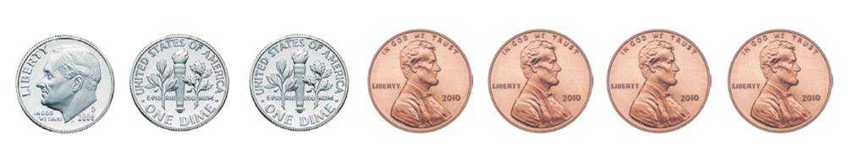

________ tens ________ ones

________ ¢

Module 7 Lesson 1 Name: _____________________________

Write the number of tens and ones. Then write the total value of the coins.

________ tens ________ ones

________ ¢
Module 7 Lesson 1 Name: _____________________________

Write the number of tens and ones. Then write the total value of the coins.

________ tens ________ ones

________ ¢

Module 7 Lesson 1 Name: _____________________________

Write the number of tens and ones. Then write the total value of the coins.

________ tens ________ ones

________ ¢
Module 7 Lesson 2 Name: _____________________________

Count to find the total value of the coins.
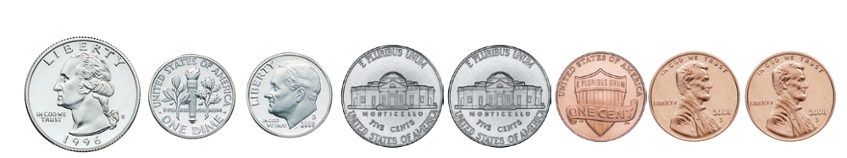

________ ¢, ________ ¢, ________ ¢, ________ ¢,

________ ¢, ________ ¢, ________ ¢, ________ ¢

Total value: ________ ¢

Module 7 Lesson 2 Name: _____________________________

Count to find the total value of the coins.

________ ¢, ________ ¢, ________ ¢, ________ ¢,

________ ¢, ________ ¢, ________ ¢, ________ ¢

Total value: ________ ¢
Module 7 Lesson 2 Name: _____________________________

Count to find the total value of the coins.

________ ¢, ________ ¢, ________ ¢, ________ ¢,

________ ¢, ________ ¢, ________ ¢, ________ ¢

Total value: ________ ¢

Module 7 Lesson 2 Name: _____________________________

Count to find the total value of the coins.

________ ¢, ________ ¢, ________ ¢, ________ ¢,

________ ¢, ________ ¢, ________ ¢, ________ ¢

Total value: ________ ¢
Module 7 Lesson 3 Name: _____________________________

Draw the coins in order from greatest value to least value. Count on to find the total value of the coins. Then write the total value of the coins.

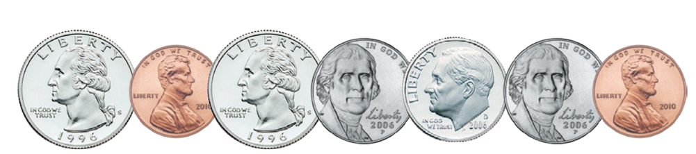

Module 7 Lesson 3 Name: _____________________________

Draw the coins in order from greatest value to least value. Count on to find the total value of the coins. Then write the total value of the coins.

Module 7 Lesson 4 Name: _____________________________

Draw how many pennies make 25¢. Then write how many pennies have the same total value as 1 quarter.

Module 7 Lesson 4 Name: _____________________________

Draw how many pennies make 25¢. Then write how many pennies have the same total value as 1 quarter.

Module 8 Lesson 1 Name: _____________________________

A granola bar costs $1. Draw the coins that you could use to buy a granola bar.

Module 8 Lesson 1 Name: _____________________________

A granola bar costs $1. Draw the coins that you could use to buy a granola bar.

Module 8 Lesson 2 Name: _____________________________

Julia has three $20 bills, two $10 bills, and two $1 bills. How much money does Julia have?

Module 8 Lesson 2 Name: _____________________________

Julia has three $20 bills, two $10 bills, and two $1 bills. How much money does Julia have?

Module 8 Lesson 2 Name: _____________________________

Julia has three $20 bills, two $10 bills, and two $1 bills. How much money does Julia have?

Module 8 Lesson 2 Name: _____________________________

Julia has three $20 bills, two $10 bills, and two $1 bills. How much money does Julia have?

Module 8 Lesson 3 Name: _____________________________

Mr. Mong has four $10 bills, two $20 bills, and six $1 bills. He wants to buy a tablet that is $100. Does he have enough money to buy the tablet? How do you know?

__________________________________________________________________________________________________________
__________________________________________________________________________________________________________
__________________________________________________________________________________________________________
__________________________________________________________________________________________________________
Module 8 Lesson 3 Name: _____________________________

Mr. Mong has four $10 bills, two $20 bills, and six $1 bills. He wants to buy a tablet that is $100. Does he have enough money to buy the tablet? How do you know?

__________________________________________________________________________________________________________
__________________________________________________________________________________________________________
__________________________________________________________________________________________________________
__________________________________________________________________________________________________________
Module 9 Lesson 1 Name: _____________________________

What time is shown on the clock? Write the time.
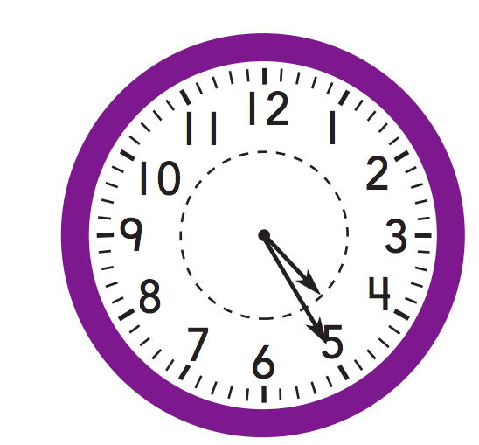

Module 9 Lesson 1 Name: _____________________________

What time is shown on the clock? Write the time.

Module 9 Lesson 1 Name: _____________________________

What time is shown on the clock? Write the time.

Module 9 Lesson 1 Name: _____________________________

What time is shown on the clock? Write the time.

Module 9 Lesson 2 Name: _____________________________

If the time is 6:30, what number does each hand point to?

__________________________________________________________________________________________________________
____________________________________________________________________________________________________________________________________________________________________________________________________________________
__________________________________________________________________________________________________________
__________________________________________________________________________________________________________
Module 9 Lesson 2 Name: _____________________________

If the time is 6:30, what number does each hand point to?

__________________________________________________________________________________________________________
____________________________________________________________________________________________________________________________________________________________________________________________________________________
__________________________________________________________________________________________________________
__________________________________________________________________________________________________________
Module 9 Lesson 3 Name: _____________________________

What time is shown on the clock? Write the time in two different ways.

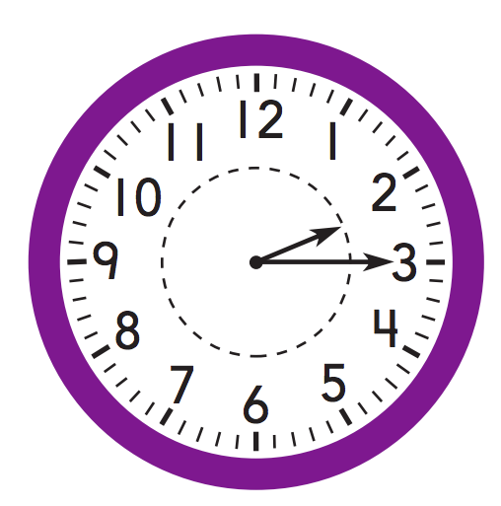

__________________________________________________________________________________________________________
__________________________________________________________________________________________________________
Module 9 Lesson 3 Name: _____________________________

What time is shown on the clock? Write the time in two different ways.

__________________________________________________________________________________________________________
__________________________________________________________________________________________________________

Module 9 Lesson 4 Name: _____________________________

John’s family eats lunch at quarter past eleven. Write that time, and tell if they eat in the a.m. or p.m.

________ : ________ a.m. or p.m.

Module 9 Lesson 4 Name: _____________________________

John’s family eats lunch at quarter past eleven. Write that time, and tell if they eat in the a.m. or p.m.

________ : ________ a.m. or p.m.

Module 9 Lesson 4 Name: _____________________________

John’s family eats lunch at quarter past eleven. Write that time, and tell if they eat in the a.m. or p.m.

________ : ________ a.m. or p.m.

Module 9 Lesson 4 Name: _____________________________

John’s family eats lunch at quarter past eleven. Write that time, and tell if they eat in the a.m. or p.m.

________ : ________ a.m. or p.m.

Module 10 Lesson 1 Name: ____________________________

Ken has 12 sports cards. He buys 20 more sports cards. How can he use a hundred chart to find how many sports cards he has now?

__________________________________________________________________________________________________________
__________________________________________________________________________________________________________
__________________________________________________________________________________________________________
__________________________________________________________________________________________________________
__________________________________________________________________________________________________________
Module 10 Lesson 1 Name: ____________________________

Ken has 12 sports cards. He buys 20 more sports cards. How can he use a hundred chart to find how many sports cards he has now?

__________________________________________________________________________________________________________
__________________________________________________________________________________________________________
__________________________________________________________________________________________________________
__________________________________________________________________________________________________________
__________________________________________________________________________________________________________
Module 10 Lesson 2 Name: _____________________________

Use the number line to solve 87 – 14.

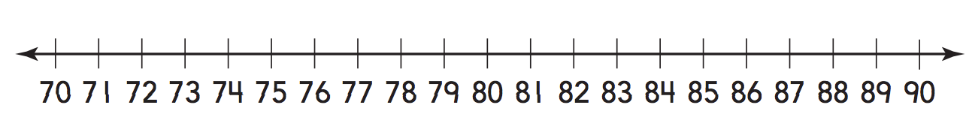

87 – 14 = ________

Module 10 Lesson 2 Name: _____________________________

Use the number line to solve 87 – 14.

87 – 14 = ________

Module 10 Lesson 2 Name: _____________________________

Use the number line to solve 87 – 14.

87 – 14 = ________

Module 10 Lesson 2 Name: _____________________________

Use the number line to solve 87 – 14.

87 – 14 = ________

Module 10 Lesson 3 Name: _____________________________

Use an open number line to solve 48 – 15.

Module 10 Lesson 3 Name: _____________________________

Use an open number line to solve 48 – 15.

Module 10 Lesson 3 Name: _____________________________

Use an open number line to solve 48 – 15.

Module 10 Lesson 3 Name: _____________________________

Use an open number line to solve 48 – 15.

Module 11 Lesson 1 Name: _____________________________

Sandra has 17 seashells. Then she finds 8 more seashells. How many seashells does Sandra have now?

Module 11 Lesson 1 Name: _____________________________

Sandra has 17 seashells. Then she finds 8 more seashells. How many seashells does Sandra have now?

Module 11 Lesson 1 Name: _____________________________

Sandra has 17 seashells. Then she finds 8 more seashells. How many seashells does Sandra have now?

Module 11 Lesson 1 Name: _____________________________

Sandra has 17 seashells. Then she finds 8 more seashells. How many seashells does Sandra have now?

Module 11 Lesson 2 Name: _____________________________

Break apart ones to subtract. Write a model to solve 86 - 9.

____________ – ____________ = ____________

____________ – ____________ = ____________

Module 11 Lesson 2 Name: _____________________________

Break apart ones to subtract. Write a model to solve 86 - 9.

____________ – ____________ = ____________

____________ – ____________ = ____________

Module 11 Lesson 2 Name: _____________________________

Break apart ones to subtract. Write a model to solve 86 - 9.

____________ – ____________ = ____________

____________ – ____________ = ____________

Module 11 Lesson 2 Name: _____________________________

Break apart ones to subtract. Write a model to solve 86 - 9.

____________ – ____________ = ____________

____________ – ____________ = ____________

Module 11 Lesson 3 Name: _____________________________

Make one addend the next tens number. Write a model to solve 66 + 17.

____________ + ____________ + ____________

____________ + ____________ = ____________

Module 11 Lesson 3 Name: _____________________________

Make one addend the next tens number. Write a model to solve 66 + 17.

____________ + ____________ + ____________

____________ + ____________ = ____________

Module 11 Lesson 3 Name: _____________________________

Make one addend the next tens number. Write a model to solve 66 + 17.

____________ + ____________ + ____________

____________ + ____________ = ____________

Module 11 Lesson 3 Name: _____________________________

Make one addend the next tens number. Write a model to solve 66 + 17.

____________ + ____________ + ____________

____________ + ____________ = ____________

Module 11 Lesson 4 Name: _____________________________

Find the sum using place value.

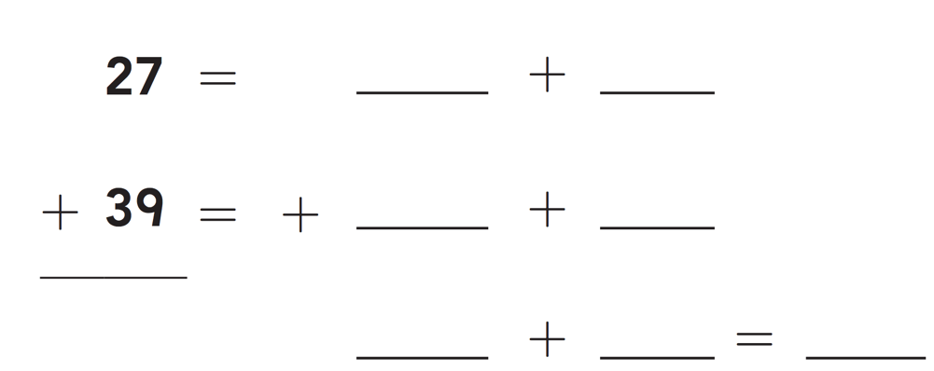

Module 11 Lesson 4 Name: _____________________________

Find the sum using place value.

Module 11 Lesson 4 Name: _____________________________

Find the sum using place value.

Module 11 Lesson 4 Name: _____________________________

Find the sum using place value.

Module 11 Lesson 5 Name: ___________________________

Subtract 68 – 25 using tens and ones.

Module 11 Lesson 5 Name: ___________________________

Subtract 68 – 25 using tens and ones.

Module 11 Lesson 5 Name: ___________________________

Subtract 68 – 25 using tens and ones.

Module 11 Lesson 5 Name: ___________________________

Subtract 68 – 25 using tens and ones.

Module 12 Lesson 1 Name: _____________________________

Add 19 and 36. Write how many tens and ones. Write the sum.

Module 12 Lesson 1 Name: _____________________________

Add 19 and 36. Write how many tens and ones. Write the sum.

Module 12 Lesson 1 Name: _____________________________

Add 19 and 36. Write how many tens and ones. Write the sum.

Module 12 Lesson 1 Name: _____________________________

Add 19 and 36. Write how many tens and ones. Write the sum.

Module 12 Lesson 2 Name: _____________________________

Subtract 17 from 42. Draw to show your work.

Module 12 Lesson 2 Name: _____________________________

Subtract 17 from 42. Draw to show your work.

Module 12 Lesson 3 Name: _____________________________

Add 29 + 21.

Module 12 Lesson 3 Name: _____________________________

Add 29 + 21.

Module 12 Lesson 4 Name: _____________________________

Subtract 12 from 40.

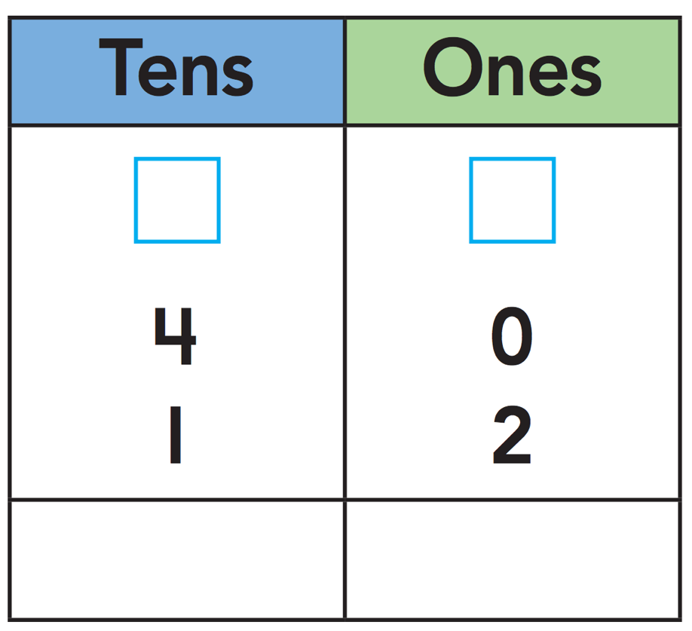

Module 12 Lesson 4 Name: _____________________________

Subtract 12 from 40.

Module 12 Lesson 5 Name: _____________________________

Add 47 + 38. Show your work.

Module 12 Lesson 5 Name: _____________________________

Add 47 + 38. Show your work.

Module 12 Lesson 6 Name: _____________________________

Subtract 85 − 37. Show your work.

Module 12 Lesson 6 Name: _____________________________

Subtract 85 − 37. Show your work.

Module 13 Lesson 1 Name: _____________________________

45 + 36 =

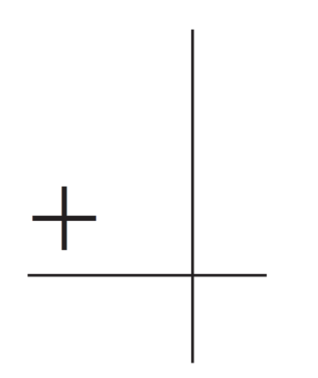

Module 13 Lesson 1 Name: _____________________________

45 + 36 =

Module 13 Lesson 1 Name: _____________________________

45 + 36 =

Module 13 Lesson 1 Name: _____________________________

45 + 36 =

Module 13 Lesson 2 Name: _____________________________

82 – 56 =

Module 13 Lesson 2 Name: _____________________________

82 – 56 =

Module 13 Lesson 2 Name: _____________________________

82 – 56 =

Module 13 Lesson 2 Name: _____________________________

82 – 56 =

Module 13 Lesson 3 Name: _____________________________

Use the number line to solve the problem.

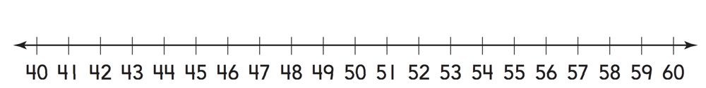

54 – 49 = _________

Module 13 Lesson 3 Name: _____________________________

Use the number line to solve the problem.

54 – 49 = _________

Module 13 Lesson 3 Name: _____________________________

Use the number line to solve the problem.

54 – 49 = _________

Module 13 Lesson 3 Name: _____________________________

Use the number line to solve the problem.

54 – 49 = _________

Module 13 Lesson 4 Name: _____________________________

Find the sum.

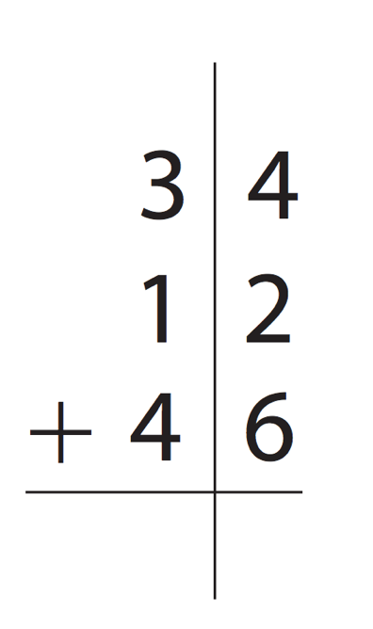

Module 13 Lesson 4 Name: _____________________________

Find the sum.

Module 13 Lesson 5 Name: _____________________________

Find the sum.

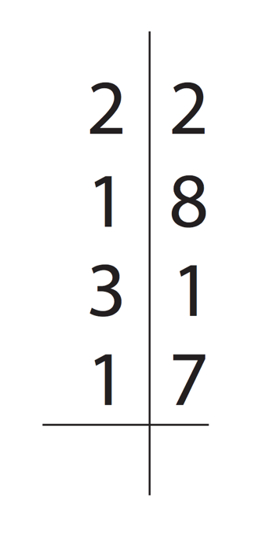

Module 13 Lesson 5 Name: _____________________________

Find the sum.

Module 14 Lesson 1 Name: _____________________________

There are 15 bananas on the tree. 4 bananas are eaten. How many bananas are still on the tree?

Complete the bar model to represent the problem. Then write an equation to solve.

Module 14 Lesson 1 Name: _____________________________

There are 15 bananas on the tree. 4 bananas are eaten. How many bananas are still on the tree?

Complete the bar model to represent the problem. Then write an equation to solve.

Module 14 Lesson 2 Name: _____________________________

There are 13 players on Leo’s football team. There are 4 players absent from practice one day. How many players are at practice?

Write an equation to represent the problem. Then find the answer.

Module 14 Lesson 2 Name: _____________________________

There are 13 players on Leo’s football team. There are 4 players absent from practice one day. How many players are at practice?

Write an equation to represent the problem. Then find the answer.

Module 14 Lesson 3 Name: _____________________________

There are 13 cans of green beans and 35 cans of corn on a shelf at the supermarket. How many cans are there in all?

Complete the bar model and write an equation to find the number of cans on the shelf.

Module 14 Lesson 3 Name: _____________________________

There are 13 cans of green beans and 35 cans of corn on a shelf at the supermarket. How many cans are there in all?

Complete the bar model and write an equation to find the number of cans on the shelf.

Module 14 Lesson 4 Name: _____________________________

Write an equation to represent the bar model, then solve.

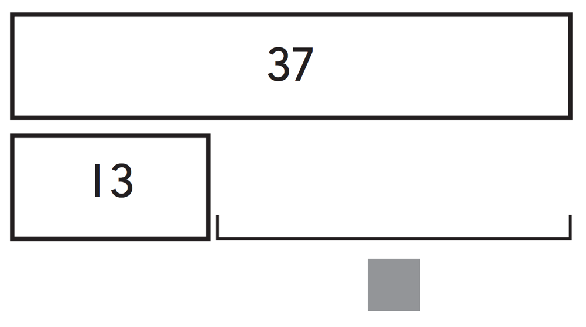

Module 14 Lesson 4 Name: _____________________________

Write an equation to represent the bar model, then solve.

Module15 Lesson 1 Name: _____________________________

Lance has 15 eggs. He buys 18 more eggs. How many eggs does he have now? Write an equation to find the answer.

Module15 Lesson 1 Name: _____________________________

Lance has 15 eggs. He buys 18 more eggs. How many eggs does he have now? Write an equation to find the answer.

Module15 Lesson 1 Name: _____________________________

Lance has 15 eggs. He buys 18 more eggs. How many eggs does he have now? Write an equation to find the answer.

Module15 Lesson 1 Name: _____________________________

Lance has 15 eggs. He buys 18 more eggs. How many eggs does he have now? Write an equation to find the answer.

Module 15 Lesson 2 Name: _____________________________

Grant drives 56 miles each day. Anna drives 39 miles each day. How many more miles does Grant drive each day? Write an equation to solve the problem.

Module 15 Lesson 2 Name: _____________________________

Grant drives 56 miles each day. Anna drives 39 miles each day. How many more miles does Grant drive each day? Write an equation to solve the problem.

Module 15 Lesson 2 Name: _____________________________

Grant drives 56 miles each day. Anna drives 39 miles each day. How many more miles does Grant drive each day? Write an equation to solve the problem.

Module 15 Lesson 2 Name: _____________________________

Grant drives 56 miles each day. Anna drives 39 miles each day. How many more miles does Grant drive each day? Write an equation to solve the problem.

Module 15 Lesson 3 Name: _____________________________

Jan and Brett each pick 15 oranges. Then they buy one bag of 12 oranges. How many oranges do they have now?

Module 15 Lesson 3 Name: _____________________________

Jan and Brett each pick 15 oranges. Then they buy one bag of 12 oranges. How many oranges do they have now?

Module 15 Lesson 3 Name: _____________________________

Jan and Brett each pick 15 oranges. Then they buy one bag of 12 oranges. How many oranges do they have now?

Module 15 Lesson 3 Name: _____________________________

Jan and Brett each pick 15 oranges. Then they buy one bag of 12 oranges. How many oranges do they have now?

Module 16 Lesson 1 Name: _____________________________

Use a quick picture to represent and solve the problem.

128 + 341 = ________

Module 16 Lesson 1 Name: _____________________________

Use a quick picture to represent and solve the problem.

128 + 341 = ________

Module 16 Lesson 2 Name: _____________________________

Show how to find the sum of 319 and 244 by breaking apart the addends. Use numbers, drawings, and words.

Module 16 Lesson 2 Name: _____________________________

Show how to find the sum of 319 and 244 by breaking apart the addends. Use numbers, drawings, and words.

Module 16 Lesson 3 Name: _____________________________

Ana adds 363 + 229. She regroups in the tens place. Is she correct? Explain your thinking.

__________________________________________________________________________________________________________
__________________________________________________________________________________________________________
__________________________________________________________________________________________________________
__________________________________________________________________________________________________________
Module 16 Lesson 3 Name: _____________________________

Ana adds 363 + 229. She regroups in the tens place. Is she correct? Explain your thinking.

__________________________________________________________________________________________________________
__________________________________________________________________________________________________________
__________________________________________________________________________________________________________
_____________________________________________________
_____________________________________________________
Module 16 Lesson 4 Name: _____________________________

Find the sum. Show your work.

673 + 294 =

Module 16 Lesson 4 Name: _____________________________

Find the sum. Show your work.

673 + 294 =

Module 16 Lesson 4 Name: _____________________________

Find the sum. Show your work.

673 + 294 =

Module 16 Lesson 4 Name: _____________________________

Find the sum. Show your work.

673 + 294 =

Module 17 Lesson 1 Name: _____________________________

Make a concrete model or draw a visual model to find 679 – 432.

Module 17 Lesson 1 Name: _____________________________

Make a concrete model or draw a visual model to find 679 – 432.

Module 17 Lesson 2 Name: _____________________________

Find 524 – 160. Make a concrete model or draw a visual model to solve.

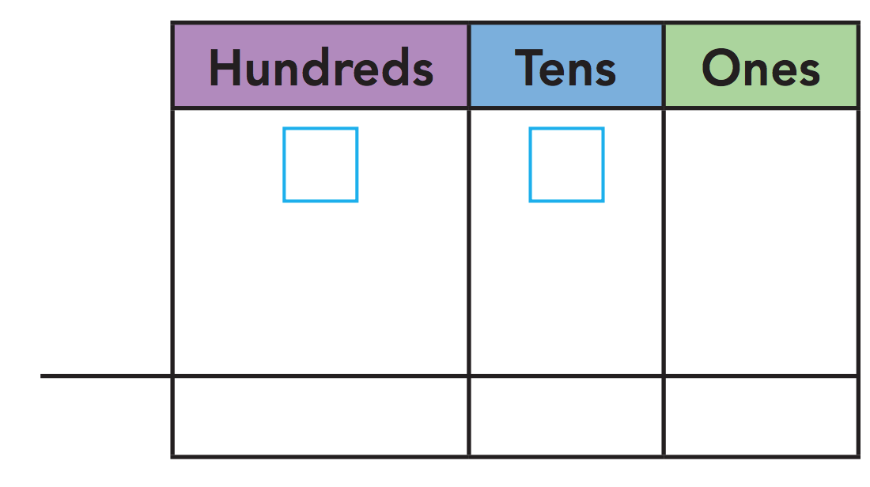

Module 17 Lesson 2 Name: _____________________________

Find 524 – 160. Make a concrete model or draw a visual model to solve.

Module 17 Lesson 3 Name: _____________________________

Find 814 – 493. Make a concrete model or draw visual model to solve.

Module 17 Lesson 3 Name: _____________________________

Find 814 – 493. Make a concrete model or draw visual model to solve.

Module 17 Lesson 4 Name: _____________________________

Find 600 – 346. Draw visual model to solve.

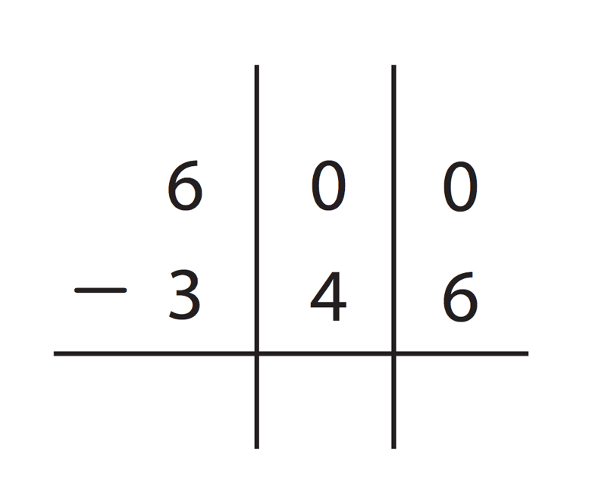

Module 17 Lesson 4 Name: _____________________________

Find 600 – 346. Draw visual model to solve.

Module 17 Lesson 5 Name: _____________________________

Subtract.

8 0 0
– 6 2 2

Module 17 Lesson 5 Name: _____________________________

Subtract.

8 0 0
– 6 2 2

Module 17 Lesson 5 Name: _____________________________

Subtract.

8 0 0
– 6 2 2

Module 17 Lesson 5 Name: _____________________________

Subtract.

8 0 0
– 6 2 2

Module 17 Lesson 6 Name: _____________________________

Solve.

6 0 2
+ 1 9 8

Module 17 Lesson 6 Name: _____________________________

Solve.

6 0 2
+ 1 9 8

Module 17 Lesson 6 Name: _____________________________

Solve.

6 0 2
+ 1 9 8

Module 17 Lesson 6 Name: _____________________________

Solve.

6 0 2
+ 1 9 8

Module 18 Lesson 1 Name: _____________________________

Explain how to estimate the length of a pencil using a 1-inch square tile.

____________________________________________________________________________________________________________________________________________________________________________________________________________________
__________________________________________________________________________________________________________
____________________________________________________________________________________________________________________________________________________________________________________________________________________
Module 18 Lesson 1 Name: _____________________________

Explain how to estimate the length of a pencil using a 1-inch square tile.

____________________________________________________________________________________________________________________________________________________________________________________________________________________
__________________________________________________________________________________________________________
____________________________________________________________________________________________________________________________________________________________________________________________________________________
Module 18 Lesson 2 Name: _____________________________

You measured this piece of ribbon with 4 square tiles and found it is about 4 inches long.

What would the length in inches of the ribbon be if it measured three squares with the paper ruler?

Module 18 Lesson 2 Name: _____________________________

You measured this piece of ribbon with 4 square tiles and found it is about 4 inches long.

What would the length in inches of the ribbon be if it measured three squares with the paper ruler?

Module 18 Lesson 2 Name: _____________________________

You measured this piece of ribbon with 4 square tiles and found it is about 4 inches long.

What would the length in inches of the ribbon be if it measured three squares with the paper ruler?

Module 18 Lesson 2 Name: _____________________________

You measured this piece of ribbon with 4 square tiles and found it is about 4 inches long.

What would the length in inches of the ribbon be if it measured three squares with the paper ruler?

Module 18 Lesson 3 Name: _____________________________

Explain how to use an inch ruler to measure the length of an object to the nearest inch.

____________________________________________________________________________________________________________________________________________________________________________________________________________________
__________________________________________________________________________________________________________
_________________________________________________________________________________________________________________________________________________________________________________________________________________________________________________________________________
Module 18 Lesson 3 Name: _____________________________

Explain how to use an inch ruler to measure the length of an object to the nearest inch.

____________________________________________________________________________________________________________________________________________________________________________________________________________________
__________________________________________________________________________________________________________
_________________________________________________________________________________________________________________________________________________________________________________________________________________________________________________________________________
Module 18 Lesson 4 Name: _____________________________

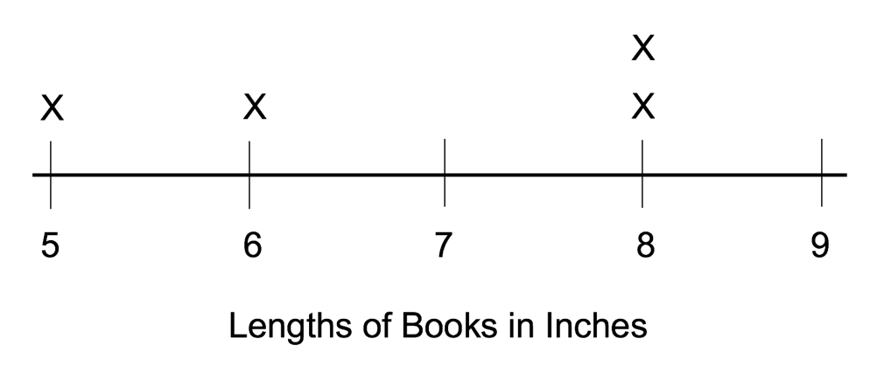

What is the length of the longest book measured?

_________________________________

What is the length of the shortest book?

_________________________________

Module 18 Lesson 4 Name: _____________________________

What is the length of the longest book measured?

_________________________________

What is the length of the shortest book?

_________________________________

Module 18 Lesson 5 Name: _____________________________

Hold up a string or ribbon that is 3 feet long. Have children estimate its length in feet.

____________________________________________________________________________________________________________________________________________________________________________________________________________________

Module 18 Lesson 5 Name: _____________________________

Hold up a string or ribbon that is 3 feet long. Have children estimate its length in feet.

____________________________________________________________________________________________________________________________________________________________________________________________________________________
Module 18 Lesson 5 Name: _____________________________

Hold up a string or ribbon that is 3 feet long. Have children estimate its length in feet.

____________________________________________________________________________________________________________________________________________________________________________________________________________________

Module 18 Lesson 5 Name: _____________________________

Hold up a string or ribbon that is 3 feet long. Have children estimate its length in feet.

____________________________________________________________________________________________________________________________________________________________________________________________________________________
Module 18 Lesson 6 Name: _____________________________

Jonas says that a picture that is 2 feet long is 48 inches long. Is Jonas correct?

____________________________________________________________________________________________________________________________________________________________________________________________________________________
___________________________________________________________________________________________________________________________________________________________________________________________________________________________________________________________________________________________________________________________________________________________________________________
Module 18 Lesson 6 Name: _____________________________

Jonas says that a picture that is 2 feet long is 48 inches long. Is Jonas correct?

____________________________________________________________________________________________________________________________________________________________________________________________________________________
___________________________________________________________________________________________________________________________________________________________________________________________________________________________________________________________________________________________________________________________________________________________________________________
Module 18 Lesson 7 Name: _____________________________

Have children point to an object that is about 1 yard long.

____________________________________________________________________________________________________________________________________________________________________________________________________________________

Module 18 Lesson 7 Name: _____________________________

Have children point to an object that is about 1 yard long.

____________________________________________________________________________________________________________________________________________________________________________________________________________________
Module 18 Lesson 7 Name: _____________________________

Have children point to an object that is about 1 yard long.

____________________________________________________________________________________________________________________________________________________________________________________________________________________

Module 18 Lesson 7 Name: _____________________________

Have children point to an object that is about 1 yard long.

____________________________________________________________________________________________________________________________________________________________________________________________________________________
Module 18 Lesson 8 Name: _____________________________

Show children an object and have them choose a tool to measure its length.

____________________________________________________________________________________________________________________________________________________________________________________________________________________

Module 18 Lesson 8 Name: _____________________________

Show children an object and have them choose a tool to measure its length.

____________________________________________________________________________________________________________________________________________________________________________________________________________________
Module 18 Lesson 8 Name: _____________________________

Show children an object and have them choose a tool to measure its length.

____________________________________________________________________________________________________________________________________________________________________________________________________________________

Module 18 Lesson 8 Name: _____________________________

Show children an object and have them choose a tool to measure its length.

____________________________________________________________________________________________________________________________________________________________________________________________________________________
Module 19 Lesson 1 Name: _____________________________

Display two objects for children. One object should be about 4 centimeters long (such as a pencil sharpener). The other object should be about 16 centimeters long (such as a pencil).

- Which object is shorter, the pencil sharpener or the pencil? _________________________ ____________________________________
- The pencil sharpener is 4 centimeters long. What is a good estimate for the length of the pencil? _______________________________ _____________________________________

Module 19 Lesson 1 Name: _____________________________

Display two objects for children. One object should be about 4 centimeters long (such as a pencil sharpener). The other object should be about 16 centimeters long (such as a pencil).

- Which object is shorter, the pencil sharpener or the pencil? _________________________ ____________________________________
- The pencil sharpener is 4 centimeters long. What is a good estimate for the length of the pencil? _______________________________ _____________________________________

Module 19 Lesson 2 Name: _____________________________

Use a centimeter ruler to measure the object.

___________ centimeters

Module 19 Lesson 2 Name: _____________________________

Use a centimeter ruler to measure the object.

___________ centimeters

Module 19 Lesson 2 Name: _____________________________

Use a centimeter ruler to measure the object.

___________ centimeters

Module 19 Lesson 2 Name: _____________________________

Use a centimeter ruler to measure the object.

___________ centimeters

Module 19 Lesson 3 Name: _____________________________

Estimate the length of the classroom wall in meters.
_______________________________________
Choose a classroom object. Estimate its length in meters.
_______________________________________

Module 19 Lesson 3 Name: _____________________________

Estimate the length of the classroom wall in meters.
_______________________________________
Choose a classroom object. Estimate its length in meters.
_______________________________________

Module 19 Lesson 3 Name: _____________________________

Estimate the length of the classroom wall in meters.
_______________________________________
Choose a classroom object. Estimate its length in meters.
_______________________________________

Module 19 Lesson 3 Name: _____________________________

Estimate the length of the classroom wall in meters.
_______________________________________
Choose a classroom object. Estimate its length in meters.
_______________________________________

Module 19 Lesson 4 Name: _____________________________

Will there be more centimeter units or meter units when measuring the length of a table? Explain.

____________________________________________________________________________________________________________________________________________________________________________________________________________________
____________________________________________________________________________________________________________________________________________________________________________________________________________________
__________________________________________________________________________________________________________
Module 19 Lesson 4 Name: _____________________________

Will there be more centimeter units or meter units when measuring the length of a table? Explain.

____________________________________________________________________________________________________________________________________________________________________________________________________________________
____________________________________________________________________________________________________________________________________________________________________________________________________________________
__________________________________________________________________________________________________________
Module 20 Lesson 1 Name: _____________________________

Use the yardstick to subtract 34 – 11. Then write the equation and answer.

Module 20 Lesson 1 Name: _____________________________

Use the yardstick to subtract 34 – 11. Then write the equation and answer.

Module 20 Lesson 1 Name: _____________________________

Use the yardstick to subtract 34 – 11. Then write the equation and answer.

Module 20 Lesson 1 Name: _____________________________

Use the yardstick to subtract 34 – 11. Then write the equation and answer.

Module 20 Lesson 2 Name: _____________________________

Sammy has 2 books. One book is 8 inches long. The other book is 12 inches long. How long are the books put together?

Write an equation using for the unknown number. Use the number line to solve.

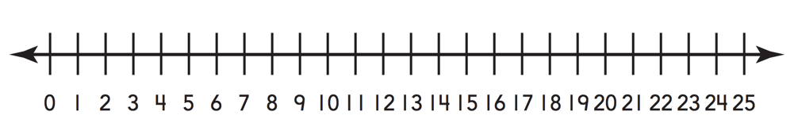

_________________________________________________

_______________ inches

Module 20 Lesson 2 Name: _____________________________

Sammy has 2 books. One book is 8 inches long. The other book is 12 inches long. How long are the books put together?

Write an equation using for the unknown number. Use the number line to solve.

_________________________________________________

_______________ inches

Module 20 Lesson 3 Name: _____________________________

Wendy has a paper chain that is 13 centimeters long. She puts 12 centimeters more on the paper chain. How long is the paper chain now?

___________ centimeters

Module 20 Lesson 3 Name: _____________________________

Wendy has a paper chain that is 13 centimeters long. She puts 12 centimeters more on the paper chain. How long is the paper chain now?

___________ centimeters

Module 20 Lesson 3 Name: _____________________________

Wendy has a paper chain that is 13 centimeters long. She puts 12 centimeters more on the paper chain. How long is the paper chain now?

___________ centimeters

Module 20 Lesson 3 Name: _____________________________

Wendy has a paper chain that is 13 centimeters long. She puts 12 centimeters more on the paper chain. How long is the paper chain now?

___________ centimeters

Module 20 Lesson 4 Name: _____________________________

A wire is 13 centimeters long. Then it is cut. Now the wire is 8 centimeters long. How many centimeters were cut off?

Write an equation using for the unknown number. Use the number line to solve.

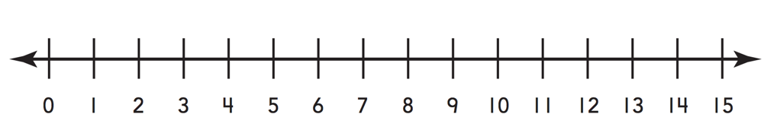

_________________________________________________

_______________ centimeters

Module 20 Lesson 4 Name: _____________________________

A wire is 13 centimeters long. Then it is cut. Now the wire is 8 centimeters long. How many centimeters were cut off?

Write an equation using for the unknown number. Use the number line to solve.

_________________________________________________

_______________ centimeters

Module 20 Lesson 5 Name: _____________________________

Write an equation describing the difference in length of the yarns. Explain.

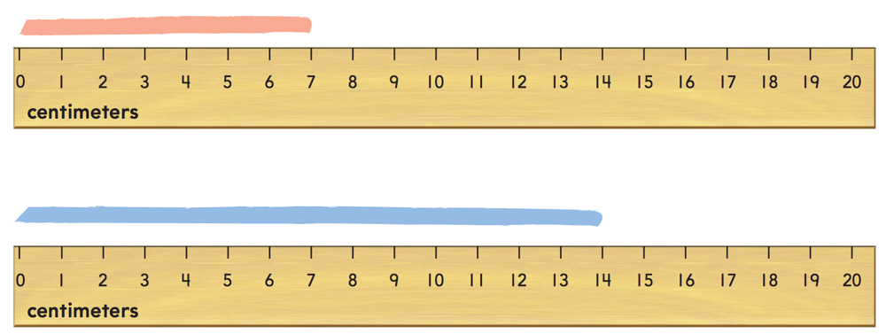

__________________________________________________________________________________________________________
__________________________________________________________________________________________________________
__________________________________________________________________________________________________________
_____________________________________________________
Module 20 Lesson 5 Name: _____________________________

Write an equation describing the difference in length of the yarns. Explain.

__________________________________________________________________________________________________________
__________________________________________________________________________________________________________
__________________________________________________________________________________________________________
_____________________________________________________
Module 21 Lesson 1 Name: _____________________________

How many faces, edges, and vertices does a cube have?

__________________________________________________________________________________________________________

Module 21 Lesson 1 Name: _____________________________

How many faces, edges, and vertices does a cube have?

__________________________________________________________________________________________________________
Module 21 Lesson 1 Name: _____________________________

How many faces, edges, and vertices does a cube have?

__________________________________________________________________________________________________________

Module 21 Lesson 1 Name: _____________________________

How many faces, edges, and vertices does a cube have?

__________________________________________________________________________________________________________
Module 21 Lesson 2 Name: _____________________________

Order the following shapes based on their number of vertices, from least to greatest:

hexagon quadrilateral triangle pentagon

_______________________________________________________________________________________________________________________________________________________________

Module 21 Lesson 2 Name: _____________________________

Order the following shapes based on their number of vertices, from least to greatest:

hexagon quadrilateral triangle pentagon

_______________________________________________________________________________________________________________________________________________________________
Module 21 Lesson 2 Name: _____________________________

Order the following shapes based on their number of vertices, from least to greatest:

hexagon quadrilateral triangle pentagon

_______________________________________________________________________________________________________________________________________________________________

Module 21 Lesson 2 Name: _____________________________

Order the following shapes based on their number of vertices, from least to greatest:

hexagon quadrilateral triangle pentagon

_______________________________________________________________________________________________________________________________________________________________
Module 21 Lesson 3 Name: _____________________________

Write the number of angles for each shapes:

triangle _____________________
quadrilateral _________________
pentagon ___________________
hexagon ____________________

Module 21 Lesson 3 Name: _____________________________

Write the number of angles for each shapes:

triangle _____________________
quadrilateral _________________
pentagon ___________________
hexagon ____________________
Module 21 Lesson 3 Name: _____________________________

Write the number of angles for each shapes:

triangle _____________________
quadrilateral _________________
pentagon ___________________
hexagon ____________________

Module 21 Lesson 3 Name: _____________________________

Write the number of angles for each shapes:

triangle _____________________
quadrilateral _________________
pentagon ___________________
hexagon ____________________
Module 22 Lesson 1 Name: _____________________________

If one row was added to Peggy’s rectangle in this rectangle, how many square tiles would be covering the rectangle?

__________________________________________

Module 22 Lesson 1 Name: _____________________________

If one row was added to Peggy’s rectangle in this rectangle, how many square tiles would be covering the rectangle?

__________________________________________
Module 22 Lesson 1 Name: _____________________________

If one row was added to Peggy’s rectangle in this rectangle, how many square tiles would be covering the rectangle?

__________________________________________

Module 22 Lesson 1 Name: _____________________________

If one row was added to Peggy’s rectangle in this rectangle, how many square tiles would be covering the rectangle?

__________________________________________

Module 22 Lesson 2 Name: _____________________________

Write how many equal shares. Then write halves, thirds, or fourths to name the shares.

__________________________________________
Module 22 Lesson 2 Name: _____________________________

Write how many equal shares. Then write halves, thirds, or fourths to name the shares.

__________________________________________

Module 22 Lesson 2 Name: _____________________________

Write how many equal shares. Then write halves, thirds, or fourths to name the shares.

__________________________________________
Module 22 Lesson 2 Name: _____________________________

Write how many equal shares. Then write halves, thirds, or fourths to name the shares.

__________________________________________

Module 22 Lesson 3 Name: _____________________________

Draw to show halves, thirds, and fourths.

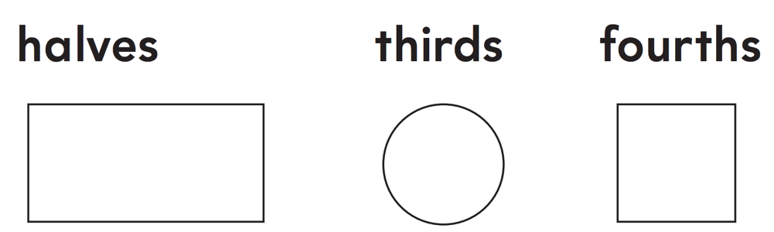

Module 22 Lesson 3 Name: _____________________________

Draw to show halves, thirds, and fourths.

Module 22 Lesson 3 Name: _____________________________

Draw to show halves, thirds, and fourths.

Module 22 Lesson 3 Name: _____________________________

Draw to show halves, thirds, and fourths.

Module 22 Lesson 4 Name: _____________________________

Draw and color to show a share of the rectangle.

A half of A third of A fourth of

Module 22 Lesson 4 Name: _____________________________

Draw and color to show a share of the rectangle.

A half of A third of A fourth of

Module 22 Lesson 4 Name: _____________________________

Draw and color to show a share of the rectangle.

A half of A third of A fourth of

Module 22 Lesson 4 Name: _____________________________

Draw and color to show a share of the rectangle.

A half of A third of A fourth of

Module 22 Lesson 5 Name: _____________________________

Draw to show halves in two different ways.

Module 22 Lesson 5 Name: _____________________________

Draw to show halves in two different ways.

Module 22 Lesson 5 Name: _____________________________

Draw to show halves in two different ways.

Module 22 Lesson 5 Name: _____________________________

Draw to show halves in two different ways.

