Get to Know Your Item Analysis Spreadsheet
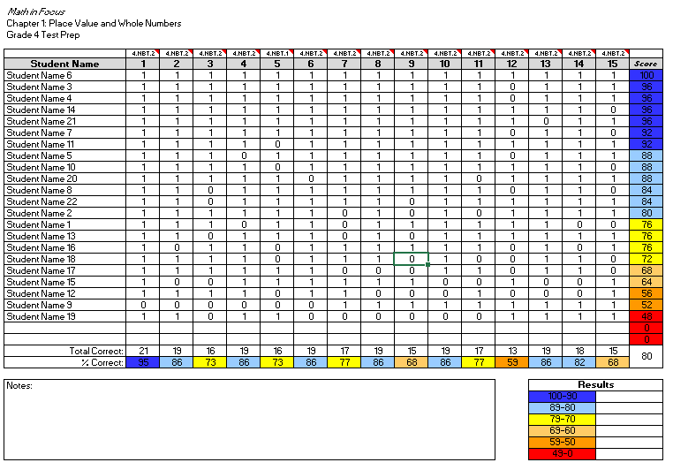
5

1

2

7

4

8

3

6

1. Test Information: This section will tell you which grade level, chapter, and type of test the spreadsheet is formatted for.
2. Common Core State Standard: Each test item is correlated with a CCSS standard. Hover your mouse over the CCSS number, and a pop-up bubble will appear with the CCSS standard to assist in easy analysis of student learning.
3. Student Score: The student score column is programed to automatically calculate student scores based on the weighted recommendations of the Math in Focus Assessment Guide.
4. Total Correct: This row will automatically count how many correct responses were attained for each question on the assessment.
5. Percent Correct: This row will automatically calculate the percentage of correct responses that were attained for each question on the assessment.
6. Average Class Score: This cell is formatted to calculate the average of all student scores entered into the spreadsheet.
7. Notes Section: This area is left blank for notes about the assessment, student responses, or reflections on student performance.
8. Results Section: Use this section to calculate the percentage of your class that falls within each scoring category.
How to Enter Student Responses
1. Enter student names into column A. It is often helpful to enter the last name first for sorting purposes.
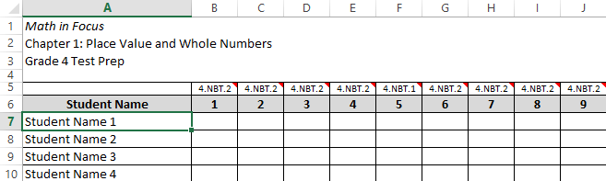
2. Next, enter a 1 or 0 for each student response. Enter 1 if the student answered the question correctly, and enter 0 if the student answered the question incorrectly. For quick entry, use the number pad and arrow keys to navigate to each cell. In order for the score to calculate properly, there must be a 1 or 0 in each cell for each student on the roster. Do not enter anything into the rows without student names.
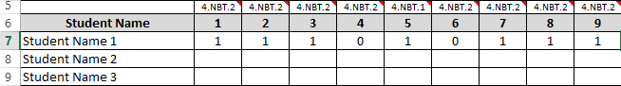
3. As you enter each student response, you will notice the score calculating in the last column. The cells in the last column of each Test Prep are formatted to calculate the weighted score as prescribed in the Math in Focus Assessment Guide.
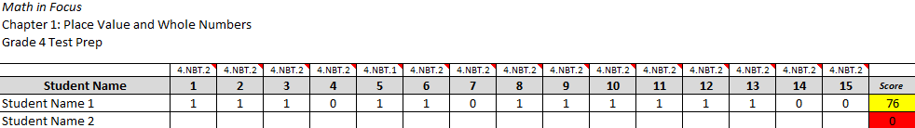
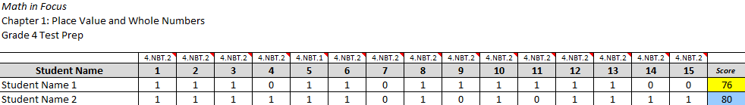
4. Once you have entered all of the student responses, you are ready you sort the data to get a better view of how the class performed.

How to Sort Student Data
1. Once you have entered student responses into the Item Analysis spreadsheet, you are ready to sort your data. Begin by selecting all of the student information as shown below.
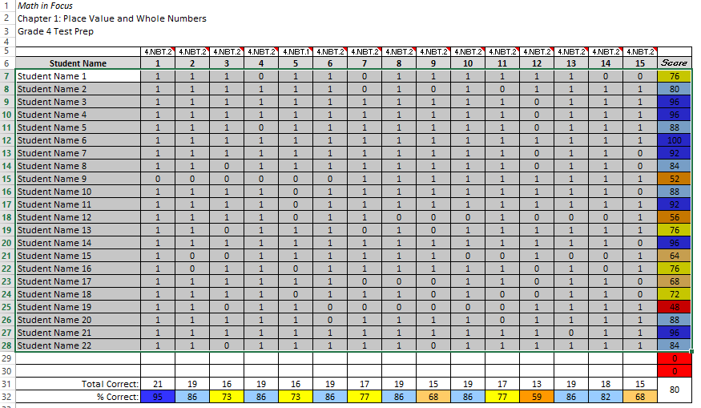
2. Next, click the Sort and Filter button located on the Home tab. Select Custom Sort.
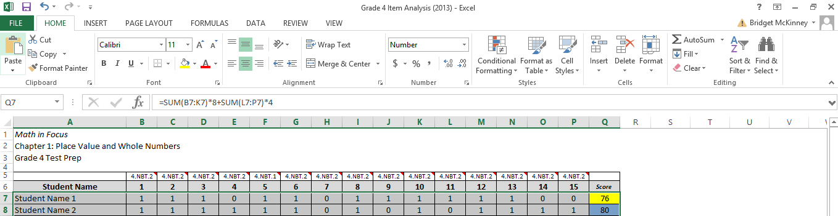
3. When the custom sort window pops up, select the following criteria: score, values, and largest to smallest. Then, click OK.
