Advanced 2

Exit Tickets

This document contains printable and customizable versions of the Exit Tickets recommended
in the Into Math Teacher Edition. The Exit Ticket is also available as a Projectable PDF on
Ed: Your Friend in Learning.

Exit Tickets are an optional way to wrap up a lesson. The problem provided for each lesson assesses
whether students grasped the lesson content.

To save paper when printing, the document is formatted with 2 to a page for some lessons and 4 to a page
in other lessons, based on the space students will likely need to answer the question(s).

Copyright © by Houghton Mifflin Harcourt Publishing Company
All rights reserved. No part of the material protected by this copyright may be reproduced or utilized in any form or by any means, electronic or mechanical, including photocopying, recording, broadcasting or by any other information storage and retrieval system, without written permission of the copyright owner unless such copying is expressly permitted by federal copyright law.
Only those pages that are specifically enabled by the program and indicated by the presence of the print icon may be printed and reproduced in classroom quantities by individual teachers using the corresponding student’s textbook or kit as the major vehicle for regular classroom instruction. Requests for information on other matters regarding duplication of this work should be submitted through our Permissions website at https://customercare.hmhco.com/contactus/Permissions.html or mailed to Houghton Mifflin Harcourt Publishing Company, Attn: Compliance, Contracts, and Licensing, 9400 Southpark Center Loop, Orlando, Florida 32819-8647.
HOUGHTON MIFFLIN HARCOURT and the HMH Logo are trademarks and service marks of Houghton Mifflin Harcourt Publishing Company. You shall not display, disparage, dilute or taint Houghton Mifflin Harcourt trademarks and service marks or use any confusingly similar marks, or use Houghton Mifflin Harcourt marks in such a way that would misrepresent the identity of the owner. Any permitted use of Houghton Mifflin Harcourt trademarks and service marks inures to the benefit of Houghton Mifflin Harcourt Publishing Company.
All other trademarks, service marks or registered trademarks appearing on Houghton Mifflin Harcourt Publishing Company websites are the trademarks or service marks of their respective owners.

Module 1 Lesson 1 Name: _____________________________

Reginald rotates a regular hexagon. What is true of the angles, side lengths, and parallel lines?

Module 1 Lesson 1 Name: _____________________________

Reginald rotates a regular hexagon. What is true of the angles, side lengths, and parallel lines?

Module 1 Lesson 1 Name: _____________________________

Reginald rotates a regular hexagon. What is true of the angles, side lengths, and parallel lines?

Module 1 Lesson 1 Name: _____________________________

Reginald rotates a regular hexagon. What is true of the angles, side lengths, and parallel lines?

Module 1 Lesson 2 Name: _____________________________

The preimage of a rectangle has vertices with coordinates
at (−3, 2), (−3, 5), (2, 5), and (2, 2). The image of the
rectangle has vertices with coordinates at (−2, 0), (−2, 3),
(3, 3), and (3, 0).

Describe the translation using mapping notation. Then compare the dimensions, angle measures, and relationship between the sides of the preimage and image.

Module 1 Lesson 2 Name: _____________________________

The preimage of a rectangle has vertices with coordinates
at (−3, 2), (−3, 5), (2, 5), and (2, 2). The image of the
rectangle has vertices with coordinates at (−2, 0), (−2, 3),
(3, 3), and (3, 0).

Describe the translation using mapping notation. Then compare the dimensions, angle measures, and relationship between the sides of the preimage and image.

Module 1 Lesson 2 Name: _____________________________

The preimage of a rectangle has vertices with coordinates
at (−3, 2), (−3, 5), (2, 5), and (2, 2). The image of the
rectangle has vertices with coordinates at (−2, 0), (−2, 3),
(3, 3), and (3, 0).

Describe the translation using mapping notation. Then compare the dimensions, angle measures, and relationship between the sides of the preimage and image.

Module 1 Lesson 2 Name: _____________________________

The preimage of a rectangle has vertices with coordinates
at (−3, 2), (−3, 5), (2, 5), and (2, 2). The image of the
rectangle has vertices with coordinates at (−2, 0), (−2, 3),
(3, 3), and (3, 0).

Describe the translation using mapping notation. Then compare the dimensions, angle measures, and relationship between the sides of the preimage and image.

Module 1 Lesson 3 Name: _____________________________

Consider a triangle with vertices (−2, −2), (−4, −5), and
(−1, −8). What would the vertices of the image be if the
triangle were reflected over the x-axis, then the y-axis?

Module 1 Lesson 3 Name: _____________________________

Consider a triangle with vertices (−2, −2), (−4, −5), and
(−1, −8). What would the vertices of the image be if the
triangle were reflected over the x-axis, then the y-axis?

Module 1 Lesson 3 Name: _____________________________

Consider a triangle with vertices (−2, −2), (−4, −5), and
(−1, −8). What would the vertices of the image be if the
triangle were reflected over the x-axis, then the y-axis?

Module 1 Lesson 3 Name: _____________________________

Consider a triangle with vertices (−2, −2), (−4, −5), and
(−1, −8). What would the vertices of the image be if the
triangle were reflected over the x-axis, then the y-axis?

Module 1 Lesson 4 Name: _____________________________

Figure 1 has vertices (–3, 4), (–1, 3), (–3, 1), and (–5, 2). Rotate it 180° to form Figure 2. Give the coordinates for the
vertices of Figure 2.

Module 1 Lesson 4 Name: _____________________________

Figure 1 has vertices (–3, 4), (–1, 3), (–3, 1), and (–5, 2). Rotate it 180° to form Figure 2. Give the coordinates for the
vertices of Figure 2.

Module 1 Lesson 4 Name: _____________________________

Figure 1 has vertices (–3, 4), (–1, 3), (–3, 1), and (–5, 2). Rotate it 180° to form Figure 2. Give the coordinates for the
vertices of Figure 2.

Module 1 Lesson 4 Name: _____________________________

Figure 1 has vertices (–3, 4), (–1, 3), (–3, 1), and (–5, 2). Rotate it 180° to form Figure 2. Give the coordinates for the
vertices of Figure 2.

Module 1 Lesson 5 Name: _____________________________

What series of transformations can transform one heart into
the other heart? Are the two hearts congruent?

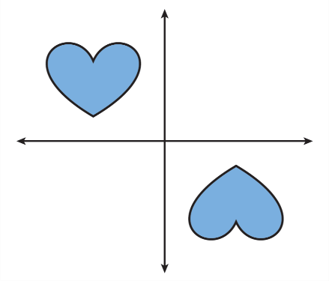

Module 1 Lesson 5 Name: _____________________________

What series of transformations can transform one heart into
the other heart? Are the two hearts congruent?

Module 1 Lesson 5 Name: _____________________________

What series of transformations can transform one heart into
the other heart? Are the two hearts congruent?

Module 1 Lesson 5 Name: _____________________________

What series of transformations can transform one heart into
the other heart? Are the two hearts congruent?

Module 2 Lesson 1 Name: _____________________________

Draw a circle with a radius of 0.5 inch. If possible, inscribe a
triangle with two angles measuring 45°. If it is not possible,
justify your answer.

Module 2 Lesson 1 Name: _____________________________

Draw a circle with a radius of 0.5 inch. If possible, inscribe a
triangle with two angles measuring 45°. If it is not possible,
justify your answer.

Module 2 Lesson 1 Name: _____________________________

Draw a circle with a radius of 0.5 inch. If possible, inscribe a
triangle with two angles measuring 45°. If it is not possible,
justify your answer.

Module 2 Lesson 1 Name: _____________________________

Draw a circle with a radius of 0.5 inch. If possible, inscribe a
triangle with two angles measuring 45°. If it is not possible,
justify your answer.

Module 2 Lesson 2 Name: _____________________________

A sculptor has wooden boards of lengths 12 inches and
14 inches the triangular base of a sculpture. Determine one
possible board length for the third side of the base.

Module 2 Lesson 2 Name: _____________________________

A sculptor has wooden boards of lengths 12 inches and
14 inches the triangular base of a sculpture. Determine one
possible board length for the third side of the base.

Module 2 Lesson 2 Name: _____________________________

A sculptor has wooden boards of lengths 12 inches and
14 inches the triangular base of a sculpture. Determine one
possible board length for the third side of the base.

Module 2 Lesson 2 Name: _____________________________

A sculptor has wooden boards of lengths 12 inches and
14 inches the triangular base of a sculpture. Determine one
possible board length for the third side of the base.

Module 2 Lesson 3 Name: _____________________________

One angle of a triangle measures 54°. Which pair of angles
could be the other two angles of the triangle?

A. 68° and 58° C. 50° and 66°

B. 73° and 73° D. 67° and 79°

Module 2 Lesson 3 Name: _____________________________

One angle of a triangle measures 54°. Which pair of angles
could be the other two angles of the triangle?

A. 68° and 58° C. 50° and 66°

B. 73° and 73° D. 67° and 79°

Module 2 Lesson 3 Name: _____________________________

One angle of a triangle measures 54°. Which pair of angles
could be the other two angles of the triangle?

A. 68° and 58° C. 50° and 66°

B. 73° and 73° D. 67° and 79°

Module 2 Lesson 3 Name: _____________________________

One angle of a triangle measures 54°. Which pair of angles
could be the other two angles of the triangle?

A. 68° and 58° C. 50° and 66°

B. 73° and 73° D. 67° and 79°

Module 2 Lesson 4 Name: _____________________________

How many triangles can you draw that have two sides
with lengths of 9 units and 5 units and a 60° angle
between them?

Module 2 Lesson 4 Name: _____________________________

How many triangles can you draw that have two sides
with lengths of 9 units and 5 units and a 60° angle
between them?

Module 2 Lesson 4 Name: _____________________________

How many triangles can you draw that have two sides
with lengths of 9 units and 5 units and a 60° angle
between them?

Module 2 Lesson 4 Name: _____________________________

How many triangles can you draw that have two sides
with lengths of 9 units and 5 units and a 60° angle
between them?

Module 2 Lesson 5 Name: _____________________________

Carpet makers are weaving a carpet using a design shown
in a scale drawing. The carpet will be 10 ft by 14 ft. Every
5 in. on the drawing represents 7 ft of carpet. What are the
length and width of the scale drawing?

Module 2 Lesson 5 Name: _____________________________

Carpet makers are weaving a carpet using a design shown
in a scale drawing. The carpet will be 10 ft by 14 ft. Every
5 in. on the drawing represents 7 ft of carpet. What are the
length and width of the scale drawing?

Module 2 Lesson 5 Name: _____________________________

Carpet makers are weaving a carpet using a design shown
in a scale drawing. The carpet will be 10 ft by 14 ft. Every
5 in. on the drawing represents 7 ft of carpet. What are the
length and width of the scale drawing?

Module 2 Lesson 5 Name: _____________________________

Carpet makers are weaving a carpet using a design shown
in a scale drawing. The carpet will be 10 ft by 14 ft. Every
5 in. on the drawing represents 7 ft of carpet. What are the
length and width of the scale drawing?

Module 3 Lesson 1 Name: _____________________________

Figure 1 is a triangle that has side lengths of 6 in., 8 in., and
10 in., and angle measures of 90°, 37°, and 53°. It is
enlarged to form Figure 2 with side lengths 1.5 times the
corresponding side lengths of Figure 1. What are the side
lengths and angle measures of Figure 2?

Module 3 Lesson 1 Name: _____________________________

Figure 1 is a triangle that has side lengths of 6 in., 8 in., and
10 in., and angle measures of 90°, 37°, and 53°. It is
enlarged to form Figure 2 with side lengths 1.5 times the
corresponding side lengths of Figure 1. What are the side
lengths and angle measures of Figure 2?

Module 3 Lesson 1 Name: _____________________________

Figure 1 is a triangle that has side lengths of 6 in., 8 in., and
10 in., and angle measures of 90°, 37°, and 53°. It is
enlarged to form Figure 2 with side lengths 1.5 times the
corresponding side lengths of Figure 1. What are the side
lengths and angle measures of Figure 2?

Module 3 Lesson 1 Name: _____________________________

Figure 1 is a triangle that has side lengths of 6 in., 8 in., and
10 in., and angle measures of 90°, 37°, and 53°. It is
enlarged to form Figure 2 with side lengths 1.5 times the
corresponding side lengths of Figure 1. What are the side
lengths and angle measures of Figure 2?

Module 3 Lesson 2 Name: _____________________________

Figure 1 is a triangle with vertices at (18, 6), (12, 15), and
(3, 9). It is dilated twice to form two additional triangles,
using the origin as center both times: once with a scale
factor of 4, and once with a scale factor of $\frac{2}{3}$ . What are the
locations of the vertices of the dilated figures?

Module 3 Lesson 2 Name: _____________________________

Figure 1 is a triangle with vertices at (18, 6), (12, 15), and
(3, 9). It is dilated twice to form two additional triangles,
using the origin as center both times: once with a scale
factor of 4, and once with a scale factor of $\frac{2}{3}$ . What are the
locations of the vertices of the dilated figures?

Module 3 Lesson 2 Name: _____________________________

Figure 1 is a triangle with vertices at (18, 6), (12, 15), and
(3, 9). It is dilated twice to form two additional triangles,
using the origin as center both times: once with a scale
factor of 4, and once with a scale factor of $\frac{2}{3}$ . What are the
locations of the vertices of the dilated figures?

Module 3 Lesson 2 Name: _____________________________

Figure 1 is a triangle with vertices at (18, 6), (12, 15), and
(3, 9). It is dilated twice to form two additional triangles,
using the origin as center both times: once with a scale
factor of 4, and once with a scale factor of $\frac{2}{3}$ . What are the
locations of the vertices of the dilated figures?

Module 3 Lesson 3 Name: _____________________________

What sequence of transformations could map B to P?

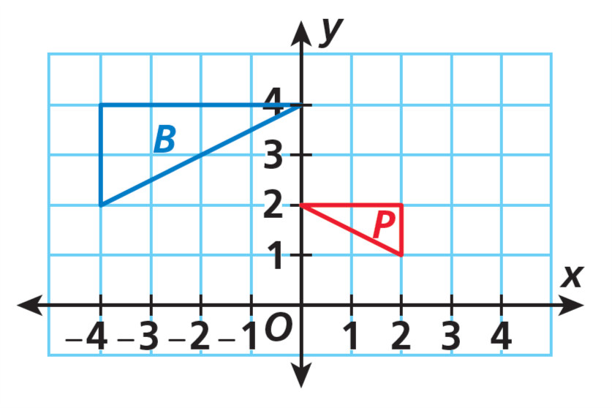

Module 3 Lesson 3 Name: _____________________________

What sequence of transformations could map B to P?

Module 3 Lesson 3 Name: _____________________________

What sequence of transformations could map B to P?

Module 3 Lesson 3 Name: _____________________________

What sequence of transformations could map B to P?

Module 4 Lesson 1 Name: _____________________________

Genevieve is 3 years older than twice her brother’s age.
Genevieve is 21 years old. Write an equation to find her
brother’s age.

Module 4 Lesson 1 Name: _____________________________

Genevieve is 3 years older than twice her brother’s age.
Genevieve is 21 years old. Write an equation to find her
brother’s age.

Module 4 Lesson 1 Name: _____________________________

Genevieve is 3 years older than twice her brother’s age.
Genevieve is 21 years old. Write an equation to find her
brother’s age.

Module 4 Lesson 1 Name: _____________________________

Genevieve is 3 years older than twice her brother’s age.
Genevieve is 21 years old. Write an equation to find her
brother’s age.

Module 4 Lesson 2 Name: _____________________________

A landlord hires a plumber to fix a burst pipe in a basement.
The plumber charges a one-time service charge of $80 plus
an hourly fee. The total cost the landlord had to pay the
plumber for 3 hours of work was $350. Write and solve an
equation to find the plumber’s hourly fee.

Module 4 Lesson 2 Name: _____________________________

A landlord hires a plumber to fix a burst pipe in a basement.
The plumber charges a one-time service charge of $80 plus
an hourly fee. The total cost the landlord had to pay the
plumber for 3 hours of work was $350. Write and solve an
equation to find the plumber’s hourly fee.

Module 4 Lesson 2 Name: _____________________________

A landlord hires a plumber to fix a burst pipe in a basement.
The plumber charges a one-time service charge of $80 plus
an hourly fee. The total cost the landlord had to pay the
plumber for 3 hours of work was $350. Write and solve an
equation to find the plumber’s hourly fee.

Module 4 Lesson 2 Name: _____________________________

A landlord hires a plumber to fix a burst pipe in a basement.
The plumber charges a one-time service charge of $80 plus
an hourly fee. The total cost the landlord had to pay the
plumber for 3 hours of work was $350. Write and solve an
equation to find the plumber’s hourly fee.

Module 4 Lesson 3 Name: _____________________________

Solve the equation using two different methods. Show
your work.

2.25x + 15 = 9.5x + 0.5

Module 4 Lesson 3 Name: _____________________________

Solve the equation using two different methods. Show
your work.

2.25x + 15 = 9.5x + 0.5

Module 4 Lesson 3 Name: _____________________________

Solve the equation using two different methods. Show
your work.

2.25x + 15 = 9.5x + 0.5

Module 4 Lesson 3 Name: _____________________________

Solve the equation using two different methods. Show
your work.

2.25x + 15 = 9.5x + 0.5

Module 4 Lesson 4 Name: _____________________________

Determine how many solutions the equation has. Explain.

2.5x − (1.1x − 2) = 2(0.7x)

Module 4 Lesson 4 Name: _____________________________

Determine how many solutions the equation has. Explain.

2.5x − (1.1x − 2) = 2(0.7x)

Module 4 Lesson 4 Name: _____________________________

Determine how many solutions the equation has. Explain.

2.5x − (1.1x − 2) = 2(0.7x)

Module 4 Lesson 4 Name: _____________________________

Determine how many solutions the equation has. Explain.

2.5x − (1.1x − 2) = 2(0.7x)

Module 4 Lesson 5 Name: _____________________________

Tory and Quentin are the same age. Tory’s younger sister is
the same age as Quentin’s younger brother. Tory is 3 years
older than her sister. Quentin’s age is 8 years less than twice
his brother’s age. Write and solve an equation to determine
Tory’s and Quentin’s ages.

Module 4 Lesson 5 Name: _____________________________

Tory and Quentin are the same age. Tory’s younger sister is
the same age as Quentin’s younger brother. Tory is 3 years
older than her sister. Quentin’s age is 8 years less than twice
his brother’s age. Write and solve an equation to determine
Tory’s and Quentin’s ages.

Module 4 Lesson 5 Name: _____________________________

Tory and Quentin are the same age. Tory’s younger sister is
the same age as Quentin’s younger brother. Tory is 3 years
older than her sister. Quentin’s age is 8 years less than twice
his brother’s age. Write and solve an equation to determine
Tory’s and Quentin’s ages.

Module 4 Lesson 5 Name: _____________________________

Tory and Quentin are the same age. Tory’s younger sister is
the same age as Quentin’s younger brother. Tory is 3 years
older than her sister. Quentin’s age is 8 years less than twice
his brother’s age. Write and solve an equation to determine
Tory’s and Quentin’s ages.

Module 5 Lesson 1 Name: _____________________________

Randall has finished $\frac{3}{5}$ of the minimum number of required
pages for his term paper. He has currently written 21 pages.
How many pages will be in his paper when he finishes?

Write an inequality that represents the problem. Solve the
inequality. Write the solution of the problem.

Module 5 Lesson 1 Name: _____________________________

Randall has finished $\frac{3}{5}$ of the minimum number of required
pages for his term paper. He has currently written 21 pages.
How many pages will be in his paper when he finishes?

Write an inequality that represents the problem. Solve the
inequality. Write the solution of the problem.

Module 5 Lesson 1 Name: _____________________________

Randall has finished $\frac{3}{5}$ of the minimum number of required
pages for his term paper. He has currently written 21 pages.
How many pages will be in his paper when he finishes?

Write an inequality that represents the problem. Solve the
inequality. Write the solution of the problem.

Module 5 Lesson 1 Name: _____________________________

Randall has finished $\frac{3}{5}$ of the minimum number of required
pages for his term paper. He has currently written 21 pages.
How many pages will be in his paper when he finishes?

Write an inequality that represents the problem. Solve the
inequality. Write the solution of the problem.

Module 5 Lesson 2 Name: _____________________________

Pedro wants to get a dog. The shelter requires a $110
rehoming fee. Pedro has $30 saved. He earns $17 per day
from his part-time job.

Write an inequality to determine the minimum number of days he will have to work to save enough for the dog.

Module 5 Lesson 2 Name: _____________________________

Pedro wants to get a dog. The shelter requires a $110
rehoming fee. Pedro has $30 saved. He earns $17 per day
from his part-time job.

Write an inequality to determine the minimum number of days he will have to work to save enough for the dog.

Module 5 Lesson 2 Name: _____________________________

Pedro wants to get a dog. The shelter requires a $110
rehoming fee. Pedro has $30 saved. He earns $17 per day
from his part-time job.

Write an inequality to determine the minimum number of days he will have to work to save enough for the dog.

Module 5 Lesson 2 Name: _____________________________

Pedro wants to get a dog. The shelter requires a $110
rehoming fee. Pedro has $30 saved. He earns $17 per day
from his part-time job.

Write an inequality to determine the minimum number of days he will have to work to save enough for the dog.

Module 5 Lesson 3 Name: _____________________________

Raj has a sticker collection with 35 stickers. He wants to
have at least 100 stickers in his collection. If stickers come in
packs of 12, at least how many packs must he buy to reach
his goal?

Module 5 Lesson 3 Name: _____________________________

Raj has a sticker collection with 35 stickers. He wants to
have at least 100 stickers in his collection. If stickers come in
packs of 12, at least how many packs must he buy to reach
his goal?

Module 5 Lesson 3 Name: _____________________________

Raj has a sticker collection with 35 stickers. He wants to
have at least 100 stickers in his collection. If stickers come in
packs of 12, at least how many packs must he buy to reach
his goal?

Module 5 Lesson 3 Name: _____________________________

Raj has a sticker collection with 35 stickers. He wants to
have at least 100 stickers in his collection. If stickers come in
packs of 12, at least how many packs must he buy to reach
his goal?

Module 6 Lesson 1 Name: _____________________________

An exterior angle of a triangle has a measure of 140°. If the
corresponding remote interior angles are congruent to each other, what is the measure of each angle?

Module 6 Lesson 1 Name: _____________________________

An exterior angle of a triangle has a measure of 140°. If the
corresponding remote interior angles are congruent to each other, what is the measure of each angle?

Module 6 Lesson 1 Name: _____________________________

An exterior angle of a triangle has a measure of 140°. If the
corresponding remote interior angles are congruent to each other, what is the measure of each angle?

Module 6 Lesson 1 Name: _____________________________

An exterior angle of a triangle has a measure of 140°. If the
corresponding remote interior angles are congruent to each other, what is the measure of each angle?

Module 6 Lesson 2 Name: _____________________________

If two triangles are NOT similar, can they have any
corresponding congruent angles? If so, how many pairs of
corresponding congruent angles can they have?

Module 6 Lesson 2 Name: _____________________________

If two triangles are NOT similar, can they have any
corresponding congruent angles? If so, how many pairs of
corresponding congruent angles can they have?

Module 6 Lesson 2 Name: _____________________________

If two triangles are NOT similar, can they have any
corresponding congruent angles? If so, how many pairs of
corresponding congruent angles can they have?

Module 6 Lesson 2 Name: _____________________________

If two triangles are NOT similar, can they have any
corresponding congruent angles? If so, how many pairs of
corresponding congruent angles can they have?

Module 6 Lesson 3 Name: _____________________________

Find the measures of the two angles.

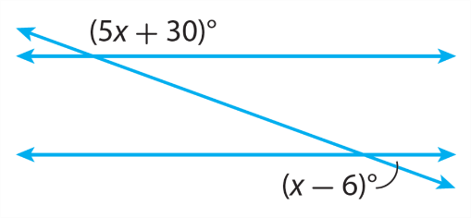

Module 6 Lesson 3 Name: _____________________________

Find the measures of the two angles.

Module 6 Lesson 3 Name: _____________________________

Find the measures of the two angles.

Module 6 Lesson 3 Name: _____________________________

Find the measures of the two angles.

Module 7 Lesson 1 Name: _____________________________

A line passes through the origin and the point (12, 9).
Identify the slope of the line and two additional points on
the line.

Module 7 Lesson 1 Name: _____________________________

A line passes through the origin and the point (12, 9).
Identify the slope of the line and two additional points on
the line.

Module 7 Lesson 1 Name: _____________________________

A line passes through the origin and the point (12, 9).
Identify the slope of the line and two additional points on
the line.

Module 7 Lesson 1 Name: _____________________________

A line passes through the origin and the point (12, 9).
Identify the slope of the line and two additional points on
the line.

Module 7 Lesson 2 Name: _____________________________

Dequan is training for a marathon. He runs 20 miles every
4 days. Write an equation to represent the total number of
miles y he runs in x days.

Module 7 Lesson 2 Name: _____________________________

Dequan is training for a marathon. He runs 20 miles every
4 days. Write an equation to represent the total number of
miles y he runs in x days.

Module 7 Lesson 2 Name: _____________________________

Dequan is training for a marathon. He runs 20 miles every
4 days. Write an equation to represent the total number of
miles y he runs in x days.
.

Module 7 Lesson 2 Name: _____________________________

Dequan is training for a marathon. He runs 20 miles every
4 days. Write an equation to represent the total number of
miles y he runs in x days.

Module 7 Lesson 3 Name: _____________________________

Describe a proportional relationship that would be best
represented with a continuous graph. Explain your reasoning.

Module 7 Lesson 3 Name: _____________________________

Describe a proportional relationship that would be best
represented with a continuous graph. Explain your reasoning.

Module 7 Lesson 3 Name: _____________________________

Describe a proportional relationship that would be best
represented with a continuous graph. Explain your reasoning.

Module 7 Lesson 3 Name: _____________________________

Describe a proportional relationship that would be best
represented with a continuous graph. Explain your reasoning.

Module 8 Lesson 1 Name: _____________________________

Geri is ordering up to six table arrangements that cost $5
each with a $10 set-up fee for the whole order. Graph the
function that represents the cost.

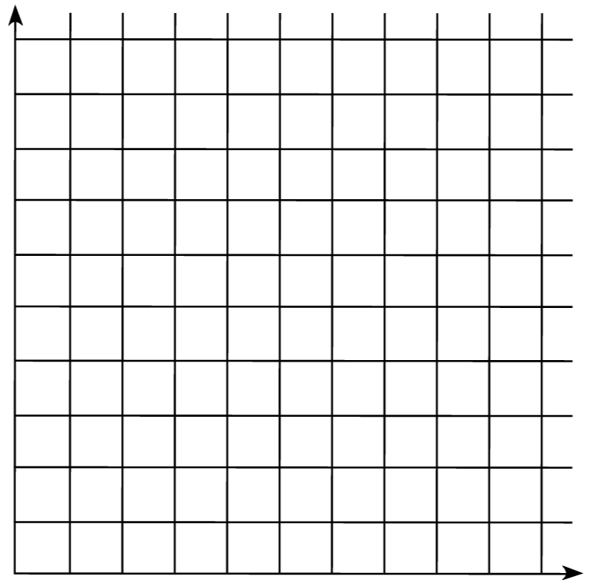

Module 8 Lesson 1 Name: _____________________________

Geri is ordering up to six table arrangements that cost $5
each with a $10 set-up fee for the whole order. Graph the
function that represents the cost.

Module 8 Lesson 1 Name: _____________________________

Geri is ordering up to six table arrangements that cost $5
each with a $10 set-up fee for the whole order. Graph the
function that represents the cost.

Module 8 Lesson 1 Name: _____________________________

Geri is ordering up to six table arrangements that cost $5
each with a $10 set-up fee for the whole order. Graph the
function that represents the cost.

Module 8 Lesson 2 Name: _____________________________

Francesca identifies one point on a line as (1, 4), and she
knows that the slope of the line is 3. What is the y-intercept
and the equation of the line?

Module 8 Lesson 2 Name: _____________________________

Francesca identifies one point on a line as (1, 4), and she
knows that the slope of the line is 3. What is the y-intercept
and the equation of the line?

Module 8 Lesson 2 Name: _____________________________

Francesca identifies one point on a line as (1, 4), and she
knows that the slope of the line is 3. What is the y-intercept
and the equation of the line?

Module 8 Lesson 2 Name: _____________________________

Francesca identifies one point on a line as (1, 4), and she
knows that the slope of the line is 3. What is the y-intercept
and the equation of the line?

Module 8 Lesson 3 Name: _____________________________

Janet purchased a classic toy car as an investment. She wrote the following equation to show the value of the car, y, in
dollars, after x years.

y = 40x - 100

a. What is the initial value, and what does it represent?

b. What is the rate of change, and what does it represent?

Module 8 Lesson 3 Name: _____________________________

Janet purchased a classic toy car as an investment. She wrote the following equation to show the value of the car, y, in
dollars, after x years.

y = 40x - 100

a. What is the initial value, and what does it represent?

b. What is the rate of change, and what does it represent?

Module 8 Lesson 3 Name: _____________________________

Janet purchased a classic toy car as an investment. She wrote the following equation to show the value of the car, y, in
dollars, after x years.

y = 40x - 100

a. What is the initial value, and what does it represent?

b. What is the rate of change, and what does it represent?

Module 8 Lesson 3 Name: _____________________________

Janet purchased a classic toy car as an investment. She wrote the following equation to show the value of the car, y, in
dollars, after x years.

y = 40x - 100

a. What is the initial value, and what does it represent?

b. What is the rate of change, and what does it represent?

Module 8 Lesson 4 Name: _____________________________

Olga is looking to lease a car. Dealer A offers her a $2400
trade-in on her old car, with lease payments of $360 a
month. Dealer B offers a trade-in of $2000 with payments of
$320 a month. Olga wants to lease the car for only 6
months. Which deal is better for her?

Module 8 Lesson 4 Name: _____________________________

Olga is looking to lease a car. Dealer A offers her a $2400
trade-in on her old car, with lease payments of $360 a
month. Dealer B offers a trade-in of $2000 with payments of
$320 a month. Olga wants to lease the car for only 6
months. Which deal is better for her?

Module 8 Lesson 4 Name: _____________________________

Olga is looking to lease a car. Dealer A offers her a $2400
trade-in on her old car, with lease payments of $360 a
month. Dealer B offers a trade-in of $2000 with payments of
$320 a month. Olga wants to lease the car for only 6
months. Which deal is better for her?

Module 8 Lesson 4 Name: _____________________________

Olga is looking to lease a car. Dealer A offers her a $2400
trade-in on her old car, with lease payments of $360 a
month. Dealer B offers a trade-in of $2000 with payments of
$320 a month. Olga wants to lease the car for only 6
months. Which deal is better for her?

Module 8 Lesson 5 Name: _____________________________

Victoria saves the same amount of money each week. After
many weeks, she has enough saved to buy a television. She
purchases the television, then starts saving the same
amount each week.

Describe a graph that represents this situation.

Module 8 Lesson 5 Name: _____________________________

Victoria saves the same amount of money each week. After
many weeks, she has enough saved to buy a television. She
purchases the television, then starts saving the same
amount each week.

Describe a graph that represents this situation.

Module 8 Lesson 5 Name: _____________________________

Victoria saves the same amount of money each week. After
many weeks, she has enough saved to buy a television. She
purchases the television, then starts saving the same
amount each week.

Describe a graph that represents this situation.

Module 8 Lesson 5 Name: _____________________________

Victoria saves the same amount of money each week. After
many weeks, she has enough saved to buy a television. She
purchases the television, then starts saving the same
amount each week.

Describe a graph that represents this situation.

Module 9 Lesson 1 Name: _____________________________

Andy is comparing the cost of frozen yogurt at two shops at
the mall. At Shop A, the total cost y of x ounces of yogurt is
y = 0.25x + 0.25. At Shop B, the total cost y of x ounces of
yogurt is y = 0.25x + 0.5.

Which shop offers a better deal? How is this shown in the graphs of the equations?

Module 9 Lesson 1 Name: _____________________________

Andy is comparing the cost of frozen yogurt at two shops at
the mall. At Shop A, the total cost y of x ounces of yogurt is
y = 0.25x + 0.25. At Shop B, the total cost y of x ounces of
yogurt is y = 0.25x + 0.5.

Which shop offers a better deal? How is this shown in the graphs of the equations?

Module 9 Lesson 1 Name: _____________________________

Andy is comparing the cost of frozen yogurt at two shops at
the mall. At Shop A, the total cost y of x ounces of yogurt is
y = 0.25x + 0.25. At Shop B, the total cost y of x ounces of
yogurt is y = 0.25x + 0.5.

Which shop offers a better deal? How is this shown in the graphs of the equations?

Module 9 Lesson 1 Name: _____________________________

Andy is comparing the cost of frozen yogurt at two shops at
the mall. At Shop A, the total cost y of x ounces of yogurt is
y = 0.25x + 0.25. At Shop B, the total cost y of x ounces of
yogurt is y = 0.25x + 0.5.

Which shop offers a better deal? How is this shown in the graphs of the equations?

Module 9 Lesson 2 Name: _____________________________

The two straight paths in a community garden are
represented by the equations y = −x + 4 and y = 0.5x − 2.
At what point, if any, do the paths intersect?

Module 9 Lesson 2 Name: _____________________________

The two straight paths in a community garden are
represented by the equations y = −x + 4 and y = 0.5x − 2.
At what point, if any, do the paths intersect?

Module 9 Lesson 2 Name: _____________________________

The two straight paths in a community garden are
represented by the equations y = −x + 4 and y = 0.5x − 2.
At what point, if any, do the paths intersect?

Module 9 Lesson 2 Name: _____________________________

The two straight paths in a community garden are
represented by the equations y = −x + 4 and y = 0.5x − 2.
At what point, if any, do the paths intersect?

Module 9 Lesson 3 Name: _____________________________

Solve the following system of equations by substitution.
$$\left\{\begin{aligned}3x-2y=-22 \\ 2x+y=-3\end{aligned}\right.$$

Module 9 Lesson 3 Name: _____________________________

Solve the following system of equations by substitution.
$$\left\{\begin{aligned}3x-2y=-22 \\ 2x+y=-3\end{aligned}\right.$$

Module 9 Lesson 3 Name: _____________________________

Solve the following system of equations by substitution.
$$\left\{\begin{aligned}3x-2y=-22 \\ 2x+y=-3\end{aligned}\right.$$

Module 9 Lesson 3 Name: _____________________________

Solve the following system of equations by substitution.
$$\left\{\begin{aligned}3x-2y=-22 \\ 2x+y=-3\end{aligned}\right.$$

Module 9 Lesson 4 Name: _____________________________

What is the value of a in the solution to the system of
equations?
$$\left\{\begin{aligned}3a+2b=3 \\ 4a+5b=18\end{aligned}\right.$$

Module 9 Lesson 4 Name: _____________________________

What is the value of a in the solution to the system of
equations?
$$\left\{\begin{aligned}3a+2b=3 \\ 4a+5b=18\end{aligned}\right.$$

Module 9 Lesson 4 Name: _____________________________

What is the value of a in the solution to the system of
equations?
$$\left\{\begin{aligned}3a+2b=3 \\ 4a+5b=18\end{aligned}\right.$$

Module 9 Lesson 4 Name: _____________________________

What is the value of a in the solution to the system of
equations?
$$\left\{\begin{aligned}3a+2b=3 \\ 4a+5b=18\end{aligned}\right.$$

Module 9 Lesson 5 Name: _____________________________

How many solutions does the system of equations have?
Explain.

$$\left\{\begin{aligned}x-2y=6 \\ y=\frac{1}{2}x+3\end{aligned}\right.$$

Module 9 Lesson 5 Name: _____________________________

How many solutions does the system of equations have?
Explain.

$$\left\{\begin{aligned}x-2y=6 \\ y=\frac{1}{2}x+3\end{aligned}\right.$$

Module 9 Lesson 5 Name: _____________________________

How many solutions does the system of equations have?
Explain.

$$\left\{\begin{aligned}x-2y=6 \\ y=\frac{1}{2}x+3\end{aligned}\right.$$

Module 9 Lesson 5 Name: _____________________________

How many solutions does the system of equations have?
Explain.

$$\left\{\begin{aligned}x-2y=6 \\ y=\frac{1}{2}x+3\end{aligned}\right.$$

Module 9 Lesson 6 Name: _____________________________

Anna and Celine buy fruit at a local farm stand. Anna pays
$3.66 for 4 apples and 3 peaches. Celine pays $4.00 for
2 apples and 5 peaches. What is the price for one apple at
the farm stand?

Module 9 Lesson 6 Name: _____________________________

Anna and Celine buy fruit at a local farm stand. Anna pays
$3.66 for 4 apples and 3 peaches. Celine pays $4.00 for
2 apples and 5 peaches. What is the price for one apple at
the farm stand?

Module 9 Lesson 6 Name: _____________________________

Anna and Celine buy fruit at a local farm stand. Anna pays
$3.66 for 4 apples and 3 peaches. Celine pays $4.00 for
2 apples and 5 peaches. What is the price for one apple at
the farm stand?

Module 9 Lesson 6 Name: _____________________________

Anna and Celine buy fruit at a local farm stand. Anna pays
$3.66 for 4 apples and 3 peaches. Celine pays $4.00 for
2 apples and 5 peaches. What is the price for one apple at
the farm stand?

Module 10 Lesson 1 Name: _____________________________

For 12 shows, theater attendance ranges from 30 to 100
patrons, with a cluster near 60, and snack sales range from
$20 to $80. Draw a possible scatter plot that shows a strong
positive association between attendance and snack sales.

Module 10 Lesson 1 Name: _____________________________

For 12 shows, theater attendance ranges from 30 to 100
patrons, with a cluster near 60, and snack sales range from
$20 to $80. Draw a possible scatter plot that shows a strong
positive association between attendance and snack sales.

Module 10 Lesson 1 Name: _____________________________

For 12 shows, theater attendance ranges from 30 to 100
patrons, with a cluster near 60, and snack sales range from
$20 to $80. Draw a possible scatter plot that shows a strong
positive association between attendance and snack sales.

Module 10 Lesson 1 Name: _____________________________

For 12 shows, theater attendance ranges from 30 to 100
patrons, with a cluster near 60, and snack sales range from
$20 to $80. Draw a possible scatter plot that shows a strong
positive association between attendance and snack sales.

Module 10 Lesson 2 Name: _____________________________

How can you determine whether a line is a reasonable trend
line for a data set?

Module 10 Lesson 2 Name: _____________________________

How can you determine whether a line is a reasonable trend
line for a data set?

Module 10 Lesson 2 Name: _____________________________

How can you determine whether a line is a reasonable trend
line for a data set?

Module 10 Lesson 2 Name: _____________________________

How can you determine whether a line is a reasonable trend
line for a data set?

Module 10 Lesson 3 Name: _____________________________

The table shows the Tigers’ scores for 10 games.

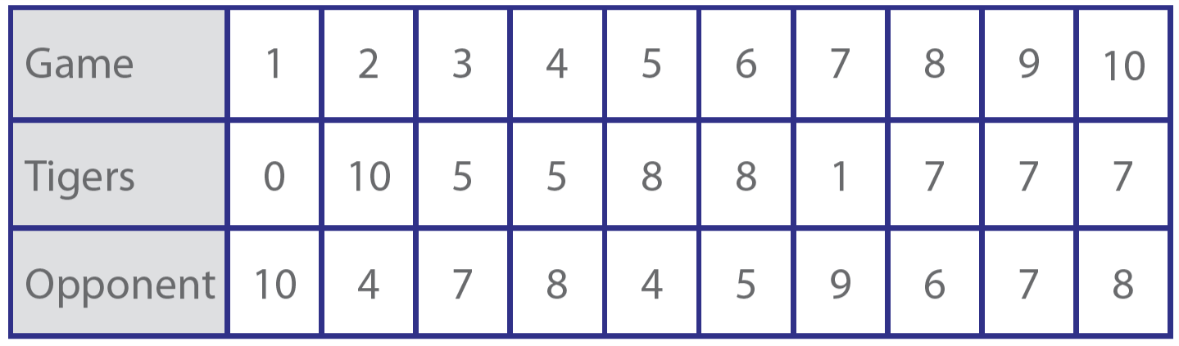

Draw a scatter plot for the data and draw a trend line. Then
describe the association.

Module 10 Lesson 3 Name: _____________________________

The table shows the Tigers’ scores for 10 games.

Draw a scatter plot for the data and draw a trend line. Then
describe the association.

Module 11 Lesson 1 Name: _____________________________

Every fifth person entering a store was asked about snacks.
Identify the population and sample. Is the sample random?

Module 11 Lesson 1 Name: _____________________________

Every fifth person entering a store was asked about snacks.
Identify the population and sample. Is the sample random?

Module 11 Lesson 1 Name: _____________________________

Every fifth person entering a store was asked about snacks.
Identify the population and sample. Is the sample random?

Module 11 Lesson 1 Name: _____________________________

Every fifth person entering a store was asked about snacks.
Identify the population and sample. Is the sample random?

Module 11 Lesson 2 Name: _____________________________

A chair manufacturer randomly selects every tenth chair from
a production line to check for flaws. Out of 200 chairs, 2 have
flaws. Predict the total number of chairs with flaws, if the total
population consists of 5,000 chairs. Show your work.

Module 11 Lesson 2 Name: _____________________________

A chair manufacturer randomly selects every tenth chair from
a production line to check for flaws. Out of 200 chairs, 2 have
flaws. Predict the total number of chairs with flaws, if the total
population consists of 5,000 chairs. Show your work.

Module 11 Lesson 2 Name: _____________________________

A chair manufacturer randomly selects every tenth chair from
a production line to check for flaws. Out of 200 chairs, 2 have
flaws. Predict the total number of chairs with flaws, if the total
population consists of 5,000 chairs. Show your work.

Module 11 Lesson 2 Name: _____________________________

A chair manufacturer randomly selects every tenth chair from
a production line to check for flaws. Out of 200 chairs, 2 have
flaws. Predict the total number of chairs with flaws, if the total
population consists of 5,000 chairs. Show your work.

Module 11 Lesson 3 Name: _____________________________

In a cafeteria, 70% of students prefer chicken tenders to
hamburgers. The cafeteria manager took a random sample
of 20 students and found that 12 students prefer chicken
tenders.

Find the sample ratio. Then compare the sample ratio to the population ratio.

Module 11 Lesson 3 Name: _____________________________

In a cafeteria, 70% of students prefer chicken tenders to
hamburgers. The cafeteria manager took a random sample
of 20 students and found that 12 students prefer chicken
tenders.

Find the sample ratio. Then compare the sample ratio to the population ratio.

Module 11 Lesson 3 Name: _____________________________

In a cafeteria, 70% of students prefer chicken tenders to
hamburgers. The cafeteria manager took a random sample
of 20 students and found that 12 students prefer chicken
tenders.

Find the sample ratio. Then compare the sample ratio to the population ratio.

Module 11 Lesson 3 Name: _____________________________

In a cafeteria, 70% of students prefer chicken tenders to
hamburgers. The cafeteria manager took a random sample
of 20 students and found that 12 students prefer chicken
tenders.

Find the sample ratio. Then compare the sample ratio to the population ratio.

Module 12 Lesson 1 Name: _____________________________

Jack compares his math exam scores from last year and this
year.

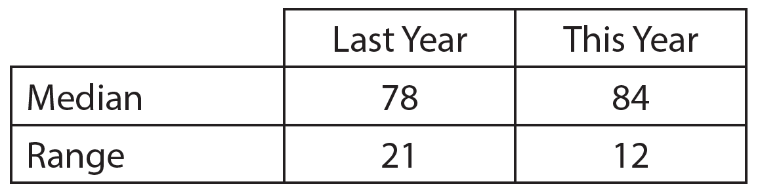

Describe how his performance in math class this year
compares to last year.

Module 12 Lesson 1 Name: _____________________________

Jack compares his math exam scores from last year and this
year.

Describe how his performance in math class this year
compares to last year.

Module 12 Lesson 1 Name: _____________________________

Jack compares his math exam scores from last year and this
year.

Describe how his performance in math class this year
compares to last year.

Module 12 Lesson 1 Name: _____________________________

Jack compares his math exam scores from last year and this
year.

Describe how his performance in math class this year
compares to last year.

Module 12 Lesson 2 Name: _____________________________

How can you use box plots to compare the centers and
spreads of data sets?

Module 12 Lesson 2 Name: _____________________________

How can you use box plots to compare the centers and
spreads of data sets?

Module 12 Lesson 2 Name: _____________________________

How can you use box plots to compare the centers and
spreads of data sets?

Module 12 Lesson 2 Name: _____________________________

How can you use box plots to compare the centers and
spreads of data sets?

Module 12 Lesson 3 Name: _____________________________

Two data samples each have a MAD close to 10.1. The
difference of the means is close to 30. What is the ratio of
the difference of the means to the MAD? Would you expect
to see a little, a lot, or no overlap when the data sets are
displayed in dot plots?

Module 12 Lesson 3 Name: _____________________________

Two data samples each have a MAD close to 10.1. The
difference of the means is close to 30. What is the ratio of
the difference of the means to the MAD? Would you expect
to see a little, a lot, or no overlap when the data sets are
displayed in dot plots?

Module 12 Lesson 3 Name: _____________________________

Two data samples each have a MAD close to 10.1. The
difference of the means is close to 30. What is the ratio of
the difference of the means to the MAD? Would you expect
to see a little, a lot, or no overlap when the data sets are
displayed in dot plots?

Module 12 Lesson 3 Name: _____________________________

Two data samples each have a MAD close to 10.1. The
difference of the means is close to 30. What is the ratio of
the difference of the means to the MAD? Would you expect
to see a little, a lot, or no overlap when the data sets are
displayed in dot plots?

Module 13 Lesson 1 Name: _____________________________

In a survey of 100 students, 60% wake up with an alarm
clock. Of those who wake up with an alarm clock, 80% eat
breakfast at home. Among those who do not use an alarm
clock, 25% eat breakfast at home. Construct a two-way
frequency table to display the data.

Module 13 Lesson 1 Name: _____________________________

In a survey of 100 students, 60% wake up with an alarm
clock. Of those who wake up with an alarm clock, 80% eat
breakfast at home. Among those who do not use an alarm
clock, 25% eat breakfast at home. Construct a two-way
frequency table to display the data.

Module 13 Lesson 1 Name: _____________________________

In a survey of 100 students, 60% wake up with an alarm
clock. Of those who wake up with an alarm clock, 80% eat
breakfast at home. Among those who do not use an alarm
clock, 25% eat breakfast at home. Construct a two-way
frequency table to display the data.

Module 13 Lesson 1 Name: _____________________________

In a survey of 100 students, 60% wake up with an alarm
clock. Of those who wake up with an alarm clock, 80% eat
breakfast at home. Among those who do not use an alarm
clock, 25% eat breakfast at home. Construct a two-way
frequency table to display the data.

Module 13 Lesson 2 Name: _____________________________

The table shows data from a survey in which students were
asked whether they study French or Spanish and whether
they are in the school’s movie club. Is there an association
between the language a student studies and whether he or
she is in the movie club? Explain.

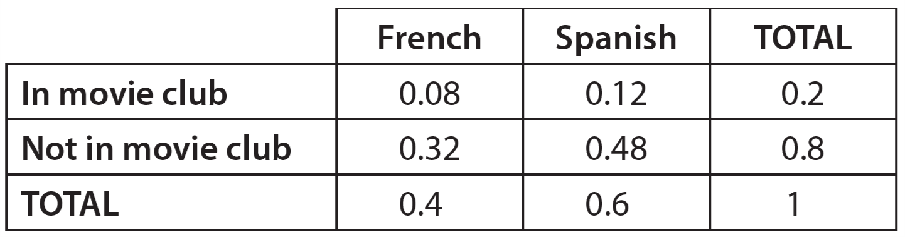

Module 13 Lesson 2 Name: _____________________________

The table shows data from a survey in which students were
asked whether they study French or Spanish and whether
they are in the school’s movie club. Is there an association
between the language a student studies and whether he or
she is in the movie club? Explain.

Module 13 Lesson 2 Name: _____________________________

The table shows data from a survey in which students were
asked whether they study French or Spanish and whether
they are in the school’s movie club. Is there an association
between the language a student studies and whether he or
she is in the movie club? Explain.

Module 13 Lesson 2 Name: _____________________________

The table shows data from a survey in which students were
asked whether they study French or Spanish and whether
they are in the school’s movie club. Is there an association
between the language a student studies and whether he or
she is in the movie club? Explain.

Module 14 Lesson 1 Name: _____________________________

Is the decimal 0.888 . . . rational or irrational? If it is rational,
write it as a fraction. If it is irrational, explain why.

Module 14 Lesson 1 Name: _____________________________

Is the decimal 0.888 . . . rational or irrational? If it is rational,
write it as a fraction. If it is irrational, explain why.

Module 14 Lesson 1 Name: _____________________________

Is the decimal 0.888 . . . rational or irrational? If it is rational,
write it as a fraction. If it is irrational, explain why.

Module 14 Lesson 1 Name: _____________________________

Is the decimal 0.888 . . . rational or irrational? If it is rational,
write it as a fraction. If it is irrational, explain why.

Module 14 Lesson 2 Name: _____________________________

A cube has a volume of $\frac{64}{125}$ cubic feet. What is the edge
length of the cube?

Module 14 Lesson 2 Name: _____________________________

A cube has a volume of $\frac{64}{125}$ cubic feet. What is the edge
length of the cube?

Module 14 Lesson 2 Name: _____________________________

A cube has a volume of $\frac{64}{125}$ cubic feet. What is the edge
length of the cube?

Module 14 Lesson 2 Name: _____________________________

A cube has a volume of $\frac{64}{125}$ cubic feet. What is the edge
length of the cube?

Module 14 Lesson 3 Name: _____________________________

Marc claims that $\sqrt{17}$ is greater than $\sqrt[3]{71}$. Jenny claims that
it is impossible to compare the numbers without a
calculator. Is either friend correct? Explain.

Module 14 Lesson 3 Name: _____________________________

Marc claims that $\sqrt{17}$ is greater than $\sqrt[3]{71}$. Jenny claims that
it is impossible to compare the numbers without a
calculator. Is either friend correct? Explain.

Module 14 Lesson 3 Name: _____________________________

Marc claims that $\sqrt{17}$ is greater than $\sqrt[3]{71}$. Jenny claims that
it is impossible to compare the numbers without a
calculator. Is either friend correct? Explain.

Module 14 Lesson 3 Name: _____________________________

Marc claims that $\sqrt{17}$ is greater than $\sqrt[3]{71}$. Jenny claims that
it is impossible to compare the numbers without a
calculator. Is either friend correct? Explain.

Module 15 Lesson 1 Name: _____________________________

A right triangle has leg lengths of 9 meters and 12 meters.
What is the length of the hypotenuse?

Module 15 Lesson 1 Name: _____________________________

A right triangle has leg lengths of 9 meters and 12 meters.
What is the length of the hypotenuse?

Module 15 Lesson 1 Name: _____________________________

A right triangle has leg lengths of 9 meters and 12 meters.
What is the length of the hypotenuse?

Module 15 Lesson 1 Name: _____________________________

A right triangle has leg lengths of 9 meters and 12 meters.
What is the length of the hypotenuse?

Module 15 Lesson 2 Name: _____________________________

An artist is constructing a piece of art in the shape of a
rectangle. The artist wants to use string to tightly tie each
vertex of the rectangle to the other three vertices. The
rectangle is 12.0 feet wide and 7.0 feet long. How much
string should the artist use? Round your answer to the
nearest tenth of a foot.

Module 15 Lesson 2 Name: _____________________________

An artist is constructing a piece of art in the shape of a
rectangle. The artist wants to use string to tightly tie each
vertex of the rectangle to the other three vertices. The
rectangle is 12.0 feet wide and 7.0 feet long. How much
string should the artist use? Round your answer to the
nearest tenth of a foot.

Module 15 Lesson 2 Name: _____________________________

An artist is constructing a piece of art in the shape of a
rectangle. The artist wants to use string to tightly tie each
vertex of the rectangle to the other three vertices. The
rectangle is 12.0 feet wide and 7.0 feet long. How much
string should the artist use? Round your answer to the
nearest tenth of a foot.

Module 15 Lesson 2 Name: _____________________________

An artist is constructing a piece of art in the shape of a
rectangle. The artist wants to use string to tightly tie each
vertex of the rectangle to the other three vertices. The
rectangle is 12.0 feet wide and 7.0 feet long. How much
string should the artist use? Round your answer to the
nearest tenth of a foot.

Module 15 Lesson 3 Name: _____________________________

Points A, B, C, and D have the following coordinates:

A: (–3, 7) B: (1, 2) C: (–3, 1) D: (3, –2)

Which segment is longer, $\overline{AB}$ or $\overline{CD}$? How much longer?
Round to the nearest tenth.

Module 15 Lesson 3 Name: _____________________________

Points A, B, C, and D have the following coordinates:

A: (–3, 7) B: (1, 2) C: (–3, 1) D: (3, –2)

Which segment is longer, $\overline{AB}$ or $\overline{CD}$? How much longer?
Round to the nearest tenth.

Module 15 Lesson 3 Name: _____________________________

Points A, B, C, and D have the following coordinates:

A: (–3, 7) B: (1, 2) C: (–3, 1) D: (3, –2)

Which segment is longer, $\overline{AB}$ or $\overline{CD}$? How much longer?
Round to the nearest tenth.

Module 15 Lesson 3 Name: _____________________________

Points A, B, C, and D have the following coordinates:

A: (–3, 7) B: (1, 2) C: (–3, 1) D: (3, –2)

Which segment is longer, $\overline{AB}$ or $\overline{CD}$? How much longer?
Round to the nearest tenth.

Module 16 Lesson 1 Name: _____________________________

Simplify $\frac{7^{-1}∙7^{5}}{7^{6}}$.

Module 16 Lesson 1 Name: _____________________________

Simplify $\frac{7^{-1}∙7^{5}}{7^{6}}$.

Module 16 Lesson 1 Name: _____________________________

Simplify $\frac{7^{-1}∙7^{5}}{7^{6}}$.

Module 16 Lesson 1 Name: _____________________________

Simplify $\frac{7^{-1}∙7^{5}}{7^{6}}$.

Module 16 Lesson 2 Name: _____________________________

Determine which number is greater and tell how many
times as great: 4.5 × 10⁹ and 9 × 10⁶.

Module 16 Lesson 2 Name: _____________________________

Determine which number is greater and tell how many
times as great: 4.5 × 10⁹ and 9 × 10⁶.

Module 16 Lesson 2 Name: _____________________________

Determine which number is greater and tell how many
times as great: 4.5 × 10⁹ and 9 × 10⁶.

Module 16 Lesson 2 Name: _____________________________

Determine which number is greater and tell how many
times as great: 4.5 × 10⁹ and 9 × 10⁶.

Module 16 Lesson 3 Name: _____________________________

The population of City A is 4.1 × 10⁶. The population of
City B is 9.6 × 10⁵. Which city has a greater population? How
much greater?

Module 16 Lesson 3 Name: _____________________________

The population of City A is 4.1 × 10⁶. The population of
City B is 9.6 × 10⁵. Which city has a greater population? How
much greater?

Module 16 Lesson 3 Name: _____________________________

The population of City A is 4.1 × 10⁶. The population of
City B is 9.6 × 10⁵. Which city has a greater population? How
much greater?

Module 16 Lesson 3 Name: _____________________________

The population of City A is 4.1 × 10⁶. The population of
City B is 9.6 × 10⁵. Which city has a greater population? How
much greater?

Module 17 Lesson 1 Name: _____________________________

Emir bought a circular clock that is 14 inches across its face.
What is the circumference of the clock? Use $\frac{22}{7}$ for π.

Module 17 Lesson 1 Name: _____________________________

Emir bought a circular clock that is 14 inches across its face.
What is the circumference of the clock? Use $\frac{22}{7}$ for π.

Module 17 Lesson 1 Name: _____________________________

Emir bought a circular clock that is 14 inches across its face.
What is the circumference of the clock? Use $\frac{22}{7}$ for π.

Module 17 Lesson 1 Name: _____________________________

Emir bought a circular clock that is 14 inches across its face.
What is the circumference of the clock? Use $\frac{22}{7}$ for π.

Module 17 Lesson 2 Name: _____________________________

Bella’s tennis racket has a circular head with a diameter of
16 inches. What is the combined area of both sides of her
racket rounded to the nearest hundredth of a square inch?
Use 3.14 for π.

Module 17 Lesson 2 Name: _____________________________

Bella’s tennis racket has a circular head with a diameter of
16 inches. What is the combined area of both sides of her
racket rounded to the nearest hundredth of a square inch?
Use 3.14 for π.

Module 17 Lesson 2 Name: _____________________________

Bella’s tennis racket has a circular head with a diameter of
16 inches. What is the combined area of both sides of her
racket rounded to the nearest hundredth of a square inch?
Use 3.14 for π.

Module 17 Lesson 2 Name: _____________________________

Bella’s tennis racket has a circular head with a diameter of
16 inches. What is the combined area of both sides of her
racket rounded to the nearest hundredth of a square inch?
Use 3.14 for π.

Module 17 Lesson 3 Name: _____________________________

Jacob is making a banner. He attaches a triangle that is
22 inches wide and 4 inches tall to a rectangle that is
36 inches tall and 22 inches wide. What is the area of
the banner?

Module 17 Lesson 3 Name: _____________________________

Jacob is making a banner. He attaches a triangle that is
22 inches wide and 4 inches tall to a rectangle that is
36 inches tall and 22 inches wide. What is the area of
the banner?

Module 17 Lesson 3 Name: _____________________________

Jacob is making a banner. He attaches a triangle that is
22 inches wide and 4 inches tall to a rectangle that is
36 inches tall and 22 inches wide. What is the area of
the banner?

Module 17 Lesson 3 Name: _____________________________

Jacob is making a banner. He attaches a triangle that is
22 inches wide and 4 inches tall to a rectangle that is
36 inches tall and 22 inches wide. What is the area of
the banner?

Module 18 Lesson 1 Name: _____________________________

Find the area of a vertical cross section through the center
of the base of a rectangular prism with a height of 18 inches
and a width of 36 inches.

Module 18 Lesson 1 Name: _____________________________

Find the area of a vertical cross section through the center
of the base of a rectangular prism with a height of 18 inches
and a width of 36 inches.

Module 18 Lesson 1 Name: _____________________________

Find the area of a vertical cross section through the center
of the base of a rectangular prism with a height of 18 inches
and a width of 36 inches.

Module 18 Lesson 1 Name: _____________________________

Find the area of a vertical cross section through the center
of the base of a rectangular prism with a height of 18 inches
and a width of 36 inches.

Module 18 Lesson 2 Name: _____________________________

A rectangular prism has dimensions 5 in. by 4 in. by 12 in.
What is the surface area of the prism?

Module 18 Lesson 2 Name: _____________________________

A rectangular prism has dimensions 5 in. by 4 in. by 12 in.
What is the surface area of the prism?

Module 18 Lesson 2 Name: _____________________________

A rectangular prism has dimensions 5 in. by 4 in. by 12 in.
What is the surface area of the prism?

Module 18 Lesson 2 Name: _____________________________

A rectangular prism has dimensions 5 in. by 4 in. by 12 in.
What is the surface area of the prism?

Module 18 Lesson 3 Name: _____________________________

A rectangular prism has dimensions 3.2 m by 6 m by 1.5 m.
What is the volume of the prism?

Module 18 Lesson 3 Name: _____________________________

A rectangular prism has dimensions 3.2 m by 6 m by 1.5 m.
What is the volume of the prism?

Module 18 Lesson 3 Name: _____________________________

A rectangular prism has dimensions 3.2 m by 6 m by 1.5 m.
What is the volume of the prism?

Module 18 Lesson 3 Name: _____________________________

A rectangular prism has dimensions 3.2 m by 6 m by 1.5 m.
What is the volume of the prism?

Module 18 Lesson 4 Name: _____________________________

A cylinder has a diameter of 8 meters and a height of 10
meters. What is the volume of the cylinder? Leave your
answer in terms of π.

Module 18 Lesson 4 Name: _____________________________

A cylinder has a diameter of 8 meters and a height of 10
meters. What is the volume of the cylinder? Leave your
answer in terms of π.

Module 18 Lesson 4 Name: _____________________________

A cylinder has a diameter of 8 meters and a height of 10
meters. What is the volume of the cylinder? Leave your
answer in terms of π.

Module 18 Lesson 4 Name: _____________________________

A cylinder has a diameter of 8 meters and a height of 10
meters. What is the volume of the cylinder? Leave your
answer in terms of π.

Module 18 Lesson 5 Name: _____________________________

A sphere has a diameter of 8 feet. What is the volume of the
sphere to the nearest tenth of a cubic foot? Use 3.14 for π.

Module 18 Lesson 5 Name: _____________________________

A sphere has a diameter of 8 feet. What is the volume of the
sphere to the nearest tenth of a cubic foot? Use 3.14 for π.

Module 18 Lesson 5 Name: _____________________________

A sphere has a diameter of 8 feet. What is the volume of the
sphere to the nearest tenth of a cubic foot? Use 3.14 for π.

Module 18 Lesson 5 Name: _____________________________

A sphere has a diameter of 8 feet. What is the volume of the
sphere to the nearest tenth of a cubic foot? Use 3.14 for π.

Module 18 Lesson 6 Name: _____________________________

A rectangular prism has a square base with side length of
10 inches. The volume of the prism is 1600 cubic inches.
Find the surface area of the prism.

Module 18 Lesson 6 Name: _____________________________

A rectangular prism has a square base with side length of
10 inches. The volume of the prism is 1600 cubic inches.
Find the surface area of the prism.

Module 18 Lesson 6 Name: _____________________________

A rectangular prism has a square base with side length of
10 inches. The volume of the prism is 1600 cubic inches.
Find the surface area of the prism.

Module 18 Lesson 6 Name: _____________________________

A rectangular prism has a square base with side length of
10 inches. The volume of the prism is 1600 cubic inches.
Find the surface area of the prism.

Module 19 Lesson 1 Name: _____________________________

Describe the probabilities of a likely event and an event that
is as likely as not using a number or a number range.

Module 19 Lesson 1 Name: _____________________________

Describe the probabilities of a likely event and an event that
is as likely as not using a number or a number range.

Module 19 Lesson 1 Name: _____________________________

Describe the probabilities of a likely event and an event that
is as likely as not using a number or a number range.

Module 19 Lesson 1 Name: _____________________________

Describe the probabilities of a likely event and an event that
is as likely as not using a number or a number range.

Module 19 Lesson 2 Name: _____________________________

Blake spun a spinner 80 times. The spinner is divided into
5 equal sections labeled A, B, C, D, and E. He landed on
A 12 times, B 16 times, C 19 times, D 18 times, and E 15
times. Find the experimental probability of each event in
simplest terms.

Module 19 Lesson 2 Name: _____________________________

Blake spun a spinner 80 times. The spinner is divided into
5 equal sections labeled A, B, C, D, and E. He landed on
A 12 times, B 16 times, C 19 times, D 18 times, and E 15
times. Find the experimental probability of each event in
simplest terms.

Module 19 Lesson 2 Name: _____________________________

Blake spun a spinner 80 times. The spinner is divided into
5 equal sections labeled A, B, C, D, and E. He landed on
A 12 times, B 16 times, C 19 times, D 18 times, and E 15
times. Find the experimental probability of each event in
simplest terms.

Module 19 Lesson 2 Name: _____________________________

Blake spun a spinner 80 times. The spinner is divided into
5 equal sections labeled A, B, C, D, and E. He landed on
A 12 times, B 16 times, C 19 times, D 18 times, and E 15
times. Find the experimental probability of each event in
simplest terms.

Module 19 Lesson 3 Name: _____________________________

The table shows the number of yogurt requests by cafe
customers. Find the experimental probability that the next
yogurt order is a low-fat peach yogurt.

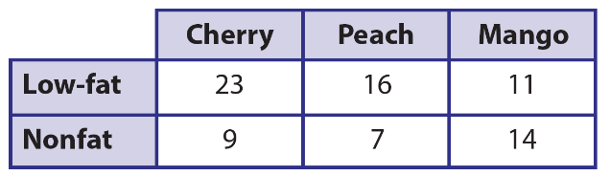

Module 19 Lesson 3 Name: _____________________________

The table shows the number of yogurt requests by cafe
customers. Find the experimental probability that the next
yogurt order is a low-fat peach yogurt.

Module 19 Lesson 3 Name: _____________________________

The table shows the number of yogurt requests by cafe
customers. Find the experimental probability that the next
yogurt order is a low-fat peach yogurt.

Module 19 Lesson 3 Name: _____________________________

The table shows the number of yogurt requests by cafe
customers. Find the experimental probability that the next
yogurt order is a low-fat peach yogurt.

Module 19 Lesson 4 Name: _____________________________

Mercedes notices that of the first 100 vehicles driving by
her school, 85 of them are cars. Using proportional
reasoning and a percent equation, estimate how many
vehicles out of the next 1,500 are cars.

Module 19 Lesson 4 Name: _____________________________

Mercedes notices that of the first 100 vehicles driving by
her school, 85 of them are cars. Using proportional
reasoning and a percent equation, estimate how many
vehicles out of the next 1,500 are cars.

Module 19 Lesson 4 Name: _____________________________

Mercedes notices that of the first 100 vehicles driving by
her school, 85 of them are cars. Using proportional
reasoning and a percent equation, estimate how many
vehicles out of the next 1,500 are cars.

Module 19 Lesson 4 Name: _____________________________

Mercedes notices that of the first 100 vehicles driving by
her school, 85 of them are cars. Using proportional
reasoning and a percent equation, estimate how many
vehicles out of the next 1,500 are cars.

Module 20 Lesson 1 Name: _____________________________

A bag contains 7 orange marbles, 4 yellow marbles, 6 blue
marbles, and 3 green marbles. What is the theoretical
probability of randomly selecting a blue marble from the
bag? Give your answer as a fraction, decimal, and
percent.

Module 20 Lesson 1 Name: _____________________________

A bag contains 7 orange marbles, 4 yellow marbles, 6 blue
marbles, and 3 green marbles. What is the theoretical
probability of randomly selecting a blue marble from the
bag? Give your answer as a fraction, decimal, and
percent.

Module 20 Lesson 1 Name: _____________________________

A bag contains 7 orange marbles, 4 yellow marbles, 6 blue
marbles, and 3 green marbles. What is the theoretical
probability of randomly selecting a blue marble from the
bag? Give your answer as a fraction, decimal, and
percent.

Module 20 Lesson 1 Name: _____________________________

A bag contains 7 orange marbles, 4 yellow marbles, 6 blue
marbles, and 3 green marbles. What is the theoretical
probability of randomly selecting a blue marble from the
bag? Give your answer as a fraction, decimal, and
percent.

Module 20 Lesson 2 Name: _____________________________

Amir spins a spinner with 4 equal sections labeled 1–4 and
rolls a number cube labeled 1–6. Find the probability that
Amir gets a sum of 7.

Module 20 Lesson 2 Name: _____________________________

Amir spins a spinner with 4 equal sections labeled 1–4 and
rolls a number cube labeled 1–6. Find the probability that
Amir gets a sum of 7.

Module 20 Lesson 2 Name: _____________________________

Amir spins a spinner with 4 equal sections labeled 1–4 and
rolls a number cube labeled 1–6. Find the probability that
Amir gets a sum of 7.

Module 20 Lesson 2 Name: _____________________________

Amir spins a spinner with 4 equal sections labeled 1–4 and
rolls a number cube labeled 1–6. Find the probability that
Amir gets a sum of 7.

Module 20 Lesson 3 Name: _____________________________

Ivan is going to spin a spinner with 6 equal sections labeled
1–6 and flip a coin 2,400 times. Write and solve a proportion
to predict the number of times the spinner lands on 5 and
the coin lands on tails.

Module 20 Lesson 3 Name: _____________________________

Ivan is going to spin a spinner with 6 equal sections labeled
1–6 and flip a coin 2,400 times. Write and solve a proportion
to predict the number of times the spinner lands on 5 and
the coin lands on tails.

Module 20 Lesson 3 Name: _____________________________

Ivan is going to spin a spinner with 6 equal sections labeled
1–6 and flip a coin 2,400 times. Write and solve a proportion
to predict the number of times the spinner lands on 5 and
the coin lands on tails.

Module 20 Lesson 3 Name: _____________________________

Ivan is going to spin a spinner with 6 equal sections labeled
1–6 and flip a coin 2,400 times. Write and solve a proportion
to predict the number of times the spinner lands on 5 and
the coin lands on tails.

Module 20 Lesson 4 Name: _____________________________

A retailer mails postcards to its customers and 40% of the
postcards include a coupon. Explain how to simulate this
situation in order to find the experimental probability that the
third postcard mailed is the first to include a coupon.

Module 20 Lesson 4 Name: _____________________________

A retailer mails postcards to its customers and 40% of the
postcards include a coupon. Explain how to simulate this
situation in order to find the experimental probability that the
third postcard mailed is the first to include a coupon.

Module 20 Lesson 4 Name: _____________________________

A retailer mails postcards to its customers and 40% of the
postcards include a coupon. Explain how to simulate this
situation in order to find the experimental probability that the
third postcard mailed is the first to include a coupon.

Module 20 Lesson 4 Name: _____________________________

A retailer mails postcards to its customers and 40% of the
postcards include a coupon. Explain how to simulate this
situation in order to find the experimental probability that the
third postcard mailed is the first to include a coupon.

