Grade K

Exit Tickets

This document contains printable and customizable versions of the Exit Tickets recommended
in the Into Math Teacher Edition. The Exit Ticket is also available as a Projectable PDF on
Ed: Your Friend in Learning.

Exit Tickets are an optional way to wrap up a lesson. The problem provided for each lesson assesses
whether students grasped the lesson content.

Exit Tickets in Grades K and 1 should be read aloud to students. The directions are provided on each Exit Ticket to ensure it is clear what students were asked to do.

To save paper when printing, the document is formatted with 2 to a page for some lessons and 4 to a page
in other lessons, based on the space students will likely need to answer the question(s).

Copyright © by Houghton Mifflin Harcourt Publishing Company
All rights reserved. No part of the material protected by this copyright may be reproduced or utilized in any form or by any means, electronic or mechanical, including photocopying, recording, broadcasting or by any other information storage and retrieval system, without written permission of the copyright owner unless such copying is expressly permitted by federal copyright law.
Only those pages that are specifically enabled by the program and indicated by the presence of the print icon may be printed and reproduced in classroom quantities by individual teachers using the corresponding student’s textbook or kit as the major vehicle for regular classroom instruction. Requests for information on other matters regarding duplication of this work should be submitted through our Permissions website at https://customercare.hmhco.com/contactus/Permissions.html or mailed to Houghton Mifflin Harcourt Publishing Company, Attn: Compliance, Contracts, and Licensing, 9400 Southpark Center Loop, Orlando, Florida 32819-8647.
HOUGHTON MIFFLIN HARCOURT and the HMH Logo are trademarks and service marks of Houghton Mifflin Harcourt Publishing Company. You shall not display, disparage, dilute or taint Houghton Mifflin Harcourt trademarks and service marks or use any confusingly similar marks, or use Houghton Mifflin Harcourt marks in such a way that would misrepresent the identity of the owner. Any permitted use of Houghton Mifflin Harcourt trademarks and service marks inures to the benefit of Houghton Mifflin Harcourt Publishing Company.
All other trademarks, service marks or registered trademarks appearing on Houghton Mifflin Harcourt Publishing Company websites are the trademarks or service marks of their respective owners.

Module 1 Lesson 1 Name: _____________________________

One white bunny hops in a field. Two brown bunnies are eating carrots.

Use counters to show how many bunnies are in each group. Then draw to show the bunnies and tell the number of each group of bunnies.

Module 1 Lesson 1 Name: _____________________________

One white bunny hops in a field. Two brown bunnies are eating carrots.

Use counters to show how many bunnies are in each group. Then draw to show the bunnies and tell the number of each group of bunnies.

Module 1 Lesson 2 Name: _____________________________

Three cows are eating in a field. Four hens are sleeping in a coop.

Draw how many cows and hens are in each group. Then tell the number that shows how many cows and hens are in each group.

Module 1 Lesson 2 Name: _____________________________

Three cows are eating in a field. Four hens are sleeping in a coop.

Draw how many cows and hens are in each group. Then tell the number that shows how many cows and hens are in each group.

Module 1 Lesson 3 Name: _____________________________

Jill is at the beach. She has four pails. Her friend has five shovels.

Use counters to show how many pails Jill has and how many shovels her friend has. Then draw the pails and shovels to show the number in each group.

Module 1 Lesson 3 Name: _____________________________

Jill is at the beach. She has four pails. Her friend has five shovels.

Use counters to show how many pails Jill has and how many shovels her friend has. Then draw the pails and shovels to show the number in each group.

Module 1 Lesson 4 Name: _____________________________

Jim has four books in his backpack. He takes all four of them out to put on his bookshelf.

How many books are in his backpack now?

Module 1 Lesson 4 Name: _____________________________

Jim has four books in his backpack. He takes all four of them out to put on his bookshelf.

How many books are in his backpack now?

Module 1 Lesson 4 Name: _____________________________

Jim has four books in his backpack. He takes all four of them out to put on his bookshelf.

How many books are in his backpack now?

Module 1 Lesson 4 Name: _____________________________

Jim has four books in his backpack. He takes all four of them out to put on his bookshelf.

How many books are in his backpack now?

Module 1 Lesson 5 Name: _____________________________

Troy has five marbles. Some of them are blue. Some of them are red.

Draw to show what Troy’s marbles might look like. How many blue marbles might Troy have? How many red marbles might he have?

Module 1 Lesson 5 Name: _____________________________

Troy has five marbles. Some of them are blue. Some of them are red.

Draw to show what Troy’s marbles might look like. How many blue marbles might Troy have? How many red marbles might he have?

Module 1 Lesson 5 Name: _____________________________

Troy has five marbles. Some of them are blue. Some of them are red.

Draw to show what Troy’s marbles might look like. How many blue marbles might Troy have? How many red marbles might he have?

Module 1 Lesson 5 Name: _____________________________

Troy has five marbles. Some of them are blue. Some of them are red.

Draw to show what Troy’s marbles might look like. How many blue marbles might Troy have? How many red marbles might he have?

Module 2 Lesson 1 Name: _____________________________

Circle the plate that has zero crackers on it. Write a number below each plate to show how many crackers are on that plate.

Module 2 Lesson 1 Name: _____________________________

Circle the plate that has zero crackers on it. Write a number below each plate to show how many crackers are on that plate.

Module 2 Lesson 1 Name: _____________________________

Circle the plate that has zero crackers on it. Write a number below each plate to show how many crackers are on that plate.

Module 2 Lesson 1 Name: _____________________________

Circle the plate that has zero crackers on it. Write a number below each plate to show how many crackers are on that plate.

Module 2 Lesson 2 Name: _____________________________

Circle the group of two cups. Write the number of cups next to each group.

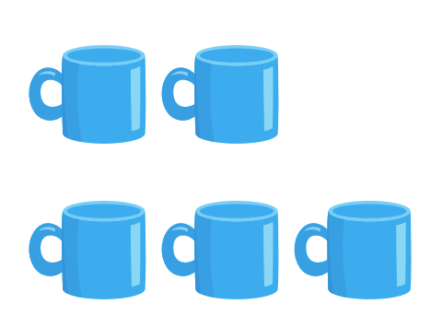

Module 2 Lesson 2 Name: _____________________________

Circle the group of two cups. Write the number of cups next to each group.

Module 2 Lesson 2 Name: _____________________________

Circle the group of two cups. Write the number of cups next to each group.

Module 2 Lesson 2 Name: _____________________________

Circle the group of two cups. Write the number of cups next to each group.

Module 2 Lesson 3 Name: _____________________________

Circle the group of five. Write the number of animals below each group of animals.

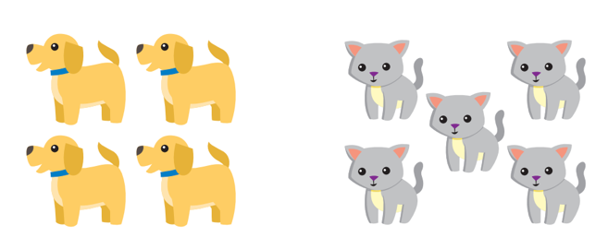

Module 2 Lesson 3 Name: _____________________________

Circle the group of five. Write the number of animals below each group of animals.

Module 2 Lesson 3 Name: _____________________________

Circle the group of five. Write the number of animals below each group of animals.

Module 2 Lesson 3 Name: _____________________________

Circle the group of five. Write the number of animals below each group of animals.

Module 2 Lesson 4 Name: _____________________________

Circle the group of four. Write the number below each group of sports equipment.

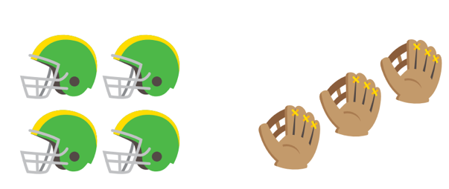

Module 2 Lesson 4 Name: _____________________________

Circle the group of four. Write the number below each group of sports equipment.

Module 2 Lesson 4 Name: _____________________________

Circle the group of four. Write the number below each group of sports equipment.

Module 2 Lesson 4 Name: _____________________________

Circle the group of four. Write the number below each group of sports equipment.

Module 2 Lesson 5 Name: _____________________________

Mark has 3 crayons. Joey has 1 more crayon than Mark. Draw a group that shows how many crayons Joey has.

Module 2 Lesson 5 Name: _____________________________

Mark has 3 crayons. Joey has 1 more crayon than Mark. Draw a group that shows how many crayons Joey has.

Module 2 Lesson 5 Name: _____________________________

Mark has 3 crayons. Joey has 1 more crayon than Mark. Draw a group that shows how many crayons Joey has.

Module 2 Lesson 5 Name: _____________________________

Mark has 3 crayons. Joey has 1 more crayon than Mark. Draw a group that shows how many crayons Joey has.

Module 3 Lesson 1 Name: _____________________________

Listen to the story. Use counters to show the groups. Then compare the groups. Maria has three carrots. Jeremy has five carrots. Who has a greater number of carrots?

Maria’s carrots

Jeremy’s carrots

Module 3 Lesson 1 Name: _____________________________

Listen to the story. Use counters to show the groups. Then compare the groups. Maria has three carrots. Jeremy has five carrots. Who has a greater number of carrots?

Maria’s carrots

Jeremy’s carrots

Module 3 Lesson 2 Name: _____________________________

Karl goes on a walk. He sees three squirrels and five chipmunks. Circle the group that has a number of animals that is less.

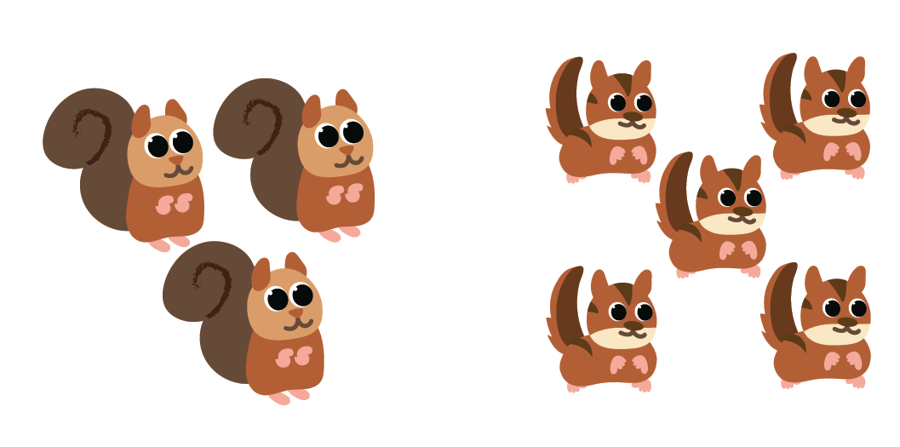

Module 3 Lesson 2 Name: _____________________________

Karl goes on a walk. He sees three squirrels and five chipmunks. Circle the group that has a number of animals that is less.

Module 3 Lesson 2 Name: _____________________________

Karl goes on a walk. He sees three squirrels and five chipmunks. Circle the group that has a number of animals that is less.

Module 3 Lesson 2 Name: _____________________________

Karl goes on a walk. He sees three squirrels and five chipmunks. Circle the group that has a number of animals that is less.

Module 3 Lesson 3 Name: _____________________________

Beth eats three carrot sticks. Then she eats three celery sticks.

Draw to show the groups of carrot sticks and celery sticks. Draw lines to match the objects in the two groups. Is the number of celery sticks greater than, less than, or equal to the number of carrot sticks?

Module 3 Lesson 3 Name: _____________________________

Beth eats three carrot sticks. Then she eats three celery sticks.

Draw to show the groups of carrot sticks and celery sticks. Draw lines to match the objects in the two groups. Is the number of celery sticks greater than, less than, or equal to the number of carrot sticks?

Module 3 Lesson 4 Name: _____________________________

Rory claps three times. Jessica claps five times.

Write the numbers. Count as you act out the clapping. Circle the number that is less than the other number. Who claps fewer times? Tell how you know.

Module 3 Lesson 4 Name: _____________________________

Rory claps three times. Jessica claps five times.

Write the numbers. Count as you act out the clapping. Circle the number that is less than the other number. Who claps fewer times? Tell how you know.

Module 3 Lesson 4 Name: _____________________________

Rory claps three times. Jessica claps five times.

Write the numbers. Count as you act out the clapping. Circle the number that is less than the other number. Who claps fewer times? Tell how you know.

Module 3 Lesson 4 Name: _____________________________

Rory claps three times. Jessica claps five times.

Write the numbers. Count as you act out the clapping. Circle the number that is less than the other number. Who claps fewer times? Tell how you know.

Module 3 Lesson 5 Name: _____________________________

Kelli draws three apples. She draws four oranges.

Draw to show the groups. Compare the groups using the words greater than or less than.

Module 3 Lesson 5 Name: _____________________________

Kelli draws three apples. She draws four oranges.

Draw to show the groups. Compare the groups using the words greater than or less than.

Module 3 Lesson 6 Name: _____________________________

Jason has one more than three toy cars. Anna has five toy cars.

Write the numbers of cars that Jason and Anna have. Who has the greater number of toy cars?

Module 3 Lesson 6 Name: _____________________________

Jason has one more than three toy cars. Anna has five toy cars.

Write the numbers of cars that Jason and Anna have. Who has the greater number of toy cars?

Module 4 Lesson 1 Name: _____________________________

Devin has five toy cars. Some cars are red, and some are black. The black cars are parked in a parking lot. The red cars are in a garage.

Draw a picture that shows the cars. Then count the cars in each group and write the numbers.

Module 4 Lesson 1 Name: _____________________________

Devin has five toy cars. Some cars are red, and some are black. The black cars are parked in a parking lot. The red cars are in a garage.

Draw a picture that shows the cars. Then count the cars in each group and write the numbers.

Module 4 Lesson 2 Name: _____________________________

Hannah used these shapes to make a picture.

Draw to classify the shapes. How many of each shape did Hannah use?

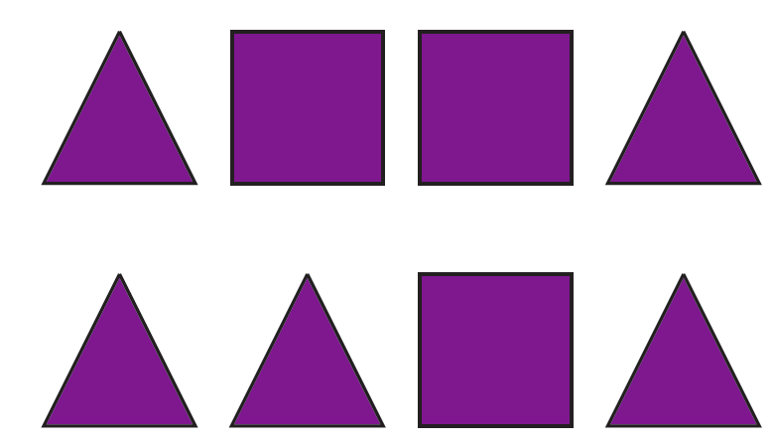

Module 4 Lesson 2 Name: _____________________________

Hannah used these shapes to make a picture.

Draw to classify the shapes. How many of each shape did Hannah use?

Module 4 Lesson 3 Name: _____________________________

Caroline has 8 books. Some books are big and the rest are small. How many small books does Caroline have?

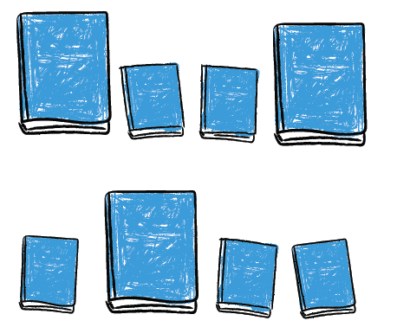

Module 4 Lesson 3 Name: _____________________________

Caroline has 8 books. Some books are big and the rest are small. How many small books does Caroline have?

Module 4 Lesson 3 Name: _____________________________

Caroline has 8 books. Some books are big and the rest are small. How many small books does Caroline have?

Module 4 Lesson 3 Name: _____________________________

Caroline has 8 books. Some books are big and the rest are small. How many small books does Caroline have?

Module 4 Lesson 4 Name: _____________________________

Howard uses blocks to build three towers. One tower is made with four red blocks, one tower is made with two green blocks, and one tower is made with three yellow blocks. Howard counts the blocks in each tower and sorts the towers by count.

Draw a picture that shows how Howard sorts his towers.

Module 4 Lesson 4 Name: _____________________________

Howard uses blocks to build three towers. One tower is made with four red blocks, one tower is made with two green blocks, and one tower is made with three yellow blocks. Howard counts the blocks in each tower and sorts the towers by count.

Draw a picture that shows how Howard sorts his towers.

Module 5 Lesson 1 Name: _____________________________

Two children are waiting in line. Three children join them. How many children are waiting in line now?

Module 5 Lesson 1 Name: _____________________________

Two children are waiting in line. Three children join them. How many children are waiting in line now?

Module 5 Lesson 2 Name: _____________________________

Five children are playing. Three children leave. How many children are playing now?

Module 5 Lesson 2 Name: _____________________________

Five children are playing. Three children leave. How many children are playing now?

Module 5 Lesson 3 Name: _____________________________

Lucy and her friend went apple picking. Lucy picked three apples. Her friend picked one apple. How many total apples did they pick?

Module 5 Lesson 3 Name: _____________________________

Lucy and her friend went apple picking. Lucy picked three apples. Her friend picked one apple. How many total apples did they pick?

Module 5 Lesson 4 Name: _____________________________

Four puppies were playing together. Two of them went to sleep. How many puppies are still playing?

Module 5 Lesson 4 Name: _____________________________

Four puppies were playing together. Two of them went to sleep. How many puppies are still playing?

Module 5 Lesson 5 Name: _____________________________

Two leaves are on the ground. Another two leaves fall to the ground. How many leaves are on the ground now?

Write an equation to show how you know.

Module 5 Lesson 5 Name: _____________________________

Two leaves are on the ground. Another two leaves fall to the ground. How many leaves are on the ground now?

Write an equation to show how you know.

Module 5 Lesson 6 Name: _____________________________

Three friends are playing at recess. One friend leaves to go inside. How many friends are still playing?

Write a subtraction equation to model the problem. Solve the problem.

Module 5 Lesson 6 Name: _____________________________

Three friends are playing at recess. One friend leaves to go inside. How many friends are still playing?

Write a subtraction equation to model the problem. Solve the problem.

Module 5 Lesson 7 Name: _____________________________

Two children are listening to a story at the library. Three more children join them. How many are listening to the story now?

Module 5 Lesson 7 Name: _____________________________

Two children are listening to a story at the library. Three more children join them. How many are listening to the story now?

Module 6 Lesson 1 Name: _____________________________

Evan has 3 yellow crayons and 2 blue crayons. Draw to show Evan’s crayons and find out how many total crayons there are.

Module 6 Lesson 1 Name: _____________________________

Evan has 3 yellow crayons and 2 blue crayons. Draw to show Evan’s crayons and find out how many total crayons there are.

Module 6 Lesson 2 Name: _____________________________

There are five pieces of fruit in a bowl. One is a banana and the rest are apples. Draw to show the pieces of fruit and find the number of apples.

Module 6 Lesson 2 Name: _____________________________

There are five pieces of fruit in a bowl. One is a banana and the rest are apples. Draw to show the pieces of fruit and find the number of apples.

Module 6 Lesson 3 Name: _____________________________

Taylor is at the park. He sees three squirrels and two birds. How many animals does he see total? Draw to represent the problem, and write an equation to model the problem.

Module 6 Lesson 3 Name: ____________________________

Taylor is at the park. He sees three squirrels and two birds. How many animals does he see total? Draw to represent the problem, and write an equation to model the problem.

Module 6 Lesson 4 Name: _____________________________

Lisa sees five flowers. Some are red and some are yellow. Tell a Take Apart problem about the flowers and then explain how to solve the problem.

Module 6 Lesson 4 Name: _____________________________

Lisa sees five flowers. Some are red and some are yellow. Tell a Take Apart problem about the flowers and then explain how to solve the problem.

Module 6 Lesson 4 Name: _____________________________

Lisa sees five flowers. Some are red and some are yellow. Tell a Take Apart problem about the flowers and then explain how to solve the problem.

Module 6 Lesson 4 Name: _____________________________

Lisa sees five flowers. Some are red and some are yellow. Tell a Take Apart problem about the flowers and then explain how to solve the problem.

Module 6 Lesson 5 Name: _____________________________

Show children a card with 1 dot when saying stuffed bears and a card showing 2 dots when saying stuffed dogs.

Terry has stuffed bears and
stuffed dogs. How many stuffed animals does Terry have total?

Module 6 Lesson 5 Name: _____________________________

Show children a card with 1 dot when saying stuffed bears and a card showing 2 dots when saying stuffed dogs.

Terry has stuffed bears and
stuffed dogs. How many stuffed animals does Terry have total?

Module 6 Lesson 6 Name: _____________________________

Show children a dot plate with 4 dots and read the question; then remove the plate.
James has 4 crayons. One of them is green and the rest are yellow. How many crayons are yellow?

Module 6 Lesson 6 Name: _____________________________

Sandy uses 21 pictures to make a photo album. She puts 3 photos on each page. Draw a bar model to show the problem. Find the number of pages Sandy uses.

Module 6 Lesson 7 Name: _____________________________

Kerry has four books. One has a blue cover, and the rest have yellow covers. How many books have a yellow cover?

Module 6 Lesson 7 Name: _____________________________

Kerry has four books. One has a blue cover, and the rest have yellow covers. How many books have a yellow cover?

Module 7 Lesson 1 Name: _____________________________

Jason has six red flowers. Emma has seven yellow flowers. Use counters to show how many flowers are in each group. Then, draw Jason’s flowers and write the number six. Draw Emma’s flowers and write the number seven.

Module 7 Lesson 1 Name: _____________________________

Jason has six red flowers. Emma has seven yellow flowers. Use counters to show how many flowers are in each group. Then, draw Jason’s flowers and write the number six. Draw Emma’s flowers and write the number seven.

Module 7 Lesson 2 Name: _____________________________

Ricky has eight books and nine marbles. Does he have more books or more marbles? Draw to show your answer.

Module 7 Lesson 2 Name: _____________________________

Ricky has eight books and nine marbles. Does he have more books or more marbles? Draw to show your answer.

Module 7 Lesson 3 Name: _____________________________

Elise saw ten yellow cars. Draw the cars that Elise saw. Then, write the number.

Module 7 Lesson 3 Name: _____________________________

Elise saw ten yellow cars. Draw the cars that Elise saw. Then, write the number.

Module 8 Lesson 1 Name: _____________________________

Rashad has six blue fish and seven green fish. Write a number to show how many blue fish Rashad has. Write a number to show how many green fish Rashad has.

Module 8 Lesson 1 Name: _____________________________

Rashad has six blue fish and seven green fish. Write a number to show how many blue fish Rashad has. Write a number to show how many green fish Rashad has.

Module 8 Lesson 1 Name: _____________________________

Rashad has six blue fish and seven green fish. Write a number to show how many blue fish Rashad has. Write a number to show how many green fish Rashad has.

Module 8 Lesson 1 Name: _____________________________

Rashad has six blue fish and seven green fish. Write a number to show how many blue fish Rashad has. Write a number to show how many green fish Rashad has.

Module 8 Lesson 2 Name: _____________________________

Victor has nine pumpkin seeds and eight carrot seeds. Write a number to show how many pumpkin seeds Victor has. Write a number to show how many carrot seeds Victor has.

Module 8 Lesson 2 Name: _____________________________

Victor has nine pumpkin seeds and eight carrot seeds. Write a number to show how many pumpkin seeds Victor has. Write a number to show how many carrot seeds Victor has.

Module 8 Lesson 2 Name: _____________________________

Victor has nine pumpkin seeds and eight carrot seeds. Write a number to show how many pumpkin seeds Victor has. Write a number to show how many carrot seeds Victor has.

Module 8 Lesson 2 Name: _____________________________

Victor has nine pumpkin seeds and eight carrot seeds. Write a number to show how many pumpkin seeds Victor has. Write a number to show how many carrot seeds Victor has.

Module 8 Lesson 3 Name: _____________________________

Brenda has eight short pencils and two long pencils. Draw Brenda’s pencils. Write a number to show how many pencils Brenda has in all.

Module 8 Lesson 3 Name: _____________________________

Brenda has eight short pencils and two long pencils. Draw Brenda’s pencils. Write a number to show how many pencils Brenda has in all.

Module 8 Lesson 4 Name: _____________________________

Jason has five notebooks for school. His teacher gives him two more notebooks. He wants to know how many he has in all. Start at five and count two more. How many notebooks does Jason have?

Module 8 Lesson 4 Name: _____________________________

Jason has five notebooks for school. His teacher gives him two more notebooks. He wants to know how many he has in all. Start at five and count two more. How many notebooks does Jason have?

Module 8 Lesson 4 Name: _____________________________

Jason has five notebooks for school. His teacher gives him two more notebooks. He wants to know how many he has in all. Start at five and count two more. How many notebooks does Jason have?

Module 8 Lesson 4 Name: _____________________________

Jason has five notebooks for school. His teacher gives him two more notebooks. He wants to know how many he has in all. Start at five and count two more. How many notebooks does Jason have?

Module 9 Lesson 1 Name: _____________________________

Camila counts the number of flowers in her garden. Camila counts from one to twenty. Circle the number that shows how many flowers Camila counted.

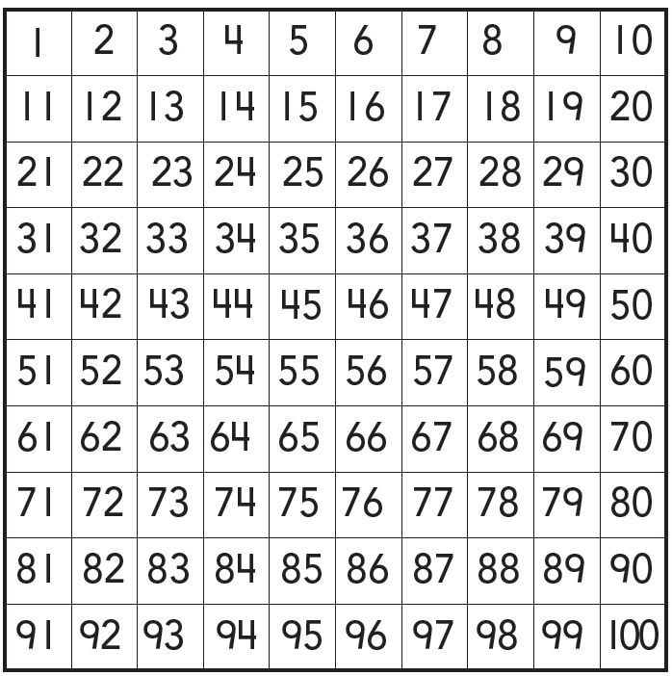

Module 9 Lesson 1 Name: _____________________________

Camila counts the number of flowers in her garden. Camila counts from one to twenty. Circle the number that shows how many flowers Camila counted.

Module 9 Lesson 2 Name: _____________________________

Carl has some stickers. He puts ten stickers in each row so he can count his stickers by tens. Count by tens to find how many stickers Carl has.

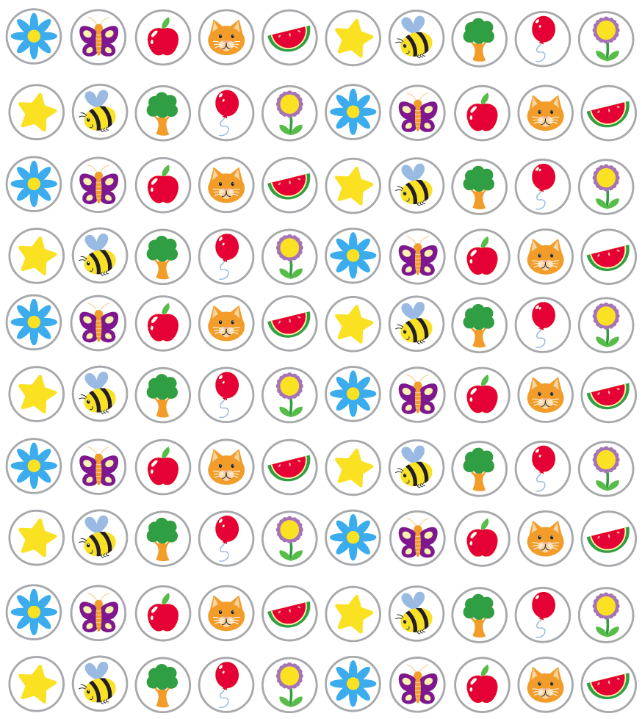

Module 9 Lesson 2 Name: _____________________________

Carl has some stickers. He puts ten stickers in each row so he can count his stickers by tens. Count by tens to find how many stickers Carl has.

Module 9 Lesson 3 Name: _____________________________

Pauline finds the number 38 on a hundred chart. She counts forward until she finds the number 45. Use red to circle the number that Pauline starts with. Use blue to circle the number that she counts forward to on the hundred chart.

Module 9 Lesson 3 Name: _____________________________

Pauline finds the number 38 on a hundred chart. She counts forward until she finds the number 45. Use red to circle the number that Pauline starts with. Use blue to circle the number that she counts forward to on the hundred chart.

Module 10 Lesson 1 Name: ____________________________

Use matching to identify which group has a greater number of objects than the other group.

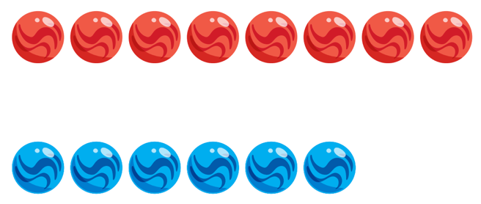

Module 10 Lesson 1 Name: ____________________________

Use matching to identify which group has a greater number of objects than the other group.

Module 10 Lesson 1 Name: ____________________________

Use matching to identify which group has a greater number of objects than the other group.

Module 10 Lesson 1 Name: ____________________________

Use matching to identify which group has a greater number of objects than the other group.

Module 10 Lesson 2 Name: _____________________________

Nolan has eight marbles. Sasha has six marbles. Compare the groups by matching. Which group has a number of marbles less than the other group?

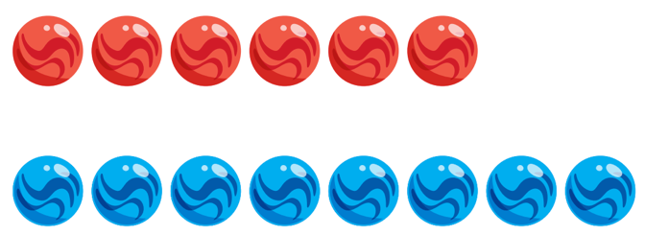

Module 10 Lesson 2 Name: _____________________________

Nolan has eight marbles. Sasha has six marbles. Compare the groups by matching. Which group has a number of marbles less than the other group?

Module 10 Lesson 2 Name: _____________________________

Nolan has eight marbles. Sasha has six marbles. Compare the groups by matching. Which group has a number of marbles less than the other group?

Module 10 Lesson 2 Name: _____________________________

Nolan has eight marbles. Sasha has six marbles. Compare the groups by matching. Which group has a number of marbles less than the other group?

Module 10 Lesson 3 Name: _____________________________

Use matching to identify whether the two groups have an equal number of objects.

Module 10 Lesson 3 Name: _____________________________

Use matching to identify whether the two groups have an equal number of objects.

Module 10 Lesson 3 Name: _____________________________

Use matching to identify whether the two groups have an equal number of objects.

Module 10 Lesson 3 Name: _____________________________

Use matching to identify whether the two groups have an equal number of objects.

Module 10 Lesson 4 Name: _____________________________

Circle the group that has a greater number of counters. Explain how you solved the problem.

Module 10 Lesson 4 Name: _____________________________

Circle the group that has a greater number of counters. Explain how you solved the problem.

Module 10 Lesson 5 Name: _____________________________

Gloria has three cats. Miguel has six turtles. How do their numbers of pets compare?

Draw Gloria’s cats and Miguel’s turtles. Match them and write the numbers. Do Gloria and Miguel have the same number of pets?

Module 10 Lesson 5 Name: _____________________________

Gloria has three cats. Miguel has six turtles. How do their numbers of pets compare?

Draw Gloria’s cats and Miguel’s turtles. Match them and write the numbers. Do Gloria and Miguel have the same number of pets?

Module 10 Lesson 6 Name: _____________________________

Color yellow the boxes that have numbers that are less than six.

Color red the boxes that have numbers that are greater than six.

Color blue the number that is equal to six.

Module 10 Lesson 6 Name: _____________________________

Color yellow the boxes that have numbers that are less than six.

Color red the boxes that have numbers that are greater than six.

Color blue the number that is equal to six.

Module 10 Lesson 6 Name: _____________________________

Color yellow the boxes that have numbers that are less than six.

Color red the boxes that have numbers that are greater than six.

Color blue the number that is equal to six.

Module 10 Lesson 6 Name: _____________________________

Color yellow the boxes that have numbers that are less than six.

Color red the boxes that have numbers that are greater than six.

Color blue the number that is equal to six.

Module 11 Lesson 1 Name: _____________________________

There are four ducks on the pond. Three more ducks land on the pond. How many ducks are on the pond now? Write an equation to solve the problem.

Module 11 Lesson 1 Name: _____________________________

There are four ducks on the pond. Three more ducks land on the pond. How many ducks are on the pond now? Write an equation to solve the problem.

Module 11 Lesson 2 Name: _____________________________

There are nine wildflowers in the field. Two wildflowers are picked. How many wildflowers are left in the field? Write an equation to model the problem.

Module 11 Lesson 2 Name: _____________________________

There are nine wildflowers in the field. Two wildflowers are picked. How many wildflowers are left in the field? Write an equation to model the problem.

Module 11 Lesson 3 Name: _____________________________

Yolanda sees four deer in the woods. Two more deer walk up. How many deer does Yolanda see? Write the equation to solve the word problem.

Module 11 Lesson 3 Name: _____________________________

Yolanda sees four deer in the woods. Two more deer walk up. How many deer does Yolanda see? Write the equation to solve the word problem.

Module 11 Lesson 4 Name: _____________________________

There are 7 apples. Five apples are eaten. How many apples are left?

Module 11 Lesson 4 Name: _____________________________

There are 7 apples. Five apples are eaten. How many apples are left?

Module 11 Lesson 5 Name: ___________________________

Six birds are in a tree. Three more birds join them. How many birds are in the tree now?

Draw to show the addition word problem. Write an equation to model the problem.

Module 11 Lesson 5 Name: ___________________________

Six birds are in a tree. Three more birds join them. How many birds are in the tree now?

Draw to show the addition word problem. Write an equation to model the problem.

Module 11 Lesson 6 Name: _____________________________

Nine children are at the park. Two children leave. How many children are still at the park?

Draw to show the subtraction word problem. Mark an X on the children leaving. Write an equation to model the problem.

Module 11 Lesson 6 Name: _____________________________

Nine children are at the park. Two children leave. How many children are still at the park?

Draw to show the subtraction word problem. Mark an X on the children leaving. Write an equation to model the problem.

Module 11 Lesson 7 Name: _____________________________

Tell an addition or subtraction problem and write an equation to represent it. Explain how the equation models the problem.

Module 11 Lesson 7 Name: _____________________________

Tell an addition or subtraction problem and write an equation to represent it. Explain how the equation models the problem.

Module 11 Lesson 7 Name: _____________________________

Tell an addition or subtraction problem and write an equation to represent it. Explain how the equation models the problem.

Module 11 Lesson 7 Name: _____________________________

Tell an addition or subtraction problem and write an equation to represent it. Explain how the equation models the problem.

Module 12 Lesson 1 Name: _____________________________

Teri sees 5 frogs sitting on a log. She sees 2 frogs swimming in the pond. How can Teri represent the problem to find the total number of frogs?

Module 12 Lesson 1 Name: _____________________________

Teri sees 5 frogs sitting on a log. She sees 2 frogs swimming in the pond. How can Teri represent the problem to find the total number of frogs?

Module 12 Lesson 2 Name: _____________________________

Pat has 6 oranges. Four of the oranges are in a bag, while the rest are on the table. What kind of equation could Pat write to show how many oranges are on the table? Model the problem with an equation.

Module 12 Lesson 2 Name: _____________________________

Pat has 6 oranges. Four of the oranges are in a bag, while the rest are on the table. What kind of equation could Pat write to show how many oranges are on the table? Model the problem with an equation.

Module 12 Lesson 3 Name: _____________________________

Emil finds 3 pennies in his pocket. He finds 7 pennies under his bed. Write an equation to model the two groups and the total number of pennies.

Module 12 Lesson 3 Name: _____________________________

Emil finds 3 pennies in his pocket. He finds 7 pennies under his bed. Write an equation to model the two groups and the total number of pennies.

Module 12 Lesson 4 Name: _____________________________

Jack has 6 apples. Four of the apples are red. The rest are green. How many apples are green?

Module 12 Lesson 4 Name: _____________________________

Jack has 6 apples. Four of the apples are red. The rest are green. How many apples are green?

Module 12 Lesson 5 Name: _____________________________

Diana has 4 red beads and 6 blue beads. She wants to know how many total beads she has. Should Diana add or subtract?

Module 12 Lesson 5 Name: _____________________________

Diana has 4 red beads and 6 blue beads. She wants to know how many total beads she has. Should Diana add or subtract?

Module 12 Lesson 5 Name: _____________________________

Diana has 4 red beads and 6 blue beads. She wants to know how many total beads she has. Should Diana add or subtract?

Module 12 Lesson 5 Name: _____________________________

Diana has 4 red beads and 6 blue beads. She wants to know how many total beads she has. Should Diana add or subtract?

Module 13 Lesson 1 Name: _____________________________

Tony has 6 crayons. Some are blue and some are red. How many crayons of each color might he have?

Draw to show Tony’s crayons. Write an equation to match.

Module 13 Lesson 1 Name: _____________________________

Tony has 6 crayons. Some are blue and some are red. How many crayons of each color might he have?

Draw to show Tony’s crayons. Write an equation to match.

Module 13 Lesson 2 Name: _____________________________

Susan has 8 colored pencils. Some are green and some are orange. How many pencils of each color might she have?

Draw to show Susan’s pencils. Write an equation to match.

Module 13 Lesson 2 Name: _____________________________

Susan has 8 colored pencils. Some are green and some are orange. How many pencils of each color might she have?

Draw to show Susan’s pencils. Write an equation to match.

Module 13 Lesson 3 Name: _____________________________

Alex sees 9 umbrellas. Some are striped and some have polka dots. How might the umbrellas be grouped?

Draw and write an equation to show the groups.

Module 13 Lesson 3 Name: _____________________________

Alex sees 9 umbrellas. Some are striped and some have polka dots. How might the umbrellas be grouped?

Draw and write an equation to show the groups.

Module 13 Lesson 4 Name: _____________________________

There are 10 scarves in a closet. Some are black and some are red. How many scarves of each color might there be?

Draw to show how many scarves of each color there are and write an equation to match your drawing.

Module 13 Lesson 4 Name: _____________________________

There are 10 scarves in a closet. Some are black and some are red. How many scarves of each color might there be?

Draw to show how many scarves of each color there are and write an equation to match your drawing.

Module 13 Lesson 5 Name: _____________________________

Harrison sees 10 rabbits. Six of the rabbits are gray. The rest are white. How many white rabbits does Harrison see? Write the equation.

Module 13 Lesson 5 Name: _____________________________

Harrison sees 10 rabbits. Six of the rabbits are gray. The rest are white. How many white rabbits does Harrison see? Write the equation.

Module 14 Lesson 1 Name: _____________________________

Draw an object that has the shape of a sphere.

Module 14 Lesson 1 Name: _____________________________

Draw an object that has the shape of a sphere.

Module 14 Lesson 1 Name: _____________________________

Draw an object that has the shape of a sphere.

Module 14 Lesson 1 Name: _____________________________

Draw an object that has the shape of a sphere.

Module 14 Lesson 2 Name: _____________________________

Point out an object that has the shape of a cube.

Module 14 Lesson 2 Name: _____________________________

Point out an object that has the shape of a cube.

Module 14 Lesson 2 Name: _____________________________

Point out an object that has the shape of a cube.

Module 14 Lesson 2 Name: _____________________________

Point out an object that has the shape of a cube.

Module 14 Lesson 3 Name: _____________________________

Draw an object that has the shape of a cylinder.

Module 14 Lesson 3 Name: _____________________________

Draw an object that has the shape of a cylinder.

Module 14 Lesson 3 Name: _____________________________

Draw an object that has the shape of a cylinder.

Module 14 Lesson 3 Name: _____________________________

Draw an object that has the shape of a cylinder.

Module 14 Lesson 4 Name: _____________________________

Point to an object that has the shape of a cone.

Module 14 Lesson 4 Name: _____________________________

Point to an object that has the shape of a cone.

Module 14 Lesson 4 Name: _____________________________

Point to an object that has the shape of a cone.

Module 14 Lesson 4 Name: _____________________________

Point to an object that has the shape of a cone.

Module 14 Lesson 5 Name: _____________________________

Make a cube using clay and sticks.

Module 14 Lesson 5 Name: _____________________________

Make a cube using clay and sticks.

Module 14 Lesson 5 Name: _____________________________

Make a cube using clay and sticks.

Module 14 Lesson 5 Name: _____________________________

Make a cube using clay and sticks.

Module15 Lesson 1 Name: _____________________________

Lori has a picture on her bedroom wall. She placed a large box below the picture. Draw a picture showing where Lori’s box is placed.

Module15 Lesson 1 Name: _____________________________

Lori has a picture on her bedroom wall. She placed a large box below the picture. Draw a picture showing where Lori’s box is placed.

Module 15 Lesson 2 Name: _____________________________

Matthew is cleaning his room. He placed a baseball beside his bed. Draw a picture showing Matthew’s room.

Module 15 Lesson 2 Name: _____________________________

Matthew is cleaning his room. He placed a baseball beside his bed. Draw a picture showing Matthew’s room.

Module 15 Lesson 3 Name: _____________________________

Valerie has some three-dimensional objects. She places an object that is shaped like a cube in front of an object that is shaped like a cone. Draw Valerie’s objects.

Module X Lesson X Name: _____________________________

Valerie has some three-dimensional objects. She places an object that is shaped like a cube in front of an object that is shaped like a cone. Draw Valerie’s objects.

Module 16 Lesson 1 Name: _____________________________

Ferdinand drew a shape on a piece of paper. The shape was flat and curved. Draw the shape that Ferdinand drew.

Module 16 Lesson 1 Name: _____________________________

Ferdinand drew a shape on a piece of paper. The shape was flat and curved. Draw the shape that Ferdinand drew.

Module 16 Lesson 1 Name: _____________________________

Ferdinand drew a shape on a piece of paper. The shape was flat and curved. Draw the shape that Ferdinand drew.

Module 16 Lesson 1 Name: _____________________________

Ferdinand drew a shape on a piece of paper. The shape was flat and curved. Draw the shape that Ferdinand drew.

Module 16 Lesson 2 Name: _____________________________

Abner drew a shape on a piece of paper. The shape had four equal sides and four corners. Draw the shape that Abner drew.

Module 16 Lesson 2 Name: _____________________________

Abner drew a shape on a piece of paper. The shape had four equal sides and four corners. Draw the shape that Abner drew.

Module 16 Lesson 2 Name: _____________________________

Abner drew a shape on a piece of paper. The shape had four equal sides and four corners. Draw the shape that Abner drew.

Module 16 Lesson 2 Name: _____________________________

Abner drew a shape on a piece of paper. The shape had four equal sides and four corners. Draw the shape that Abner drew.

Module 16 Lesson 3 Name: _____________________________

Hussein drew a shape on a piece of paper. The shape had three equal sides and three corners. Draw the shape that Hussein drew.

Module 16 Lesson 3 Name: _____________________________

Hussein drew a shape on a piece of paper. The shape had three equal sides and three corners. Draw the shape that Hussein drew.

Module 16 Lesson 3 Name: _____________________________

Hussein drew a shape on a piece of paper. The shape had three equal sides and three corners. Draw the shape that Hussein drew.

Module 16 Lesson 3 Name: _____________________________

Hussein drew a shape on a piece of paper. The shape had three equal sides and three corners. Draw the shape that Hussein drew.

Module 16 Lesson 4 Name: _____________________________

Reese is drawing on a piece of paper. The paper has four unequal sides and four corners. Draw what Reese’s paper might look like.

Module 16 Lesson 4 Name: _____________________________

Reese is drawing on a piece of paper. The paper has four unequal sides and four corners. Draw what Reese’s paper might look like.

Module 16 Lesson 4 Name: _____________________________

Reese is drawing on a piece of paper. The paper has four unequal sides and four corners. Draw what Reese’s paper might look like.

Module 16 Lesson 4 Name: _____________________________

Reese is drawing on a piece of paper. The paper has four unequal sides and four corners. Draw what Reese’s paper might look like.

Module 16 Lesson 5 Name: _____________________________

Norman sees a shape that has six equal sides and six corners. Keisha sees a shape that has six unequal sides and six corners. Draw the shape that Norman sees. Draw the shape that Keisha sees. What are the names of the shapes?

Module 16 Lesson 5 Name: _____________________________

Norman sees a shape that has six equal sides and six corners. Keisha sees a shape that has six unequal sides and six corners. Draw the shape that Norman sees. Draw the shape that Keisha sees. What are the names of the shapes?

Module 16 Lesson 6 Name: _____________________________

Marco and Kaya are composing a hexagon. Marco composes the shape one way, and Kaya composes it a different way. Draw to show a way that each child could have composed the shape.

Module 16 Lesson 6 Name: _____________________________

Marco and Kaya are composing a hexagon. Marco composes the shape one way, and Kaya composes it a different way. Draw to show a way that each child could have composed the shape.

Module 16 Lesson 7 Name: _____________________________

Sam has a toy that is shaped like a three-dimensional shape with sides that look like squares. What shape is his toy?

Module 16 Lesson 7 Name: _____________________________

Sam has a toy that is shaped like a three-dimensional shape with sides that look like squares. What shape is his toy?

Module 16 Lesson 7 Name: _____________________________

Sam has a toy that is shaped like a three-dimensional shape with sides that look like squares. What shape is his toy?

Module 16 Lesson 7 Name: _____________________________

Sam has a toy that is shaped like a three-dimensional shape with sides that look like squares. What shape is his toy?

Module 17 Lesson 1 Name: _____________________________

Naomi has ten oranges in one basket and four oranges in another basket. Draw to represent the number of oranges Naomi has.

How can you describe the two groups of oranges?

Module 17 Lesson 1 Name: _____________________________

Naomi has ten oranges in one basket and four oranges in another basket. Draw to represent the number of oranges Naomi has.

How can you describe the two groups of oranges?

Module 17 Lesson 2 Name: _____________________________

Derrick has ten strawberries in one basket and five in another basket. How can you describe the number of strawberries that Derrick has?

Module 17 Lesson 2 Name: _____________________________

Derrick has ten strawberries in one basket and five in another basket. How can you describe the number of strawberries that Derrick has?

Module 17 Lesson 3 Name: _____________________________

Justin has sixteen rocks in his rock collection. Draw a picture to show how he could group his rocks into 10 ones and some more ones.

Module 17 Lesson 3 Name: _____________________________

Justin has sixteen rocks in his rock collection. Draw a picture to show how he could group his rocks into 10 ones and some more ones.

Module 17 Lesson 4 Name: _____________________________

Leah has 20 teddy bears. Draw Leah’s teddy bears.

Module 17 Lesson 4 Name: _____________________________

Leah has 20 teddy bears. Draw Leah’s teddy bears.

Module 18 Lesson 1 Name: _____________________________

Draw one group of 11 stars and one group of 14 hearts.

Module 18 Lesson 1 Name: _____________________________

Draw one group of 11 stars and one group of 14 hearts.

Module 18 Lesson 2 Name: _____________________________

Draw 15 squares and write an equation to represent the squares using ten ones and some more ones.

Module 18 Lesson 2 Name: _____________________________

Draw 15 squares and write an equation to represent the squares using ten ones and some more ones.

Module 18 Lesson 3 Name: _____________________________

Draw one group of 17 flowers and one group of 18 trees.

Module 18 Lesson 3 Name: _____________________________

Draw one group of 17 flowers and one group of 18 trees.

Module 18 Lesson 4 Name: _____________________________

Draw 20 circles and write the number.

Module 18 Lesson 4 Name: _____________________________

Draw 20 circles and write the number.

Module 19 Lesson 1 Name: _____________________________

Anna wants to know if a pencil will fit inside a pencil case. What does she need to do?

Module 19 Lesson 1 Name: _____________________________

Anna wants to know if a pencil will fit inside a pencil case. What does she need to do?

Module 19 Lesson 2 Name: _____________________________

Use five cubes to make a cube train. Draw a crayon that is shorter than the cube train.

Module 19 Lesson 2 Name: _____________________________

Use five cubes to make a cube train. Draw a crayon that is shorter than the cube train.

Module 19 Lesson 3 Name: _____________________________

Use ten connecting cubes to make a tower. Draw a crayon that is shorter than the tower.

Module 19 Lesson 3 Name: _____________________________

Use ten connecting cubes to make a tower. Draw a crayon that is shorter than the tower.

Module 20 Lesson 1 Name: _____________________________

Maria looks out her window. She sees a squirrel and a deer. Draw the animals that Maria sees. Circle the animal that is heavy.

Module 20 Lesson 1 Name: _____________________________

Maria looks out her window. She sees a squirrel and a deer. Draw the animals that Maria sees. Circle the animal that is heavy.

Module 20 Lesson 2 Name: _____________________________

There are two boxes on the teacher’s table. One box is empty. The other box is full of oranges. Compare the weights of the empty box and the full box. Use the words heavier and lighter.

Module 20 Lesson 2 Name: _____________________________

There are two boxes on the teacher’s table. One box is empty. The other box is full of oranges. Compare the weights of the empty box and the full box. Use the words heavier and lighter.

Module 20 Lesson 2 Name: _____________________________

There are two boxes on the teacher’s table. One box is empty. The other box is full of oranges. Compare the weights of the empty box and the full box. Use the words heavier and lighter.

Module 20 Lesson 2 Name: _____________________________

There are two boxes on the teacher’s table. One box is empty. The other box is full of oranges. Compare the weights of the empty box and the full box. Use the words heavier and lighter.

Module 20 Lesson 3 Name: _____________________________

Circle the object that is long and light. How would you describe the other object in the picture?

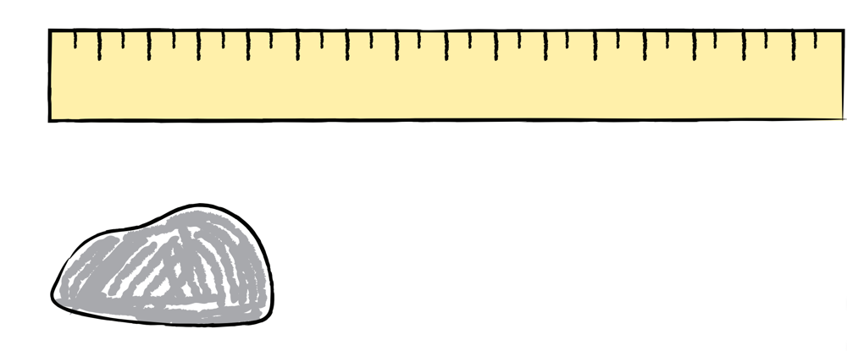

Module 20 Lesson 3 Name: _____________________________

Circle the object that is long and light. How would you describe the other object in the picture?

